Assessment Policy
2015-16

 | Name |  | Signature |  | Date
Prepared by:
Checked and Reviewed by:
Approved by: | Name: Chair of Governing Body
Document Title: | Policy – Assessment Policy
Version Number: | 1 | Date of Next Review:

Introduction
Planning and Assessment Policy 2015

At Canonbury we believe that:
- Assessment should be an integral part of the teaching and learning process;
- Teachers, support staff, pupils and parents all have an important part to play in that process.

General Principles and Aims
Our assessment and recording procedures will:
- Support quality teaching and learning;
- Provide reliable and credible information to support progression in learning;
- Find out and build on what children already know;
- Be based on clear and shared success criteria;
- Motivate and actively involve children in reviewing their work;
- Be manageable, sustainable, consistent and useful;
- Describe the child’s progress against expectation;
- Highlight a child’s success and progress;
- Identify areas for improvement and how they can be addressed;
- Meet statutory requirements.

Planning
Planning is the key to effective assessment and the quality of learning. Assessment should inform planning. All plans, whether long, medium or short term, should be realistic, relevant and adaptable.

Aims
The aims of planning are to:
- Provide a broad and balanced curriculum;
- Provide for progression, continuity and differentiation between pupils;
- Inform and make use of available resources;
- Provide a record of work covered over the term, year and Key Stage;
- Help plan time effectively;
- Help focus on classroom organisation and groupings;

Canonbury Curriculum Map
All planning is based on the ‘Canonbury Curriculum Map’, which plans out the National Curriculum (NC) objectives that need to be covered by each year group. This map outlines topics, the big idea, NC objectives and big questions. The National Curriculum also outlines the curriculum for English and Maths.
The Foundation Stage has a two-year topic cycle based on the Early Learning Goals.

Medium Term Plans
Each term, the class teacher refers to the ‘Canonbury Curriculum Map’ and devises a topic that links these requirements together. Topics can last for a term or half a term. Where possible, literacy skills and outcomes will relate to experiences in other subjects.

Teachers will refer to the ‘Canonbury Literacy Map’ for the core texts to be taught in English. The Map suggests writing outcomes and text types to follow. The children need to experience a broad range of text types throughout every year. To accompany the Literacy Map, there is a whole school Grammar and Punctuation map. Writing outcomes will be identified in the planning, with a series of literacy lessons teaching the skills leading up to this. The ‘Power of Reading’ (CLPE) planning resources will be used to support the teaching of English.

It is recognised that some areas will be taught discretely e.g. maths or science. Teachers will make links when this is possible.

School visits are an integral part of the planning process and should be carefully planned to tie in with classroom-based activities. Teachers are expected to plan at least two visits or visitors per term.

A wide range of resources are used to write the Medium Term Plans. The starting point is the National Curriculum. For English, planning is focussed on high quality texts and suggestions from ‘The Power of Reading’ website (CLPE). For Maths the online resource ‘Abacus’. For R.E. the ‘Islington Agreed Syllabus for Religious Education' is used. Islington guidance alongside our school’s scheme of work are also followed for the PHSE and Citizenship Curriculum.

Teachers in the Foundation Stage are expected to complete and save copies of: Topic planning linked to all six Areas of Learning

Key Stage 1 and 2 class teachers are expected to complete and save copies of:

- Literacy and Maths weekly plans using our pro formas;
- Medium Term Plans – including the objectives and activities for history, geography, science, Computing, Art, D.T., Music, R.E. P.E., PSHE, Philosophy for children, visits, entry/exit point and cross-curricular links using the school pro forma

All Medium Term planning will be monitored on a termly basis by SLT and subject leaders, with teachers receiving written feedback.

Weekly Planning
Teachers are expected to save all weekly plans (English and Maths) in the shared teaching area and use a standardised planning format.

All weekly planning will be monitored on a regular basis by SLT and subject leaders, with teachers receiving written feedback.

Assessment

Classroom assessment
Assessment is a formal or informal dialogue between teacher and pupil about work in progress or completed work. It may take place between the teacher and an individual child or with a group or class. It may take the form of open-ended questioning, dialogue focusing on learning objectives, a written record of observations or written on the child’s work.
Essentially it should provide clear and realistic feedback to pupils about where they need to go next. We place great emphasis on this type of dialogic marking, developing teachers’ ability to question so as to assess a child’s understanding and next steps.
There are times when specific formative comments on pupil’s work can act as a record as well as being a reminder of the focus for future progress.

Teachers must choose a piece of extended writing and Maths every week that requires good quality feedback that will enable the child to move forward in their learning.

Marking and Feedback
At Canonbury Primary School, we believe that feedback and marking should provide constructive feedback to every child, focusing on success and improvement needs against learning intentions; enabling children to become reflective learners and helping them to close the gap between current and desired performance.
Principles:
Marking and Feedback should:
- Relate to learning objectives, which need to be shared with all children
- Involve all adults working with children in the classroom
- Give children opportunities to become aware of and reflect on their learning needs
- Give recognition and appropriate praise for achievement
- Give clear strategies for improvement
- Allow specific time for the children to read, reflect and respond to marking
- Involve children in the same process (whether oral or written), to ensure equity across subjects and abilities
- Respond to individual needs, marking face to face with some, and at a distance for others
- Inform future planning and individual target setting
- Be accessible to children
- Use a consistent method across the school
- Ultimately be seen by children as positive in improving their learning
- Encourage and teach children to self-mark wherever possible
- Be manageable for teachers

Strategies:
The following Strategies can be used to mark, assess and give /generate feedback.
- ‘Knowledge harvest’ activity at the start of each unit.
- Where prior knowledge allows, generate process Success Criteria together, with teacher guidance
- Record observations e.g. on post it notes
- Keep planning handy to annotate. All planning for the week should be kept in a folder on the wall, and annotated where appropriate. It should be filed away at the end of each week.
- Use Plenary to assess work against the process Success Criteria
- If Focus marking work, ensure to leave 5 mins at the beginning of the next lesson for children to respond to your feedback
- Mark work to the Learning Objective, using the Success Criteria. Supply teachers should not Focus Mark – it should be the class teacher wherever possible.
- Please ensure that both the L.O and S.C are visible throughout the lesson, where appropriate.
- Quality time should be allocated for formative assessment in lessons
- Peer and self assessment should be used regularly.
- Teachers should indicate on their plans the work that will be marked for improvement.
- As a school we use Yellow and Green Highlighters to Focus mark. Green indicates Success and Yellow indicates an area that needs further development.
- Work should always be marked to the Learning Objective, using the Success Criteria as a guide.
- Any comments should always refer to the next steps for learning, instead of effort or quality of presentation.
- If you must leave a comment to do with effort or presentation, ensure these comments are written on post it notes and attached to the work. Permanent comments should relate to learning only.

Marking should:
- Identify attainment
- Recognise achievement
- Praise success
- Highlight areas for improvement and ways of achieving it
- Encourage self-assessment
- Be capable of easy interpretation by pupils and parents
- Help children to take responsibility for their own learning
- Extend children’s learning

MARKING AND FEEDBACK GUIDELINES - Maths
Maths Books – The Essentials
- All work must be marked every day
- All children must receive quality feedback comments at least once a week for Maths
- All children must respond to the next step
- All responses be acknowledged by the teacher

On the other four days you can use…
- Self-assessment

- Peer assessment

- Green Pen Questions

- Acknowledgement marking

Quality Next Step Marking
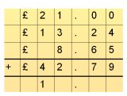
- Quality marking can be done in a number of different ways, but must always involve a child responding to a next step.

Method | What is it? | Example
Model | Teacher models a calculation for the child to complete | e.g. complete the column method
Image | Use an image of a resources to help the child to respond | e.g. Can you use this number line to help you work out this calculation?  91 – 65 =
Closed / multiple choice question | Give the child a question with one answer | e.g. Circle the numbers that round to 50 - 49 40 55.
Open question | Give the child a question with a range of answers | e.g. How could you arrange 20 cakes into equal rows?
Finish the sentence | Scaffold the answer so that the child just has to complete a statement | e.g. Four 5 pences are the same value as…............and …………...”
Explanation/Generalisation | If a child has successfully completed their work, you could provide a question to enable the child to reflect on / deepen their understanding. | e.g. Why does 30 + 29 + 31 equal 90?”

MARKING AND FEEDBACK GUIDELINES - English
English Books – The Essentials
  - All work must be marked every day
  - Teachers must give quality feedback to every child at least once a week in their English books
  - All children must respond to the next step identified in the quality feedback-
  - All responses should be acknowledged by the teacher
  - If a child has not responded (or the response is not an improvement) they must have another go

On the other four days you can use…

- Self-assessment

- Peer assessment

- Green Pen Questions

- Acknowledgement marking

Quality Next Step Marking – Highlighting
- Highlight two sentences (words/letters for emergent writers) in GREEN
- Highlight one sentence (words/letters for emergent writers) in YELLOW
- Give concise comment to show why sentences are GREEN
- Give improvement prompts (see examples below) to help the child improve the
YELLOW sentence
- Highlight where you want the child to respond to marking

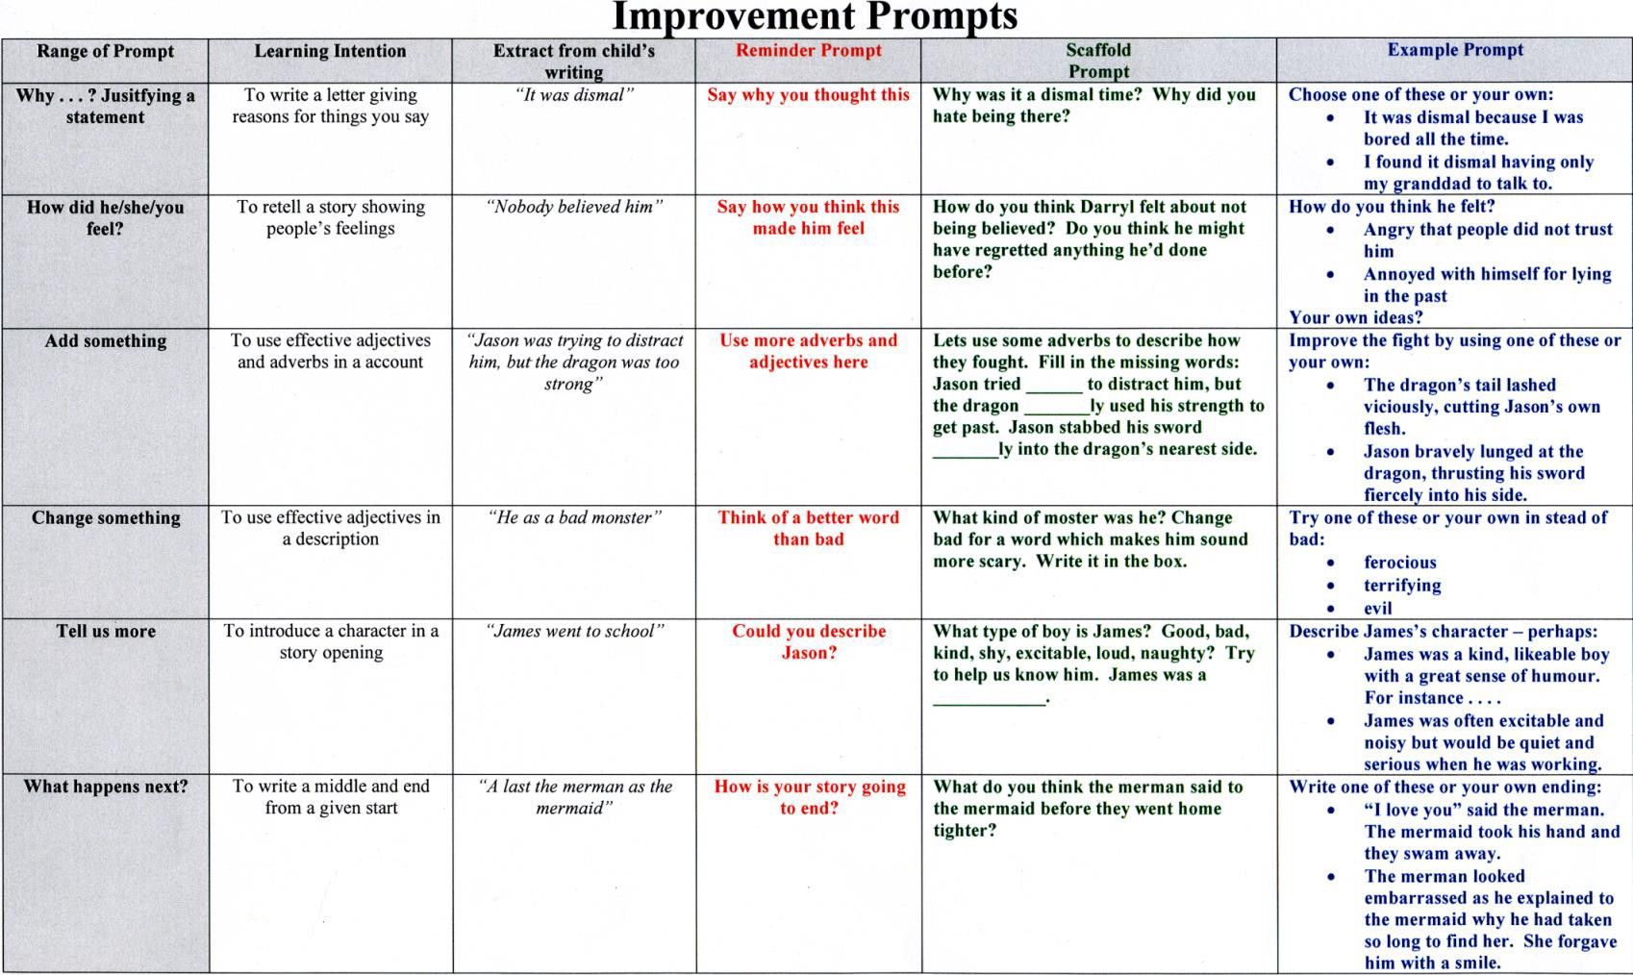

Self/Peer Assessment
We believe that there should be opportunities for pupils to develop the skills and vocabulary needed for self-assessment and that this should be built on year by year.
Learning Objectives should be shared with pupils and used as a focus for dialogue when discussing work and progress.
In maths children can mark their own work, or write a sentence reflecting on what they have achieved in the lesson. Teachers must model what they expect and insist on a high standard of reflection. Giving sentence starters can be a useful strategy.

In writing, children can select words or sentences that are linked to the LO. They could also write a sentence reflecting on what they have achieved in the lesson. Teachers must model what they expect and insist on a high standard of reflection. Giving sentence starters can be a useful strategy.

With peer assessment there should be opportunities for children to reflect positively on the work of others. This should be the same format as self –assessment. Teachers must model what they expect and insist on a high standard of reflection.

Running Records
From Reception teachers and support staff carry out ‘Running Records’ to assess children’s reading level. The school uses the PM Benchmark books to carry out these assessments which show the readers level of accuracy (children achieving 95% or more are ready to move on to the next level) and what reading strategies children use and don’t use so thus informs teaching.
Reception to Year 2 carry out Running Records on the whole class each term but complete additional ones as they see fit – if a child has made exceptional or little progress. TAs in Key Stage 2 carry them out on readers they focus on to inform how they support these children and in order to ascertain which level book is appropriate.

Life Without Levels

Ongoing Assessment
To assist teachers with their assessments we are using Target Tracker. Teachers will no longer be using optional SATs in years 1-5 to make assessment judgements. Target tracker allows teachers to use the new curriculum objectives to make a judgement on whether each child is at the expected level for their year group.

Target Tracker (TT)
Teachers from Nursery to Year 6 should use TT to look at each statement from the relevant curriculum and assess all children as…
- Working towards or…
- Achieved…
- Not begun

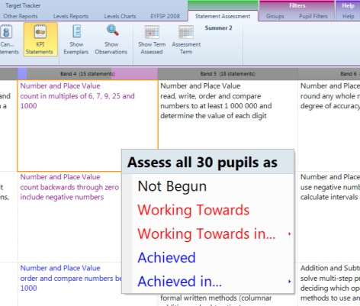

It can also be used to assess where a child is in relation to national expectation
- Beginning in the year band
- Working within the year band
- Secure within the year band (the aim for each child in Y1-6)
- Secure + within the year band

Teachers Judgements
All teachers will have to share their Reading, Writing and Maths assessments in the Autumn, Spring and Summer terms. Reception, Year 1 (phonics), Year 2 and Year 6 will have to share their results with the LA.

Reading:
Teachers will use the notes taken in Guided Reading sessions to inform their level judgements. This will be an ongoing process that will ensure that the children are consistently taught from the new curriculum. Pro formas have been provided for the teachers to use.

Writing:
Each week, children are expected to complete a lengthy piece of Writing. As the unit progresses, the expectation is that the piece would be lengthier. It is important that the children have a range of opportunities to complete:
- Unaided writing
- Scaffolded writing
- Extended writing
- Published redrafted writing
These samples will be used when comparing to the year group assessment expectations. Canonbury are working with other Islington schools to develop a standards file for teachers to use when making their judgements.

Maths:
Teachers will use the children’s books and termly Abacus assessments to inform their decisions.

Moderation
To ensure that there is consistency across the school, there is a rigorous moderation process. This involves moderation across the year group, with SLT support and in collaboration with other Islington schools.

Year group moderation: Class teachers work together to ensure that their assessment judgements are consistent with each other. Time is given towards this, but teachers are expected to also use their PPA for this.

SLT moderation: Meetings during the school day are arranged to ensure that SLT are in agreement with the class teachers.

Partnership Moderations: Partnerships have been set up with local Islington schools to ensure that we are in agreement with their assessment judgements. In 2015-16 three staff meetings have been arranged to focus on: Writing (Autumn term), Maths (Spring Term) and Reading (Summer Term).

Reporting to Parents
We believe that reports should have a positive effect on children’s attitudes, motivation and self-esteem. We also value the input we receives from parents and see reports as one way of further developing the relationship between the school and parents.

The Annual Report to Parents will include:
- Highlights of positive achievements and progress made;
- Careful chosen language that clearly communicates whether the child is Below national expectation
Within Secure
A summary of the child’s attendance and punctuality;
- In Years 2 and 6, pupil’s National Curriculum assessment results
- Positive suggestions that would help further development;
- General comments about the child’s attitude and social skills;
- Child’s reflection on his/her year’s work.

Parent/Teacher Consultations:
All parents will be informed as to where their child is at the point in the year, in relation to the national expectation of their year group.

They could be:
  - Beginning in the year band
  - Working within the year band
  - Secure within the year band (the aim for each child in Y1-6)
  - Secure + within the year band

Two Parents’ Evenings are held during the school year:

Autumn - is an opportunity for the parents to meet the class teacher and share concerns, worries and so forth. It is an opportunity for parents to ask questions about the year ahead. Parents sign up for a specific time slot.

Spring - parents will have an opportunity to look at their child’s work and discuss with the teacher their child’s progress on a one-to-one basis. Parents sign up for a specific time slot.

In the Summer term there will be an evening where parents are welcome to make an appointment to review their child’s report with the class teacher.

Members of the senior leadership team will also be available at each evening to meet parents with additional concerns.

