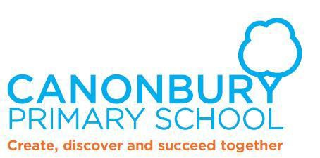

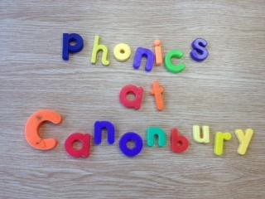

Introduction

At Canonbury we use the Letters and Sounds phonics programme which aims to build upon children's speaking and listening skills as well as preparing them for learning to read by developing their phonic knowledge and skills. It sets out a detailed and systematic programme for teaching phonic skills for children with the aim of them becoming fluent readers by the age of seven.

Letters and Sounds is split into 6 phases. This document details what children will learn in each phase.

How is my child taught phonics at school?

Children are taught phonics in a daily 20 minute session. The session includes 5 minutes spent on revising sounds that have previously been taught, 10 minutes teaching a new sound and practising reading and writing the sound in words. The session then concludes with 5 minutes being spent on reading or writing a sentence that includes the new sound.

In Reception up to Year 2, children are taught phonics in phase groups- if they are working in Phase 5, they are taught with other children who are working at this level.

Please ask your child’s class teacher if you wish to know the phonics phase your child is working in.

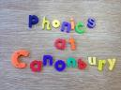

Phase One (Nursery / Pre-school)

The aim of this phase is to foster children’s speaking and listening skills as preparation for learning to read with phonics. Parents can play a vital role in helping their children develop these skills, by encouraging their children to listen carefully and talk extensively about what they hear, see and do.

In this on-going phase, your child will be learning to:
- Have fun with sounds
- Listen carefully
- Develop their vocabulary
- Speak confidently to you, other adults and other children
- Tune into sounds
- Listen and remember sounds
- Talk about sounds
- Understand that spoken words are made up of different sounds.

Phase 1 consists of seven interlinking parts:
- Environmental sounds
- Instrumental sounds
- Body percussion
- Rhythm and rhyme
- Alliteration (words that begin with the same sound)
- Voice sounds
- Oral blending and segmenting.

Phase 1- Ways to support your child at home:

Aspect 1 Environmental sounds

Go on a sound walk, what can you hear? Encourage your child to listen out for cars, birds tweeting, people walking etc. Are they loud or quiet sounds?

Make sounds together using sticks, can you make a loud sound by banging the stick on the ground?

Play sound lotto using the sounds heard on the sound walk. Draw pictures of the sound source e.g. cars, birds, aeroplanes and ask your child to guess the sound source ,
e.g. car from your impression of a car revving.
Phase 1- Ways to support your child at home:

Aspect 2 Instrumental sounds

Make junk model instruments together using margarine tubs, tubes and boxes. These can be filled with a variety of rice and pasta and will make a range of sounds.

Take a song or rhyme that your child knows well and create new lyrics! You could use the junk model percussion instruments to accompany the new songs.
Phase 1- Ways to support your child at home:

Aspect 3 Body Percussion

Sing songs that involve actions, such as Roly Poly- Ro….ly….poo…ly…ever…so….slowly Ro...ly…poly faster.
(Increase the speed of the action as you increase the speed of the rhyme Stamp…your…feet….ever…..so…..slowly Stamp….your feet faster.

You could then add your own sounds and movements.

Phase 1- Ways to support your child at home:

Aspect 4 Rhythm and rhyme

Regularly read rhyming books such as the Gingerbread man. Encourage your child to join in with repetitive phrases such as Run, run, as fast as you can, you can’t catch me, I’m the Gingerbread Man.

Encourage your child’s word play by inventing new rhymes with them such as Hickory, Dickory Dable, the mouse ran up the…..

Phase 1- Ways to support your child at home:

Aspect 5 Alliteration

Using your child’s name think up simple tongue twisters to link objects at home e.g. Millie’s marvellous, magic mittens and David’s dangerous dinosaur.

Collect objects that start with the same sound in a box, create a song such as ‘what is in our sound box today?’ before taking out each object, saying what it is and emphasising the initial sound e.g. s-s-snake, s-s-s-sock, s- s-s-sausage

Phase 1- Ways to support your child at home:

Aspect 6 Voice Sounds
Show your child how they can make sounds with their voices, for example:
- Make your voice go down a slide- wheee!
- Make your voice bounce like a ball – boing, boing
- Hiss like a snake – sssss
- Keep everyone quiet- shshshsh
- Be a steam train chchchchch
- Buzz like a bumble bee – zzzzz
- Be a clock- tick tock

Phase 1- Ways to support your child at home:

Aspect 7 Oral blending and segmenting

Sound out simple words for your child e.g. zip, pin, nip, tip, pit, pup, pig, tug- can they blend the sounds to say the full word?

I Spy- put some objects on the table e.g. cup, peg, hat, ball. Say I spy with my little eye a c-u-p. Can your child blend the sounds together to say the word?

Clapping sounds- show your child one of the objects from the eye spy game- can you split the word up into sounds together e.g. cat = c-a-t. Clap with your child each sound they can hear.

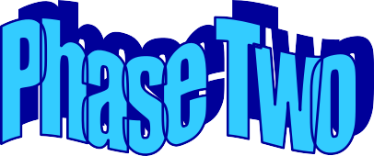

-Reception

In Phase 2 children are taught a new letter and it’s sound in a daily 20 minute session. In the sessions children learn that words are made up of different sounds (phonemes) and these sounds can be linked to letters (graphemes). For example, the sound ‘s’ can be made from the graphemes ‘ss’ or ‘s’.

In Phase 2 children learn the following letters and sounds:

s a t p i n m d g o c k ck e u r h b f ff ll ss

The letters are taught in this order so that children are quickly able to blend the sounds to read simple words such as sat, sat, pin.

We teach children to draw a ‘sound button’ (a dot drawn with their pencil) underneath each sound they can hear. Here are some examples:

s a t p i n h u ff
. . . . . . . . .

‘Pseudo Words’
Pseudo words, sometimes called ‘fake words’ are words that can be sounded out and blended but have no meaning. These are very important as they help adults to understand whether a child has learnt the skills of decoding as the child probably won’t have been exposed to the word before on signs and labels.

Phase 2- Ways to support your child at home:
Pseudo words- can your child read and spell these words? These words could be written onto small pieces of card to use at home

tis | tas | ip | nis | san
nam | mim | nim | pid | dap
das | dit | gack | teck | tem
sot | nop | gom | gat | mig
gam | pom | gop | pom | nop
nug | gug | mun | dup | giff
fam | fot | holl | leb | nass
hess | pess | noss

Phase 2- Ways to support your child at home: Tricky Words
Tricky words cannot be decoded and need to be learned as ‘sight words’ Can your child read the words in the table below?

to | the | no | go | I
into

How do you pronounce each sound?

Please follow the link to the ‘Enunciation of Phonemes’ video on own school website. This is saved in the year group folders.

Alternatively you can speak to your child’s class teacher who will be happy to help.

The following website also contains a game which models each sound:

http://www.kenttrustweb.org.uk/kentict/content/games/ph onemeChecker.html

-Reception

By the time they reach Phase 3, children will already be able to blend (putting sounds together to read a word) and segment (splitting words up into sounds to spell) words containing the 19 letters taught in Phase 2.

Over the twelve weeks which Phase 3 is expected to last, twenty-five new graphemes are introduced (one at a time).

During Phase 3, children will also learn the letter names using an alphabet song, although they will continue to use the sounds when decoding words.

In Phase 3 more of the sounds that are made up of two letters (digraphs) are introduced, we also introduce sounds that are made up of three letters (trigraphs).
Digraph = ‘sh’ ‘ch’ ‘th’ Trigraph = ‘ure’ ‘ear’ ‘air’

In Phase 3 children learn the following sounds:

j v w x y z zz qu
ch sh ch th ng ai ee igh oa oo ar or ur ow oi ear air ure er

We teach children to draw a ‘sound button’ (a dot drawn with their pencil) underneath each sound they can hear. Here are some examples:

Ch i p th i ng c l ear
. . . . . . . . .

‘Pseudo Words’
Pseudo words, sometimes called ‘fake words’ are words that can be sounded out and blended but have no meaning. These are very important as they help adults to understand whether a child has learnt the skills of decoding as the child probably won’t have been exposed to the word before on signs and labels.

Phase 3- Ways to support your child at home:
Pseudo words- can your child read and spell these words? These words could be written onto small pieces of card to use at home

jom | jot | jad | vit | veb
woss | wid | waff | dex | hox
jix | yeff | zum | ruzz | zick
muzz | quiz | quib | quiss | chud
chog | lish | nush | yong | chait
chaim | reesh | theed | gight | bigh
woap | hoat | doan | yart | tark
zort | furp | zur | hinner | zadder
owf | yow | zoil | moin | theard
keard | quair | sair | nure | bature

Phase 3- Ways to support your child at home: Tricky Words
Tricky words cannot be decoded and need to be learned as ‘sight words’ Can your child read the words in the table below?

he | she | we | me | be
was | you | they | all | are
my | her

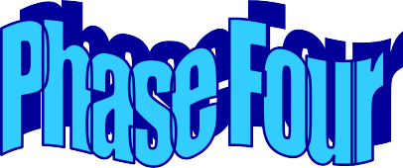

Reception/ Year 1

In Phase 4, no new sounds are taught. Children consolidate previous sounds taught in Phase 1 and 2 and are introduced to letters that blend together at the beginning or the end of words. We call these letters adjacent consonants.

Examples of adjacent consonants-

br- (as in bran) cr- (as in crib) fl- (as in flip)

These consonants together do not make one sound, they remain as two separate sounds. We teach the children to draw a separate sound button underneath each sound in adjacent consonants-

b r a n c r i b f l i p
. . . . . . . . . . . .
In Phase 4, children will be introduced to 2 syllable words- clapping the beats in a word e.g. windmill.

Phase 4- Ways to support your child at home: Tricky Words
Tricky words cannot be decoded and need to be learned as ‘sight words’ Can your child read the words in the table below?

said | have | like | so | do
some | come | were | there | little
one | when | out | what

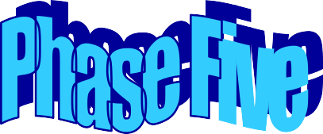

Year 1

In Phase Five, children will learn more graphemes and phonemes. For example, they already know ai as in rain, but now they will be introduced to ay as in day and a-e as in make.

During Phase 5, children are taught the following new graphemes:

oy (b-oy) ay (s-ay) ou (ou-t) ie (t-ie)
ea (ea-t) ir (s-t-ir) ue (c-ue) aw (s-aw)
wh (wh-i-ch) ph (g-r-a-ph) ew- (d-ew) oe (t-oe) au (P-au-l)

During Phase 5, children are taught the following split digraphs, where the ‘e’ changes the sound of the vowel from a short sound e.g. a,e,i,o,u to a long sound.

a-e (m-a-k-e) e-e (th-e-s-e) i-e (l-i-k-e) o-e (h-o-m-e) u-e (r-u-l-e)

Phase 5- Ways to support your child at home: Tricky Words
Tricky words cannot be decoded and need to be learned as ‘sight words’ Can your child read the words in the table below?

oh | their | people | Mr | Mrs
looked | called | asked | could

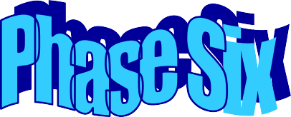

-Throughout Year 2

In Phase 6 children are given opportunities to become fluent readers and are encouraged to read with fluency and accuracy, taking punctuation into account.

The focus during phonics sessions is spelling and grammar, they are taught about writing in the ‘past tense’ and they investigate rules to change the endings of words e.g.

‘I looked’ not ‘I was looking’

Suffixes
These are letters that are added at the ends of words to change the meaning

‘ing’ ‘ed’ ‘s’ ‘er’ ‘est’ ‘y’ ‘en’ ‘ment’ ‘ness’

Like – liked | read – reading | full - fully
Rule – ruled | big - biggest | write - writer
Spelling strategies
Children are also taught different spelling strategies
- Syllables – break the word into syllables
e.g. Sep-tem-ber

- Base words = smiling smile+ing

- Words already known e.g. could - think of should and would

- Mnemonics – using a sentence you make up to help you remember a spelling
e.g. because- big elephants can’t always use small exits.

The Year 1 Phonics Screening Check

The Year 1 phonics screening check is a compulsory short assessment to confirm whether individual pupils have learnt phonic decoding to an appropriate standard.

It is administered during the summer term by a teacher that is familiar to your child. The check involves pupils reading 40 words- 20 real words and 20 pseudo words. Your child’s class teacher will send further details about the phonics screening check during the autumn term

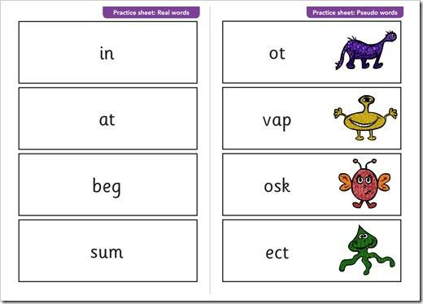

Further questions

If you have any questions about phonics and how to support your child at home, please do not hesitate to speak to your child’s class teacher.

