Art - SUMMER 1, WEEK 3

LO: To create original pieces that are influenced by studies of others

Lots of artists set up and recreate ‘still life’ pictures. Here are some painted by Henri Matisse, a famous French painter:
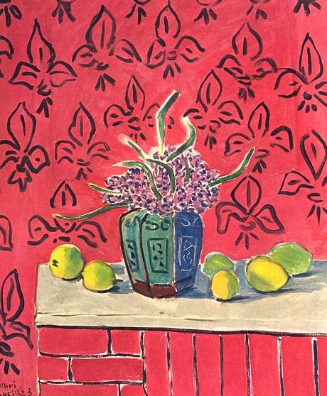
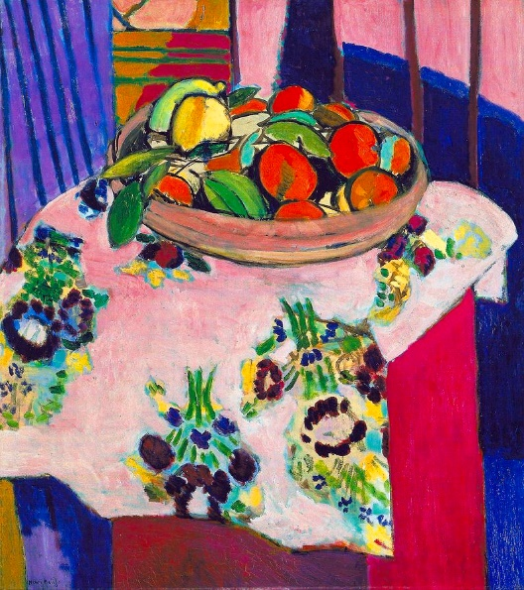
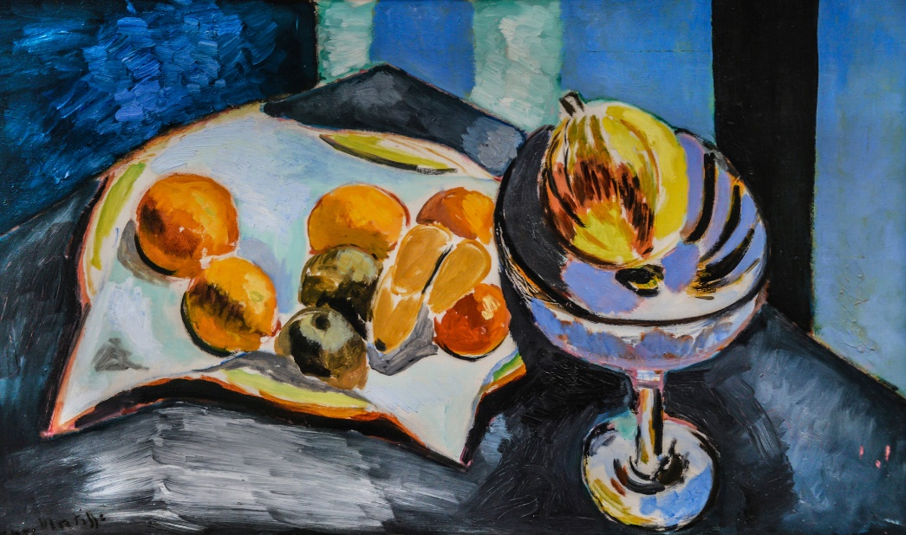

What do you like about these pictures? What objects can you spot in them? What colours and patterns have been used?
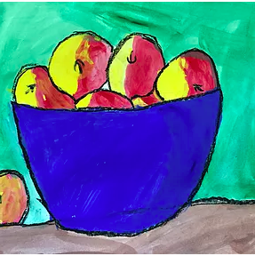
If you can, watch this video to find out a bit more about the artist and then try and make a poster to show what you have found out and what you like about his still life art: https://www.youtube.com/watch?v=s37OoBXkYAc&t=59s

Set up your own still life picture with some fruit or some of your favourite objects at home and then have a go at sketching it carefully and then colouring it in with pencils, pens, paints or anything else you have at home.

