Art – SUMMER 2, WEEK 2
LO: To use some of the ideas of artists studied to create pieces
What happens when you stare at this artwork by Bridget Riley?

Bridget Riley is an English painter who was born in London in 1931. She is most famous for her ‘Op Art’, which is optical illusion art (art which can play tricks with your eyes!) The patterns and colours Bridget uses in her pictures often make them look like they are moving of popping out of the wall/paper. Some people have often felt like they are falling or even feel seasick after staring at her pictures for a long time. Find out more about her life and work here:
https://www.tate.org.uk/kids/explore/who-is/who-bridget-riley

She is most famous for her black and white pictures, but sometimes she does use a few colours in her pictures too. She has always been interested in the effects that colours and lines have on her work.

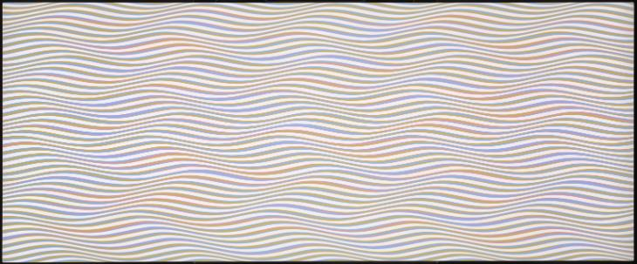
Have a go at creating your own Bridget Riley-style op art hand. If you follow the instructions on the video carefully, you will able to make a picture that looks like it is popping out of the page!
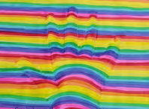
- Watch the video all the way through the to end to see what you will be doing:
https://www.youtube.com/watch?v=k0WsMInlIl8
- Pause the video as you are working to give you time to do each step.
- Take a photo of your brilliant work and upload it to Class Dojo so your teacher and I can see it

Good luck – I can’t wait to see your work!

