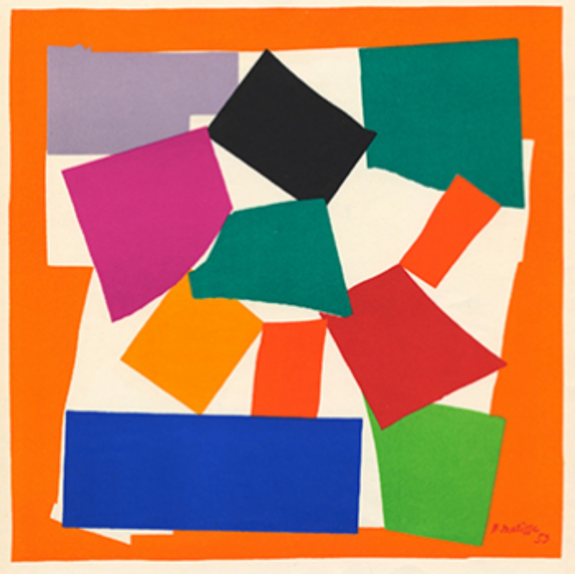
Art – SUMMER 2, WEEK 3
LO: To use some of the ideas of artists studied to create pieces
What creature do you think Henri Matisse was trying to create in this picture?

Henri Matisse is a French artist who created this collage, called The Snail, in 1953. He was born in 1869 and actually fell in love with painting initially, but as he got older and unable to paint freely, he began using scissors and painted paper to cut out shapes of different colours to arrange in collages. Find out more about his life and work here:
https://www.tate.org.uk/kids/explore/who-is/who-henri-matisse
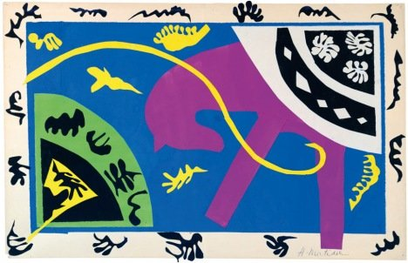
Henri Matisse tried to cut different coloured shapes with varying amounts of detail for his collages. His shapes were also different sizes, like in this work, The Horse, The Rider and The Clown made between 1943-1944. You can see the large purple horse as well as the small, more detailed black, white and yellow shapes. Once his shapes were cut, he would spend a long while arranging and rearranging the shapes before he finally stuck them down when he was happy with the composition.

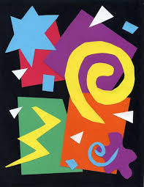
Have a go at creating your own Henri Matisse-style colourful collage. Try to use as much scrap paper from your home as possible – old newspapers, magazines, envelopes, leaflets etc.

- Watch the video all the way through the to end to see what you will be doing. Not only does this explain the activity, but it also gives another introduction to the life and work of Henri Matisse:
https://www.youtube.com/watch?v=hy4DUpsC22c&t=216s
- Take a photo of your brilliant work and upload it to Class Dojo so your teacher and I can see it

Good luck – I can’t wait to see your work!

