Art - SUMMER 1, WEEK 4

LO: To use some of the ideas of artists studied to create pieces

Have a look at these pieces of art created by American Pop Artist Roy Lichtenstein and look carefully at the colours he chooses and how he adds colour to his work:

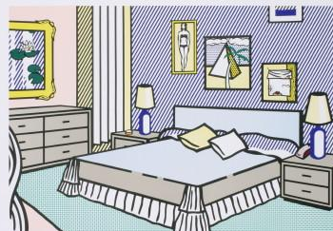
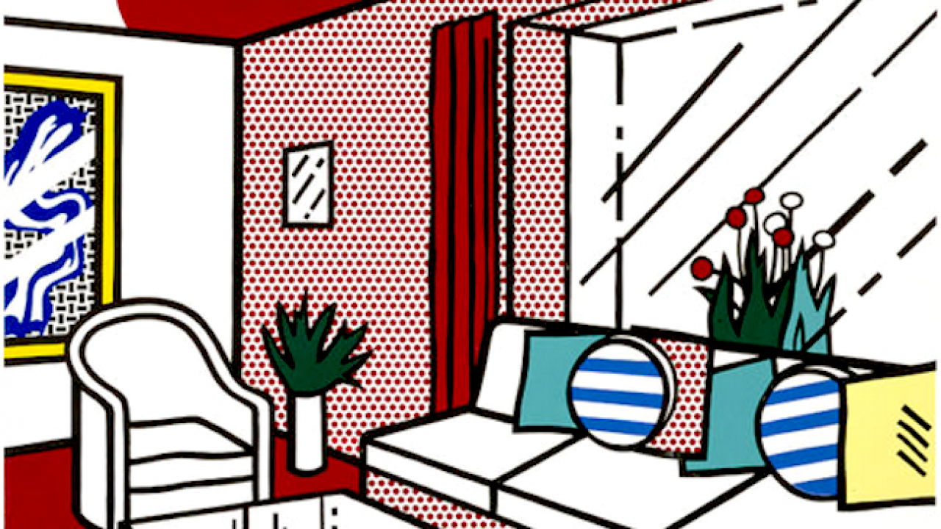
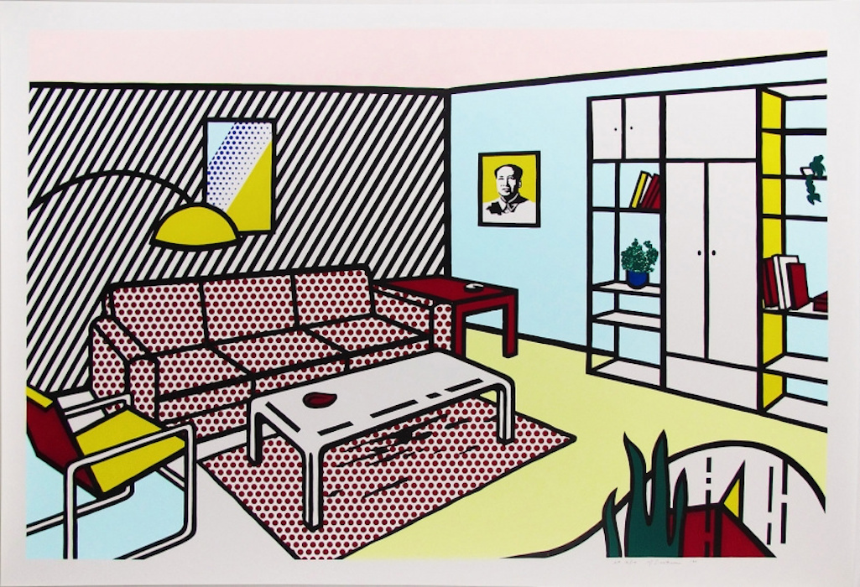

Check out this section of the Tate website to find out more about his work: https://www.tate.org.uk/kids/explore/who-is/who-roy-lichtenstein

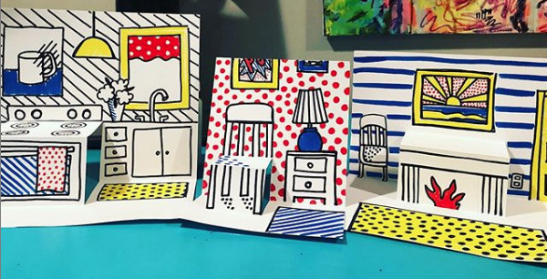
Have a go at creating a pencil sketch of one of the rooms in your house – your kitchen, your living room, your bedroom? Or even try creating your dream room, like some of the above pictures by Roy Lichtenstein. Once you have sketched it, use a black pen to go over all of your lines and then try and use just primary colours to shade in your work. Remember, try to use stripes and spots in some parts.

You might also want to watch this video carefully for instructions on how to create a pop up room in the style of Roy Lichtenstein: https://www.youtube.com/watch?v=kN4qv61SUjw

