Literacy: At Nursery, we completed our ‘The Very Hungry Caterpillar’ story map where the children were involved in deciding the pictures and actions. On Tapestry, I have uploaded the story map which supports children in remembering which part of the story comes next, as well as a video of the actions. You can learn the story along with your child and they can perform it. This encourages story language, understanding of story structure and using expression in story telling.

Physical:

Can you do 10 star jumps in a row? Try doing these before and after you sit down to do an activity to increase concentration levels.

Song:

It’s Raining, It’s Pouring- what sounds might you hear outside? Do you like the sound of rain?

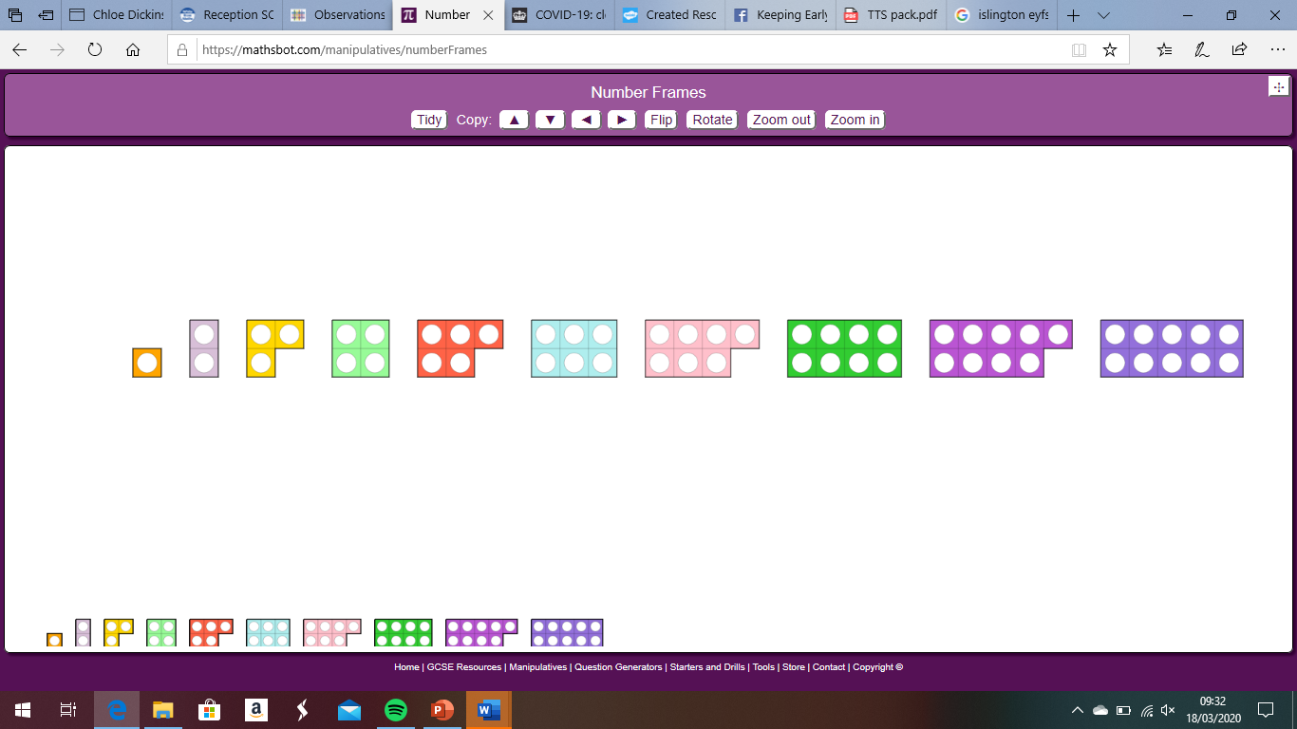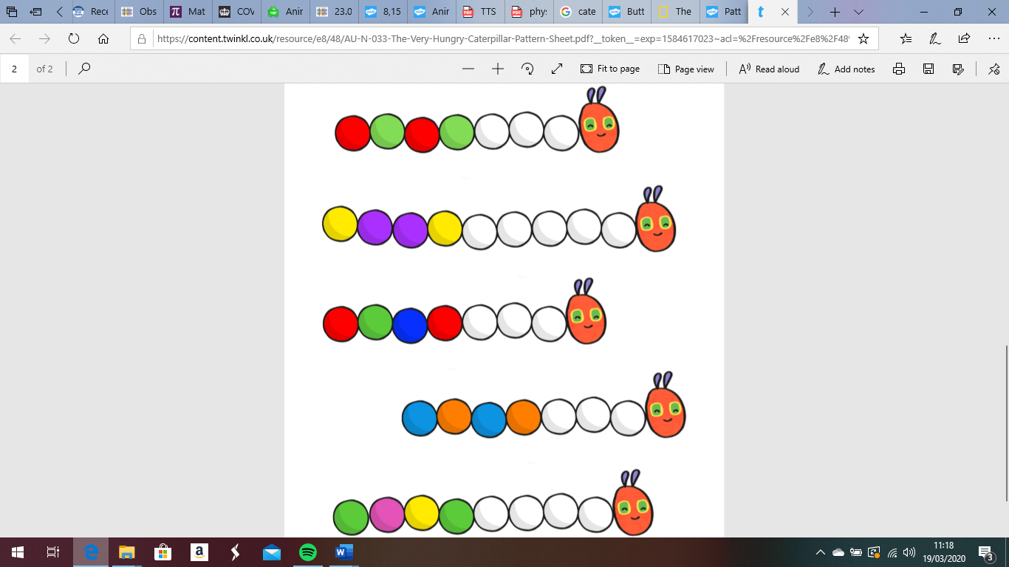[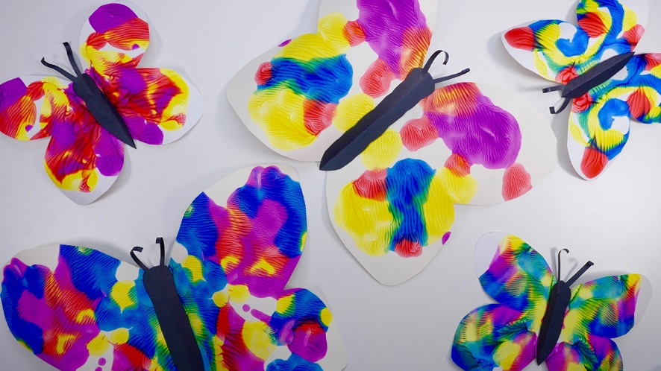](https://www.google.co.uk/url?sa=i&url=https://www.tes.com/lessons/DLe_9r0x5LYZ0A/copy-of-symmetry-butterflies-and-bugs&psig=AOvVaw2CbdmhEiYGUMww95AKrC8T&ust=1584702440583000&source=images&cd=vfe&ved=0CAIQjRxqFwoTCNjhjuKypugCFQAAAAAdAAAAABAn)

Maths: As you know, we have been using Numicon at Nursery to support our learning of numbers and their value. I have uploaded a picture of the Numicon pieces to Tapestry. If you have a printer, please print these off and cut them out, if not, you and your child could draw them yourselves. As you draw the Numicon, make sure you use the correct colour and have the right number of holes. Once you have cut these out, you can use them in a variety of ways.

-see which Numicon the children recognise without having to count the number of holes

-can they put the Numicon in the correct order from 1-10?

-can they find the same number of objects to match the Numicon piece, for example, 3 socks to match the Numicon 3?

-can they match Numicon together to make a new, bigger number? They can put Numicon on top of each other to check this, eg putting Numicon 2 and 1 on top of Numicon 3.

Allow your child to explore the Numicon in different ways and show you how to use it, as we will use them to support our Maths learning throughout the weeks.

Phonics: Listen to the sounds you hear around you, either in your house or outside if you can go for a walk around where you live. Talk to your child about the sounds they heard, which did they like? Were there any sounds they didn’t like? Can they draw some pictures of their favourite sounds? You could model this for them; draw a bird singing or a picture of a kettle boiling.

This week’s Expressive Arts and Design:

Can you make a pattern using a butterfly or a caterpillar picture? Draw the outline of one or the other (or both).

For the butterfly, give your child some paint to be able to paint one side of the butterfly. Try to encourage them to think carefully about detail, look at a picture of the butterfly to see the different colours and shapes. Can they paint some small circles or a variety of lines- wavy, straight, curved etc? Fold the paper to print the same pattern on the other side.

For the caterpillar, can they paint or draw

a repeated pattern using different colours

or different shapes along its body?