Literacy:

1. Handwriting warm up: practice forming the letters c a d g o s

(remember to say the description for each letter as you write it).

1. Start your bean diary:

* Cut out the pictures on the instruction page and put them in the order you think you will need to use when you sow your seed.
* Next using a small pot e.g. a clean yoghurt pot, plant your bean seed (ask a grown up to put a small hole in the bottom for drainage.
* Finally, draw and label all the things you think your bean seed will need to grow healthily.
* That’s all for your bean diary for this week. Next Monday you will draw and write about what your bean plant looks like after seven days. So don’t forget to water your bean plant and sing it a song.

If you would like to see what happens to your seed as it grows watch: <https://www.youtube.com/watch?v=w77zPAtVTuI>

Physical:

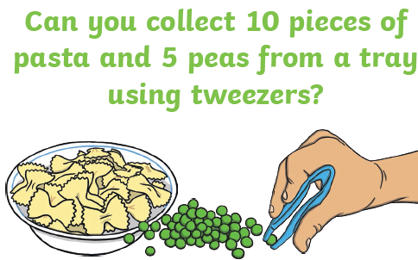

This week’s

Expressive Arts and Design

Make the Giant’s castle. You can use any materials that you have in your house. You can draw or use old boxes. You could use lego or even cut up pictures from magazines. You choose! Take a picture and put it on Tapestry.

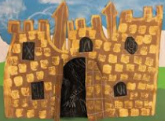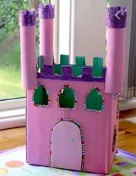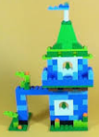

Song

<https://www.bbc.co.uk/teach/school-radio/nursery-rhymes-oats-and-beans-and-barley-grow/z4xdrj6>



Maths:

1. Mix up the number flashcards we sent home and then order them to 10, 20 or 30.
2. Number doubles.

Look at the Numicon and see what has happened. Try to explain it to your parents. See if you can explain what doubling means in your own words.

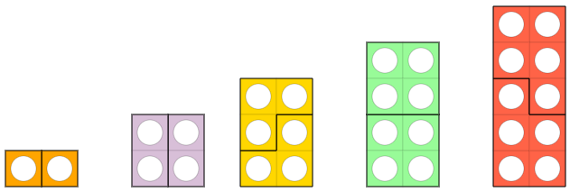

Then look around the house and find 1 ,2, 3, 4 or 5 objects. Now double it. How many do you have?

Try to write 1+1=2 etc.

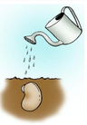

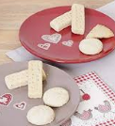

**Phonics – choose the one you need to learn next or have a go at them all.**

U (u – u – umbrella) in the middle of words

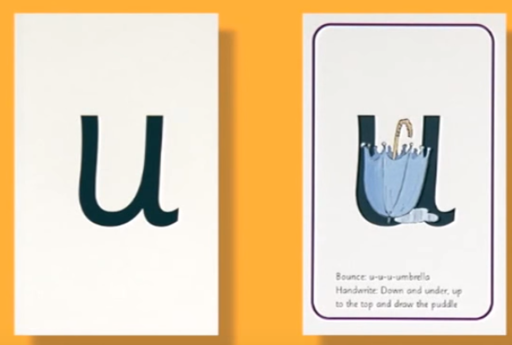

Handwrite: down and under, up to the top and draw the puddle.

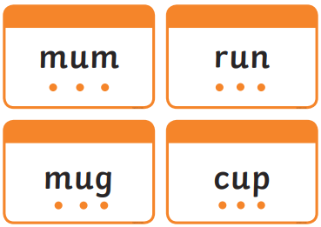

Read the sentence and match to the pictures.

*ch* “ch-ch-ch-choo”. ‘The horse sneezes when the caterpillar’s hairs get up his nose.’

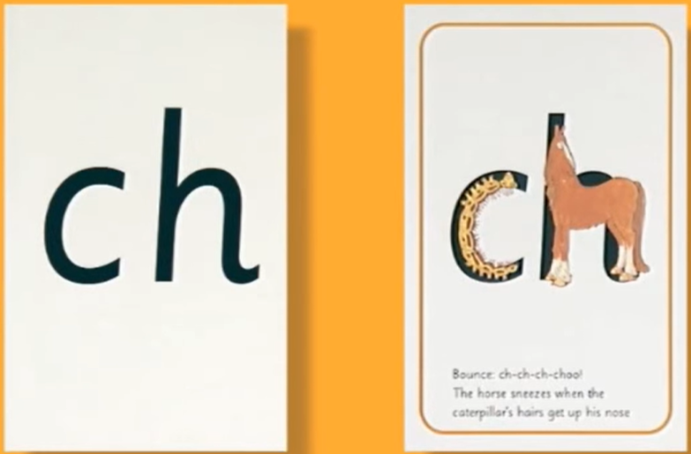

Look for things around the house that have the *ch* sound in them; remember the *ch* sound can also be at the end of the word.

Read these words:

 

Think of a sentence about this *ch* picture and then write a sentence to go with it:



Don’t forget…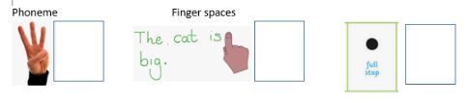

Don’t forget…

oo “poo at the zoo”

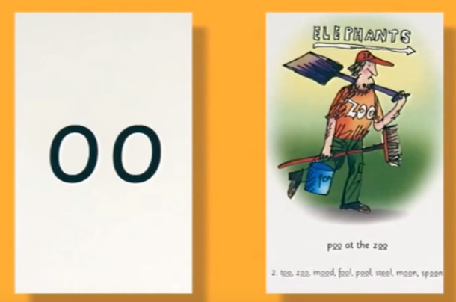

Look for objects in your home with this sound.

Quickwrite these words with sound buttons:



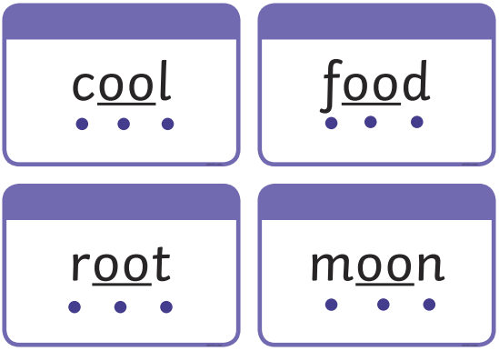

Dictate one or two of these sentences to your child and ask them to fill in the missing word.

