Year 6 Maths
Developing activity
Lesson 1
LO: TBAT identify sequences and patterns.
Success Criteria:
- Identify the numbers in the sequence.
- Count on from each number to identify the pattern.
- Be aware that some patterns may increase or decrease by different amounts.

Model
Now you try…
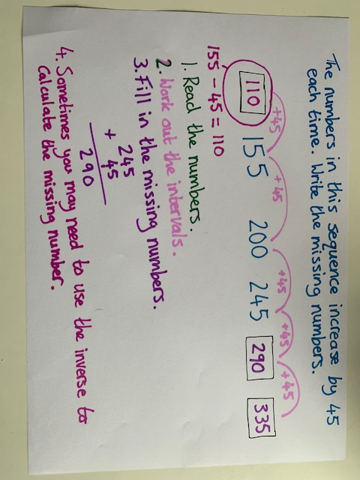
Copy and complete the tables, following the rules.
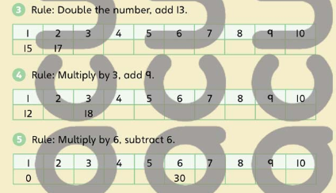
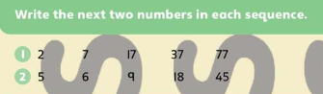
Year 6 Maths
Expected/ Greater depth activity
Lesson 1
LO: TBAT solve problems including number patterns and sequences.
Task:

You are going apply your knowledge to solve several problems including number patterns and sequences.
Success Criteria:
- Identify the numbers in the sequence.
- Count on from each number to identify the pattern.
- Be aware that some patterns may increase or decrease by different amounts.
- Explain your answer using examples from the sequence.
Recap:
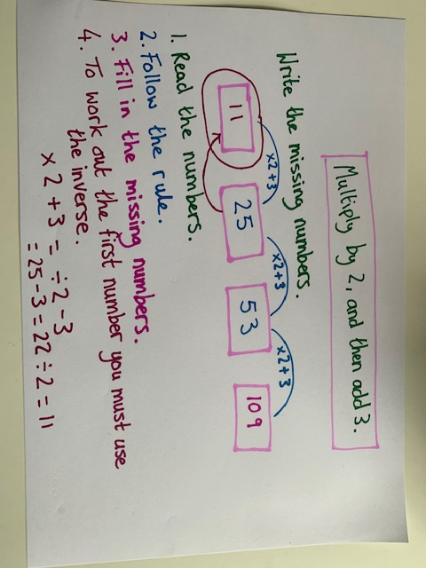 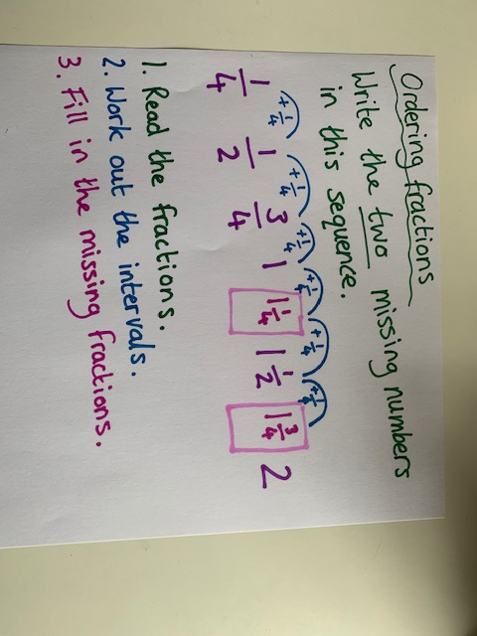
Year 6 Maths
Main activity
Complete at least 2 columns, more if you can!
Task 1 | Task 2 | Task 3 | Task 4
Practice  Complete the number sequences.  - 20, 31, 42, __ , __ , __ , __ .  - 26, 23, 20, __ , __ , __ , __ .  - 11, 17, 23, __ , __ , __ , __ .  - -16, -9, -2, __ , __ , __ , __ .  - 133, 130, 127, __ , __ , __ .  - -25, -20, -15, __ , __ , __ , __ . | Arithmetic  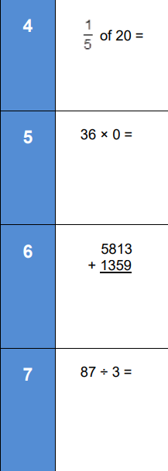 | Problem Solving  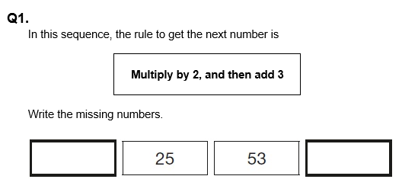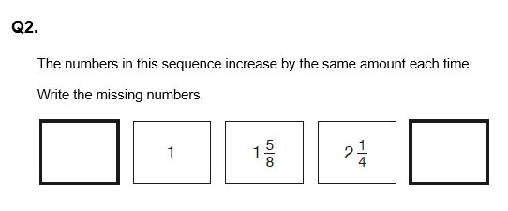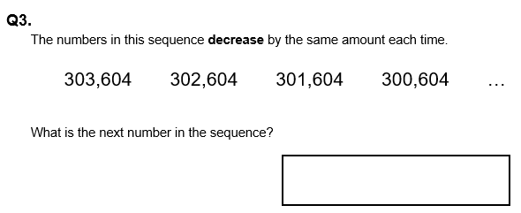 | Reasoning  