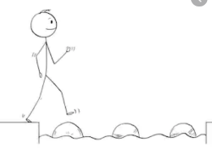
Year 4 Maths
Steppingstone activity
Lesson 1
LO: To use written methods for addition
Success Criteria:
- Write out the calculation – check digits are in the correct columns!
- Add the ones digits – write the digit underneath the O column
- Add the tens digits– write the digit underneath the T column
- Add the hundreds digits – write the digit underneath the H column
- Add the thousands digits – write the digit underneath the Th column

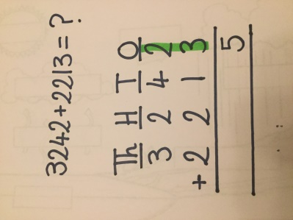
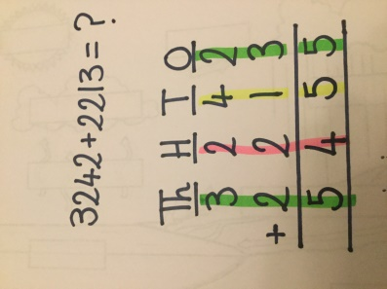
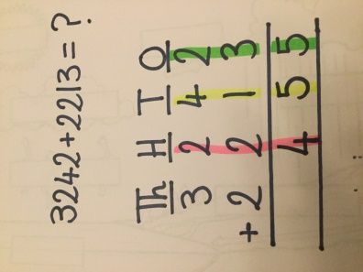
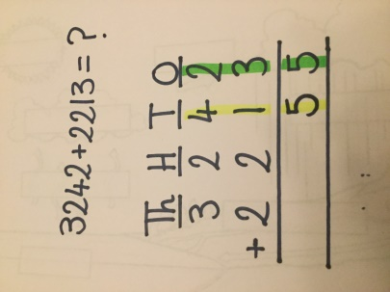
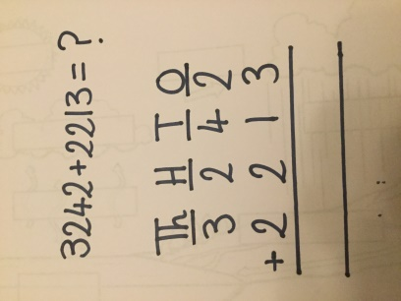
Model
- 2. 3. 4. 5.

Now you try…

4623 + 5163 = 9786 5406 + 1472 = 6878 3041 + 6257 = 9298 7294 + 3104 = 10398
Year 4 Maths
Lesson 1
LO: To use written methods for addition
Task:
You are going to practise adding with exchanges.
Success Criteria:
- Write out the calculation – check digits are in the correct columns!
- Add the ones - if the answer is 10 or over, write the one digit in the ones column and carry the tens digit underneath the tens column.
- Add the tens, including any carried over digits.
- Repeat for the hundreds.
- Repeat for the thousands.

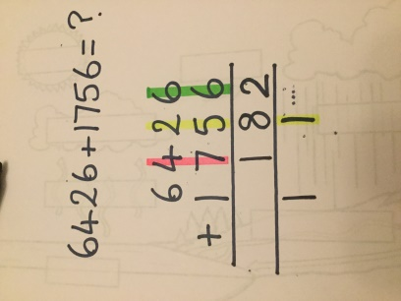
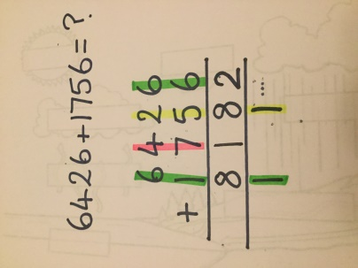
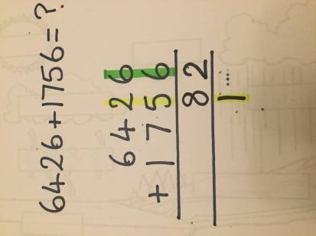
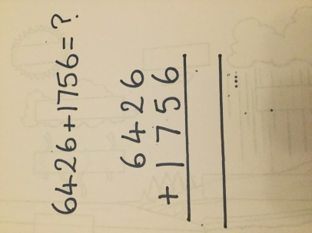
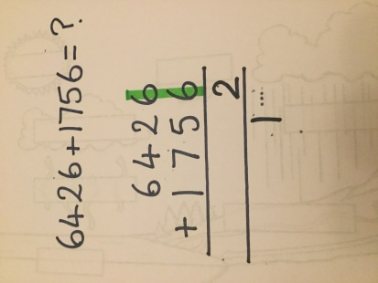
Model:
1. 2. 3. 4. 5.

Make sure all your answers are in the correct columns!!!
Year 4 Maths
Main activity
Complete at least 2 columns, more if you can!
Task 1 | Task 2 | Task 3 | Task 4
Practice  Have a go at these additions (one exchange)  2146 + 1237 =  3383  3164 + 3164 =  6328  6532 + 1724 =  8256  7641 + 1282 = 8923  1334 + 7823 =  9157 | Practice  Have a go at these additions (more than one exchange)  2394 + 2843 =  5237  2746 + 1537 =  4283  2657 + 2657 =  5314  6586 + 1724 =  8310  4067 + 7923 =  11990 | Reasoning  6a. She is incorrect. The exchange takes place from the ones to the tens (9 + 1 = 10).  7a. 3,641 + 4,456 = 8,097 | Problem solving  