Year 2 Maths day 1
ANSWERS
Task 1 | Task 2 | Task 3 | Task 4
Practice  Any three different ways you have made:  36  47  58  99 | Practice  Have a go at completing these calculations to make a total of 100.  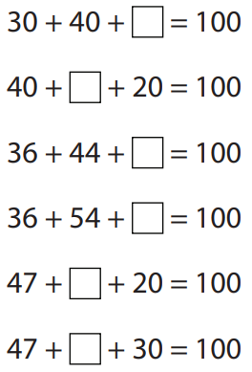  23  33  10  20  40  30 | Reasoning  Explain your answers.  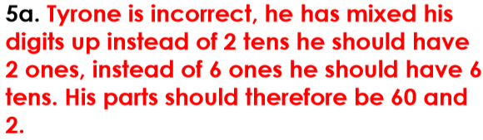  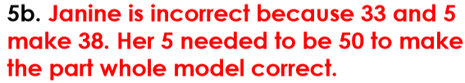 | Problem solving  Complete the extended part-whole model:  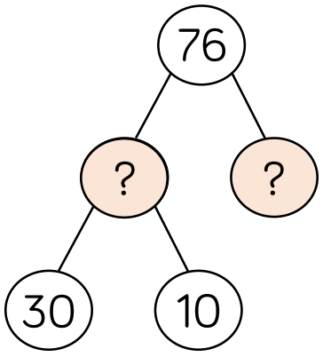  30  6  Can you create your own extended part-whole model for 76?

