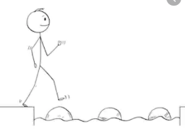
Year 5 Maths
Steppingstone activity
Week 3 Lesson 1 – 20.04.20
LO: To recognise decimals up to 2 decimal places
Success Criteria:
- First draw your place value grid including the decimal point
- Then draw the ‘one (1)’ counters in the grid.
- Next draw the ‘Tenths (0.1)’ counters
- Lastly, draw the ‘Hundredths (0.01)’ counters and write the sentences underneath.

Model The decimal point separates the whole numbers from the decimals or parts of the number.

Now you try drawing a grid as above for these numbers and partitioning as above:
1.23 5.67 3.89 16.08 25.09
Then, come up with some of your own!
Year 5 Maths
Week 3 Lesson 1 – 20.04.20
LO: To recognise decimals up to 2 decimal places
Success Criteria:
You are going to practise Decimals!
Success Criteria:
- First draw your place value grid including the decimal point
- Then draw the ‘one (1)’ counters in the grid.
- Next draw the ‘Tenths (0.1)’ counters
- Lastly, draw the ‘Hundredths (0.01)’ counters and write the sentences underneath.

Model:
Year 5 Maths
Main activity Week 3 Lesson 1 – 20.04.20
Complete at least 2 columns, more if you can!
Task 1 | Task 2 | Task 3
Practice  represent each of these numbers in a place value chart and complete the sentences | Now try these: | Have a go at these problems:

