Literacy: If you have stories about spiders then you can read them together, e.g. Eric Carle’s ‘The Very Busy Spider’. Click here if you don’t have any stories on spiders or other insects- <https://www.youtube.com/watch?v=TfL0g-XRxnA>

You might share rhymes such as Little Miss Muffet or There was an old lady who swallowed a fly. Talking about the stories and rhymes together is a great way to support language skills. You might want to introduce new vocabulary to enrich your child’s use of words e.g. how do spiders move? Rather than,

just saying ‘run’...do they scurry, creep or crawl?

Physical: Threading- You could cut out a piece of card or paper plate and then create some holes. You can then weave a web using some wool or string. You could also make

your own spider (instructions on Tapestry).

Make sure you check out The Body Coach

YouTube channel for some morning exercises!

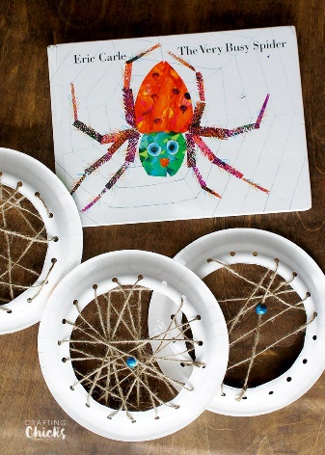

Song:

Incy Wincy Spider- our daily activities will be linked to this song!

<https://www.bbc.co.uk/teach/school-radio/nursery-rhymes-incy-wincy-spider/zr4yt39>

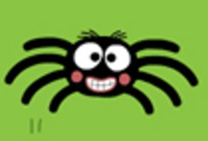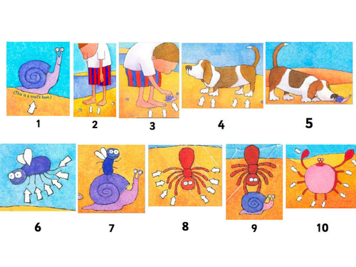

Phonics:

Incy Wincy- lets talk about rhyming words. Sing the song together, adding the actions. After, talk through or sing the song slowly, pointing out or seeing if your child can identify the rhyming words. So, ‘climbed up the water **spout,** down came the rain and washed the spider **out’** what sounds the same, or “can you hear that, spout and out, they end with the same sound, they **rhyme.”** Once you’ve made your spider, you could make up some silly names for it- “Incy Wincy”, “Bug Wug”, “Mack Pack”- they don’t have to make sense or be an actual word, just get into the habit of pointing out the rhyming sounds.

Maths: Talk about spiders and how they have 8 legs. Your spider’s legs could be made from strips of cardboard, paper straws, wool or pipe cleaners. Can you count out loud together up to 8? Are there any other animals that have 8 legs? Why don’t you read the story ‘1 Is A Snail, 10 Is A Crab’? If you don’t have this story, have a look on, <https://www.youtube.com/watch?v=zDjp7rTXtsk> (I’m sorry, I would have pre-recorded some stories if I knew what was going to happen!) If you have the story, why don’t you record you and your child reading it and upload it to Tapestry for others

to see 😊 In this story, you can then talk

about different combinations of numbers

to make new numbers- two dogs have

four legs each, that makes 8 altogether,

or one spider etc. You could cut out the

Numicon or make Numicon and try

different variations of making 8!

This week’s

Expressive Arts and Design:

Design your own Easter Egg using whatever materials you have in the house. Initially, use pens, pencils or even paint. You could then find some tissue paper, feathers, sequins, glitter if you have it! Demonstrate scrunching tissue paper for different effects and holding their scissors correctly. I found this little rhyme to support this-

Open shut, open shut, that’s the way we cut, cut, cut. Fingers on bottom, thumb on top, do not let the paper drop!

