**Year 5 Writing   
Week 3, Lesson 1  
Monday 20th April 2020  
LO: To create setting descriptions**

**Task (with links):**

Watch this video clip called ‘The Ocean Maker’: <https://www.literacyshed.com/oceanmaker.html>

Look carefully at the images below and create descriptive sentences for the settings.

Use your five senses to help you create sentences about these settings.

EXT: Use subordinating conjunctions within your sentences: *if, since, as, when, although, while, after, before, until, because*

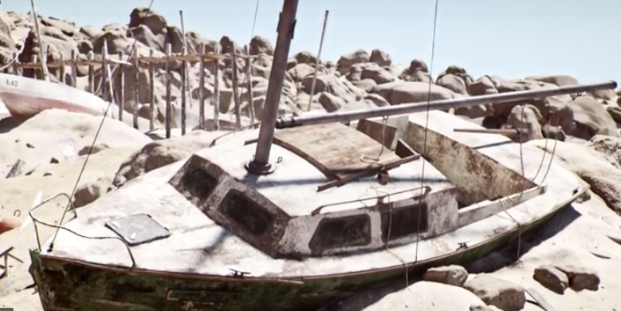 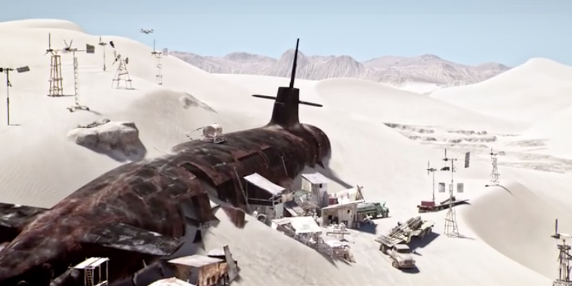 

 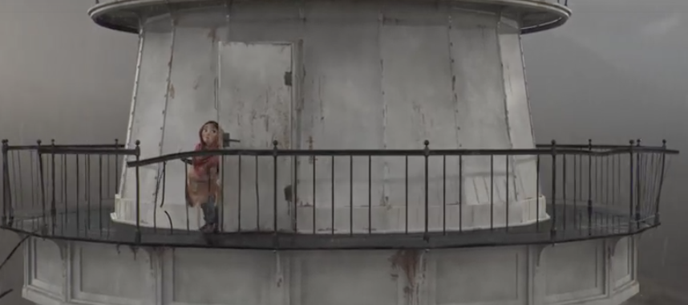

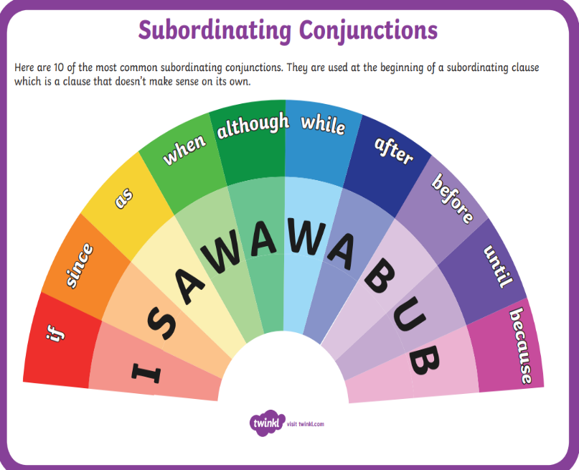**E.g. While trying to evade the sky-pirates in the blackened sky, a burst of bullets shot past Katrina.**