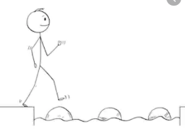
Year 5 Maths
Steppingstone activity
Lesson 1
LO: To multiply 2 digit numbers by 2 digit numbers
Success Criteria:
- Layout your multiplication accurately (brackets in line with answers)
- Multiply the top 2 digit number by the units first
- Multiply the top 2 digit number by the 10’s remembering to add a ‘0’ as a placeholder
- Add the two amounts together to form an answer.
- Layout your multiplication accurately (brackets in line with answers)

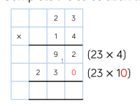
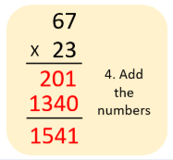
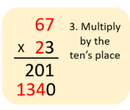
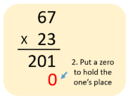
Model
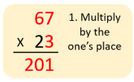
- 2. 3. 4.

Now you try…
45 x 23 = 1,035 36 x 31 = 1,116 47 x 23 = 1,081 65 x 38 = 2,470 52 x 42 = 2,184 63 x 15 = 945
Then, come up with some of your own!

Year 5 Maths
Lesson 1
LO: To multiply 3-digit numbers by 2-digit numbers
Task:
You are going to practise multiplying!
Success Criteria:
- Layout your multiplication accurately (brackets in line with answers)
- Multiply the top 3 digit number by the units first
- Multiply the top 3 digit number by the 10’s remembering to add a ‘0’ as a placeholder.
- Add the two amounts together to form an answer.
- Layout your multiplication accurately (brackets in line with answers)

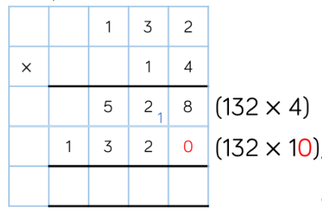
Model:

Make sure all your answers are in the correct columns!!!
Year 5 Maths
Main activity
Complete at least 2 columns, more if you can!
Task 1 | Task 2 | Task 3 | Task 4
Practice  Have a go at these multiplications.  13 x 42= 585  26 x 53= 1,378  27 x 32=864  71 x 69= 4,899  84 x 17=1,428  92 x 39= 3,588 | Practice  Have a go at these multiplications.  134 x 31= 4,154  231 x 24= 5,544  235 x 14= 3,290  230 x 59= 13,570  453 x 32 =14,496  562 x 55 = 30,910 | Reasoning  Explain your answers.  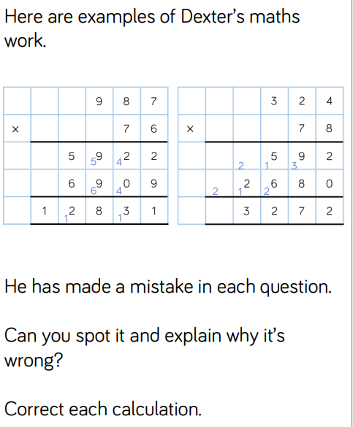 | 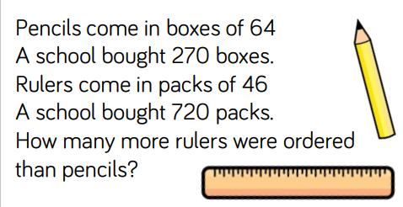  Problem solving  Pencils – 17,280 Rulers – 33,120  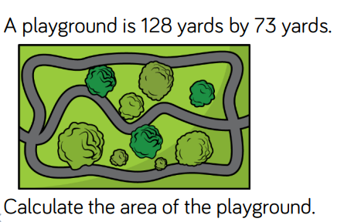  15,840 more Rulers.  9,344yards2

