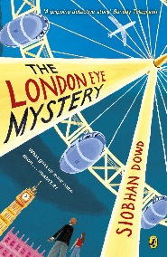
Year 5 Reading
Week 1: 1 Lesson 1
Monday 20th April 2020
LO: To retrieve and record information from a text.

Starter: Aim to answer the following quick retrieval questions in less than 2 minutes –feel free to time yourself too!
The questions are based on page 19 and 20 from chapter 4: The Hurricane makes Landfall.
- How long was the half term holiday?
- In which direction were the rain showers moving that day?
- What vehicle did Salim and Aunt Gloria arrive to the house in?
- What colour hair did both Salim and his mother have?
- Name 2 items that Salim was wearing as he entered the house.
Main task: Draw a picture of the scene when Aunt Gloria and Salim arrive at the house.
Success Criteria:
In your picture include:
- All the characters mentioned on pages 19-20
- What the characters are wearing
- What the weather was like that day
- Facial expressions and thought bubbles that suggests how the characters feel
- Finish reading chapter 4.

