Year 6 Maths
Developing activity
Week 2, Lesson 5
LO: TBAT calculate the missing value in a number sentence (algebra).
Success Criteria:
- Write out the number sentence.
- Solve the calculation in the brackets first and then complete the rest of the sum using BIDMAS
- For missing number sums… Write out the sum.
- Use the inverse to calculate the value of the missing number.
Model
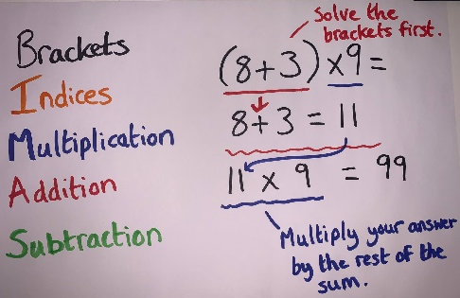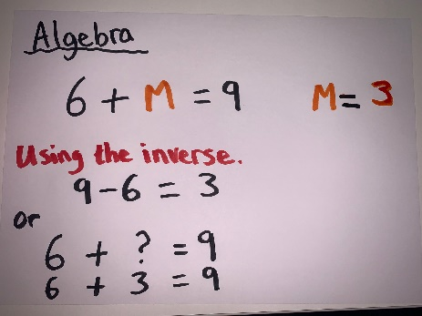
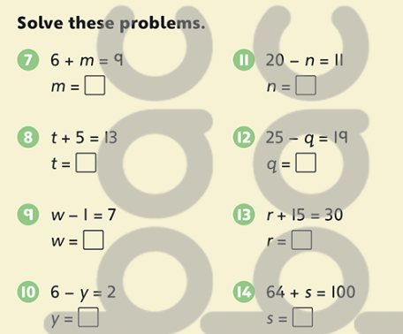
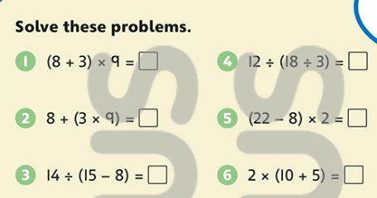
Now you try…

Year 6 Maths
Expected/ Greater depth activity
Week 2, lesson 5
LO: TBAT use algebra in a range of contexts.
Task:
You are going apply your knowledge of algebra to solve a range of problems.
Success Criteria:
- Write out your calculation.
- Decide if BIDMAS needs to be used.
- Use the inverse to help find the missing value.
- Check your calculation.

Recap:
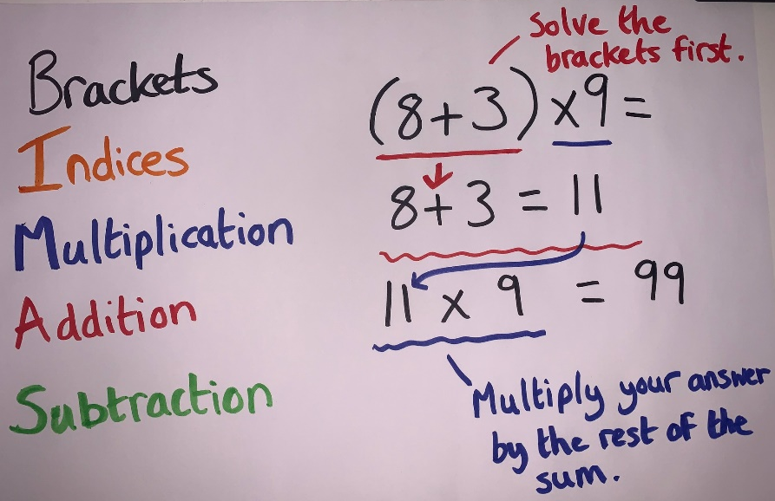 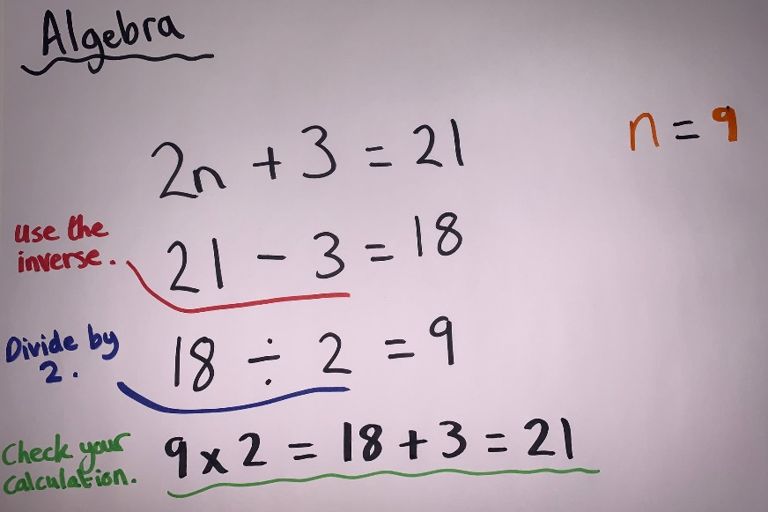
Year 6 Maths
Main activity
Complete at least 2 columns, more if you can!
Task 1 | Task 2 | Task 3 | Task 4
Practice  Have a go at these additions. Use the written method:  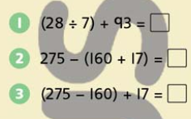  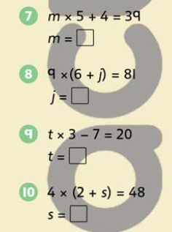 | Arithmetic  Have a go at these additions.  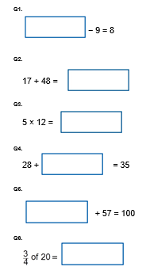 | Reasoning  Explain your answers.  Task 1  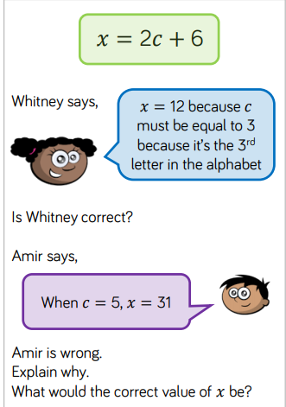  Task 2  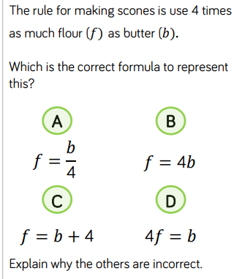 | Problem solving  Task 1  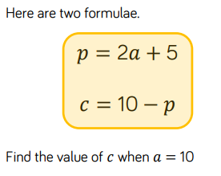  Task 2  