Year 6 Reading
Week 2, Lesson 5
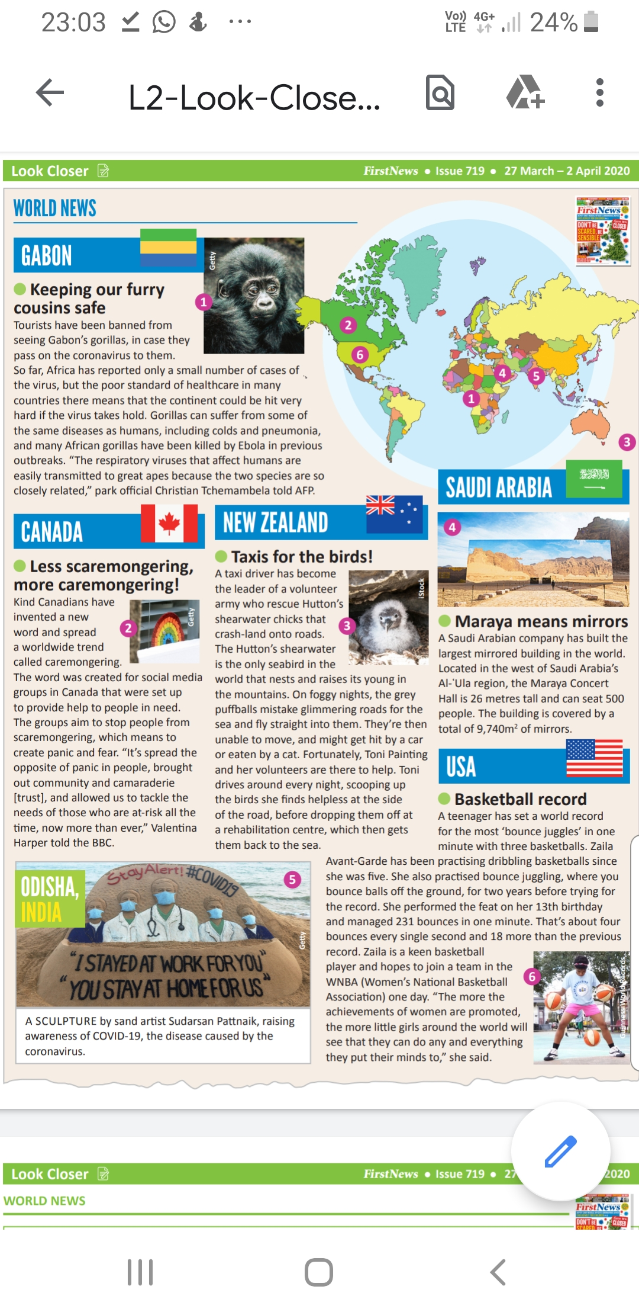
Activity: Complete the First News Comprehension.
