Physical: Head over to Tapestry to see a Dough Disco video you can follow and some photos of the actions. You can also type Dough Disco in online to find some videos/ pictures OR ask your child! They should be an expert by now! Use the playdough you have made to practise the moves. Once you’ve done this, encourage some mark making with their strong grip.

Literacy: Using the story map given yesterday, think about which aspects of the story you could change or innovate. We were talking about the differences between fruit and vegetables. Maybe you could choose 5 vegetables to change what the caterpillar eats between Monday and Friday. Give your child some paper and pens to see if they can recreate the story map with new food. As they make some marks for the story,

you can talk through the main events and characters.

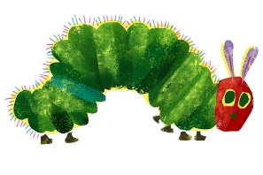

Song:

BaaBaa Black sheep- can the children remember the signs?

[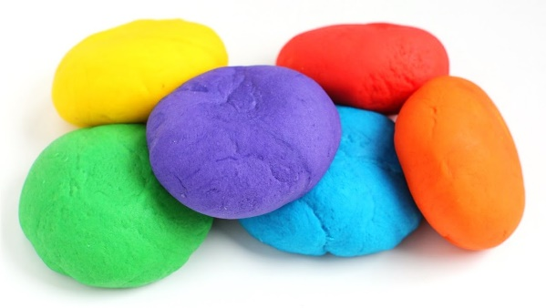](https://www.google.co.uk/url?sa=i&url=https://www.youtube.com/watch?v%3DdHKOny3xjCc&psig=AOvVaw1wMnKt7KkwuqRYLWIESErU&ust=1584626338560000&source=images&cd=vfe&ved=0CAIQjRxqFwoTCID_56GXpOgCFQAAAAAdAAAAABAE)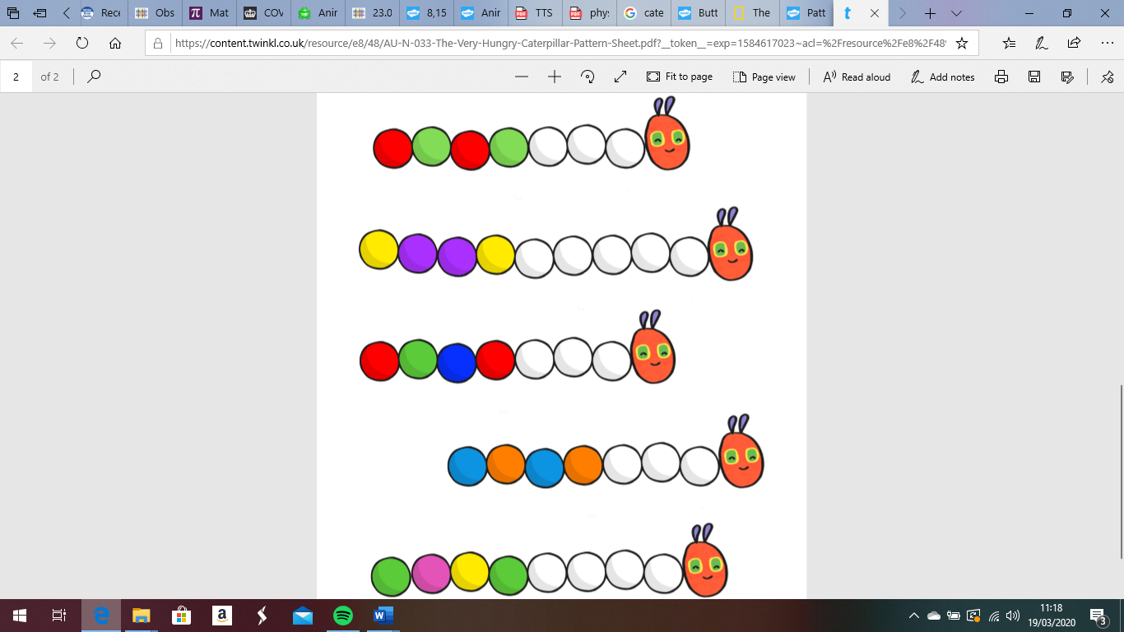[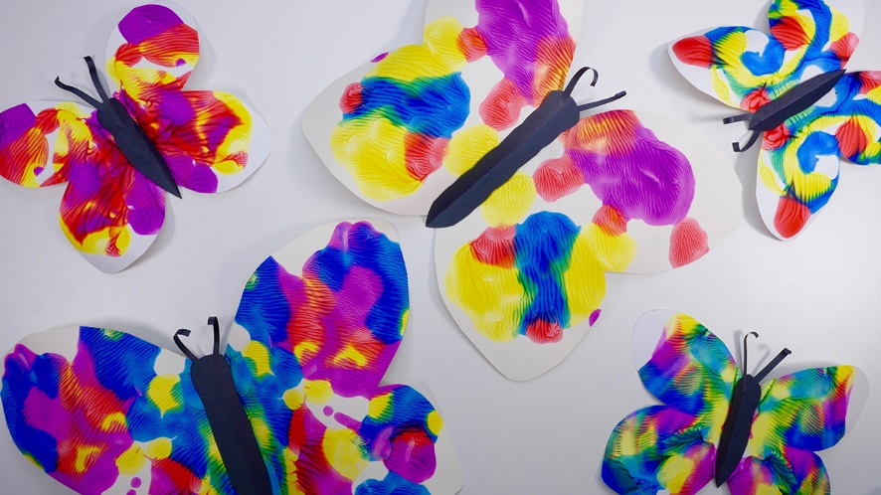](https://www.google.co.uk/url?sa=i&url=https://www.tes.com/lessons/DLe_9r0x5LYZ0A/copy-of-symmetry-butterflies-and-bugs&psig=AOvVaw2CbdmhEiYGUMww95AKrC8T&ust=1584702440583000&source=images&cd=vfe&ved=0CAIQjRxqFwoTCNjhjuKypugCFQAAAAAdAAAAABAn)

Maths: Measuring- use the recipe to create some non-cook playdough. Once you have done this once, you’ll understand how easy it is to do and it is a god-send for Early Years practitioners! Children love the texture and adaptability of playdough. We love how it can strengthen children’s hands and fingers, to develop their pencil grip.

Talk to your child about how much of each ingredient we need, use mathematical language such as ‘more’ and ‘less’. You may need ‘more’ flour if the playdough is sticky. If you don’t have food colouring, paint works, and if neither, playdough still works without colour!! Put your playdough in a sealed bag so it doesn’t go hard and lasts longer.

Once you’ve made the playdough, ask your child to share the playdough out with however many people are in your family.

You could make the playdough into small balls

and, using the Numicon as a visual, ask your child

to make the correct number of balls to match the

Numicon. Make sure when you are counting, you

model putting your finger on each piece and saying

one number so they know that each piece needs

to be counted once.

Phonics: Listening and attention skills, guess the animal. Use the links to play some animal guessing games!

<https://www.phonicsplay.co.uk/member-only/AnimalBingo.html>

<https://www.busythings.co.uk/play/> - go to Early Years, Nursery, Communication and Language, Sound Discrimination

Or if you’re feeling creative, why don’t you make an animal bingo board? Once your animal sound is played, you can put a counter over the picture! I’ve put an example on Tapestry, and if you type animal noises into Google, they give you a range of animal sounds to play with!

This week’s Expressive Arts and Design:

Can you make a pattern using a butterfly or a caterpillar picture? Draw the outline of one or the other (or both).

For the butterfly, give your child some paint to be able to paint one side of the butterfly. Try to encourage them to think carefully about detail, look at a picture of the butterfly to see the different colours and shapes. Can they paint some small circles or a variety of lines- wavy, straight, curved etc. Fold the paper to print the same pattern on the other side.

For the caterpillar, can they paint or draw

a repeated pattern using different colours

or different shapes along its body.