Literacy:

1. Handwriting warm up: practice forming the letters c a d g o s

(remember to say the description for each letter as you write it).

1. Today, use your lglf login to listen to the fairytale, Jack and the Beanstalk <https://www.lgfl.net/learning-resources/summary-page/fairytales>
2. When you are familiar with the story, try and tell the story without the volume
3. Tell the story to someone else in your family

Physical:

Pretend you are a little seed growing into a plant. Find a space in your home and use this link for the dance programme BBC Time to Move about growing:

<https://www.bbc.co.uk/sounds/play/p03pcv3h>

This week’s

Expressive Arts and Design

Make the Giant’s castle. You can use any materials that you have in your house. You can draw or use old boxes. You could use lego or even cut up pictures from magazines. You choose! Take a picture and put it on Tapestry.

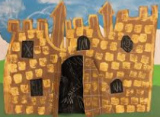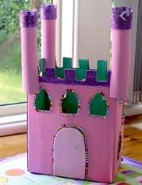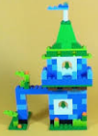

Song

The Animals Went in 2 by 2

<https://www.bbc.co.uk/teach/school-radio/nursery-rhymes-the-animals-went-in-two-by-two/zr88bdm>

Maths:

1. Order your flashcards 10 to 20. Take it in turns to hide one behind your back and ask your partner to spot which one is missing.
2. Number doubles. Look at these Numicon doubles and find double 6, double 7, double 8, double 9 and double 10.

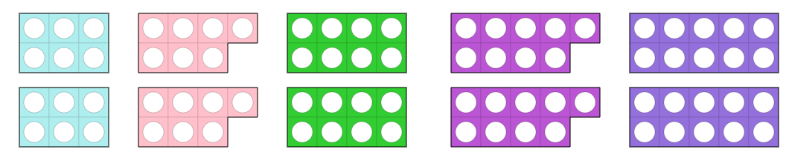

Write 6 + 6 = 12 etc.

Try to learn this off by heart as a poem (or make it into a song!)

One and one are two, two and two are four

We’re doubling our numbers now let’s double up some more

Three and three are six, four and four are eight,

We’re doubling our numbers so don’t be late

Five and five are ten, six and six are twelve

Doubling our numbers is oh so swell!

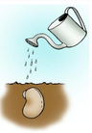

**Phonics – choose the one you need to learn next or have a go at them all.**

u (u – u – umbrella) in the middle of words

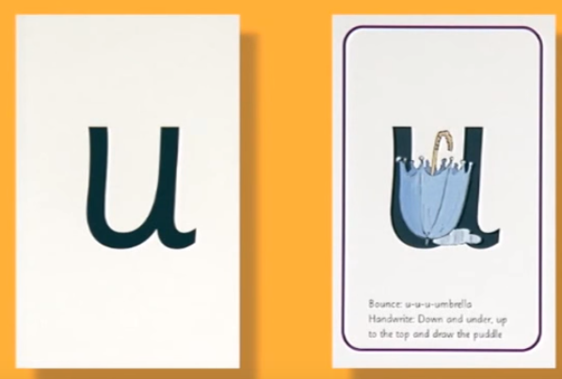

Can you match the words to the pictures?

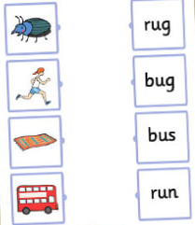

Revisit ch and sh sounds:

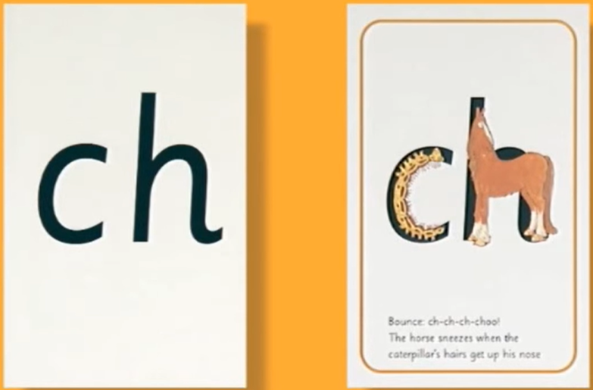 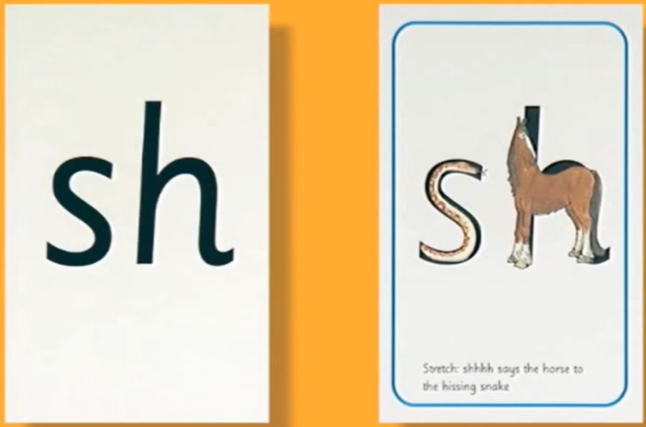

Match the words and the pictures and write the word under each picture

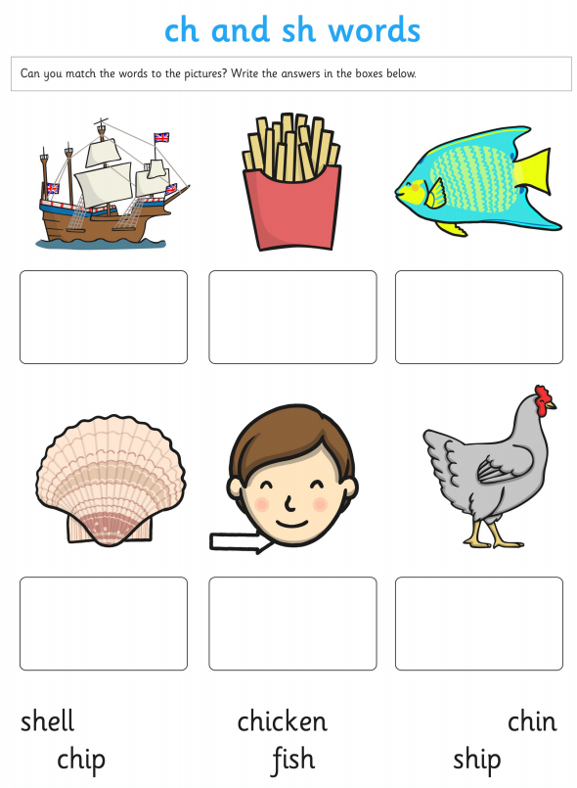

oo “poo at the zoo”

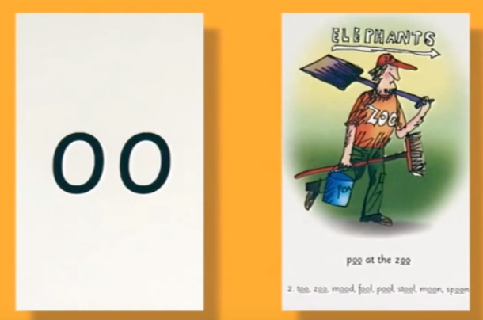

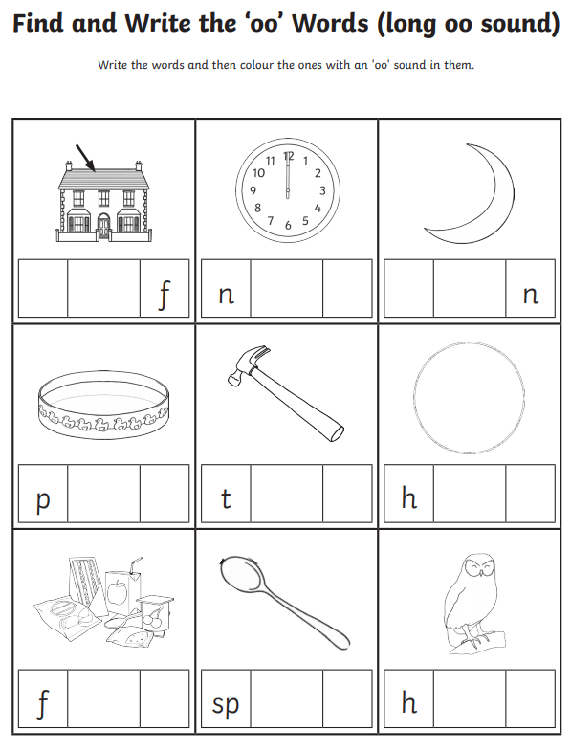

Write two sentences using an oo word. Remember

*sh* “sh says the horse to the hissing snake”

*ch* “ch-ch-ch-choo”. ‘The horse sneezes when the caterpillar’s hairs get up his nose.

