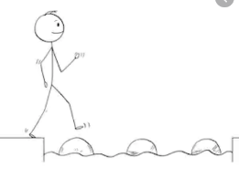
Year 3 Maths
Steppingstone activity
Lesson 2
LO: To understand hours in a day
Success Criteria:
- Read and say the days of the week out loud
- Count how many days there are in a week
- Think about what time of day you do each of the events

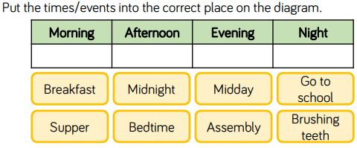
Model
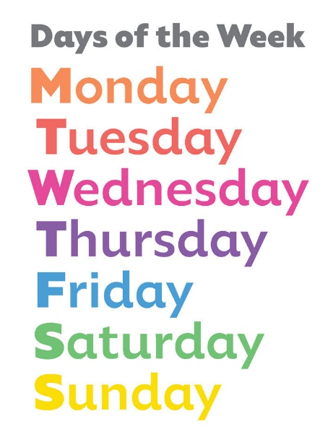

Think!
What time does the day start?
How many hours are there in a day?
What time is midnight? What time is midday?

Year 3 Maths
Lesson 2
LO: To calculate time in hours
Success Criteria:
- Decide if your are calculating number of hours or number of days
- If given hours to find number of days, divide by 24
- If given days to find number of hours, times by 24

Model
72 hours is equal to _?_ days
To calculate the number of days equal to an amount of hours, divide the hours by 24.
e.g. 72 ÷ 24 = 3 days
Remember you can use a number line to help:
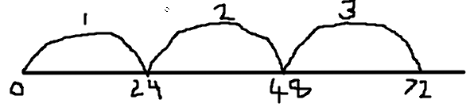
There are 24 hours in one day.
To calculate hours in a certain number of days, multiply the number of days by 24.
e.g. hours in 3 days = 24 x 3 = 72 hours
Remember you can use the grid method for multiplying large numbers:
x | 20 | 4
3 | 60 | +12 | = 72

Now you try:
- How many hours are there in 6 days?
- How many days are equal to 192 hours?

Year 3 Maths - Main activity
Complete at least 2 columns, more if you can!
Task 1 | Task 2 | Task 3 | Task 4
Practice  Fill in the gaps in the sentence stems.  a)There are ___ days in a whole week.  b)There are ___ days in a school week.  c)There are ___ hours in a day.  d) There are ___ and a half hours in a school day.  e) There are approximately ___ weeks in a month. | Practice  Fill in the missing numbers.  - ___ day = 24 hours  - ____ days = 120 hours  - 2 days = ____ hours  - ____ days = 240 hours  - 20 days = ____ hours  - Half a day = ____ hours  - Quarter of a day = _____ hours  - ____ days = 60 hours | Reasoning  Explain your answers.  True or false?  “There are 24 hours in a day. That means there are 168 hours in a week.”  Explain how you know.  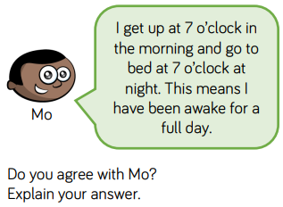 | Problem solving  How many times in this month will it be 6 o’clock?  