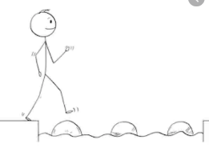
Year 2 Maths
Steppingstone activity
Lesson 2
LO: To represent numbers to 50
Success Criteria:
- Draw a table with five columns.
- Write number, tens and ones, Base 10, Numicon, and words in each column.
- Fill in each column by representing the numbers given as; tens and ones, Base 10 jottings, Numicon jottings, and written as words.
- Complete the table for each number.
Number | Tens and ones | Base 10 | Numicon | Words
22 | 2 tens  2 ones | 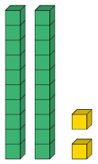 | 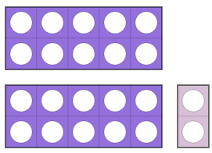 | twenty-two
29 | __ tens  __ ones | 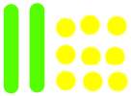
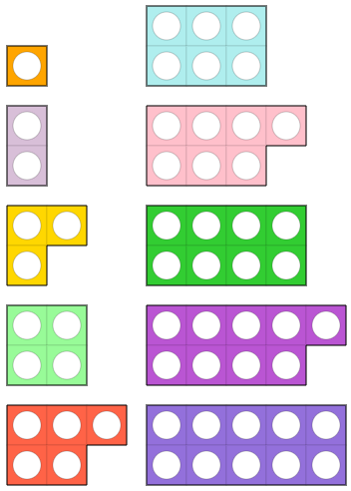
Model:

one two three four five six seven eight nine ten
twenty thirty forty fifty

Now you try…
34 38 41 46 50
If you’d like to represent numbers beyond 50, feel free to come up with some of your own!

Year 2 Maths
Lesson 2
LO: To compare number sentences
Task:
You are going to be using the greater than >, less than <, and equal to = symbols to compare numbers
Success Criteria:
- Write the first number sentence with the answer beneath it.
- Leave a space, then write the second number sentence with the answer beneath it.
- Compare the two answers.
- Write the correct symbol (>, <, =) in the space.

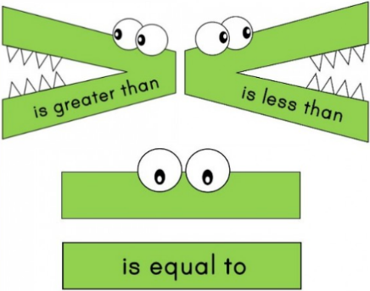
Model:

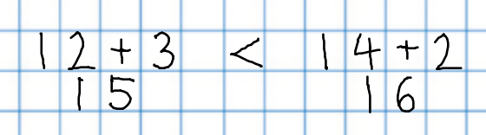
Year 2 Maths
Main activity
Complete at least 2 columns, more if you can!
3.
4.
2.
1.
Task 1 | Task 2 | Task 3 | Task 4
Practice  Have a go at comparing these number sentences:  6 + 4 5 + 6  13 + 5 15 + 2  10 + 10 12 + 8  22 + 13 27 + 11  31 + 18 32 + 17 | Practice  Have a go at comparing these number sentences:  13 + 6 20 - 2  24 - 8 30 - 10  32 + 8 40 - 0  24 + 12 46 - 14  21 + 17 46 - 8 | Reasoning  Explain your answers.  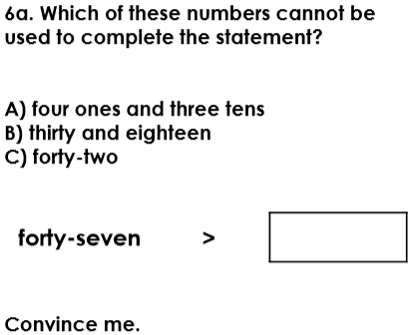  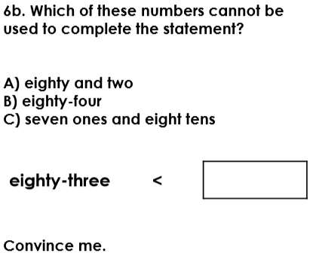 | Problem solving  Find all the possible combinations to complete the statement using up to two of these digit cards:  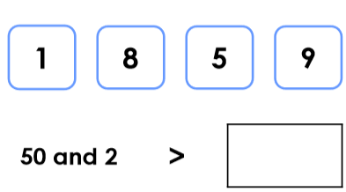  Can you create your own extended part-whole model for 76?

