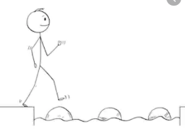
Year 4 Maths
Steppingstone activity
Lesson 2
LO: To use written methods for addition
Success Criteria:
- Write out the calculation – check digits are in the correct columns!
- Add the ones - if the answer is 10 or over, write the one digit in the ones column and carry the tens digit underneath the tens column.
- Add the tens, including any carried over digits.
- Repeat for the hundreds.
- Repeat for the thousands.

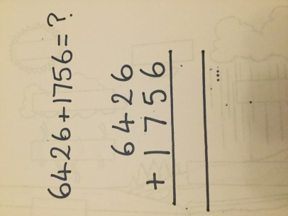
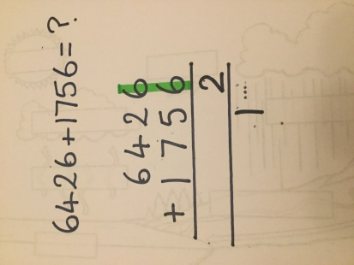
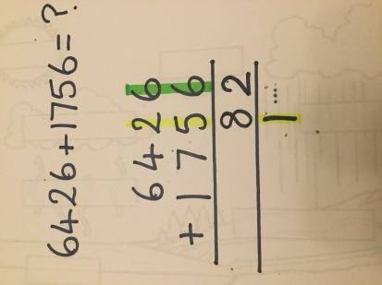
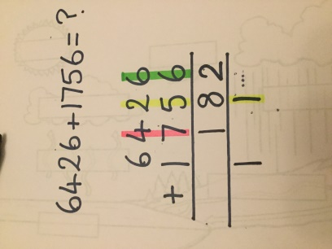
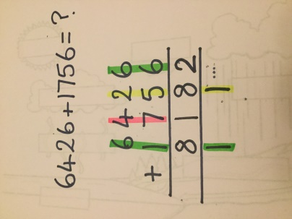
Model
- 2. 3. 4. 5.

Now you try…
2146 + 1237 = 3383 3164 + 3164 = 6328 6532 + 1724 = 8256 2394 + 2843 = 5237
2746 + 1537 = 4283

Year 4 Maths
Lesson 2
LO: To use written methods for addition
Task:
You are going to practise adding with exchanges.
Success Criteria:
- Write out the calculation – check digits are in the correct columns!
- Add the ones - if the answer is 10 or over, write the one digit in the ones column and carry the tens digit underneath the tens column.
- Add the tens, including any carried over digits.
- Repeat for the hundreds.
- Repeat for the thousands.

Model:
1. 2. 3. 4. 5.

Make sure all your answers are in the correct columns!!!
Year 4 Maths
Main activity
Complete at least 2 columns, more if you can!
Task 1 |  | Task 2 | Task 3 | Task 4
Practice  Have a go at these additions (more than one exchange)  1346 + 2367 = 3713  8569 + 8619 =  17188  4272 + 4778 =  9050  9764 + 3763 =  13527  4785 +6546 =  11331 | Practice  Add two of the numbers represented below to make one odd and one even total.  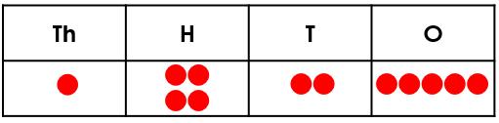  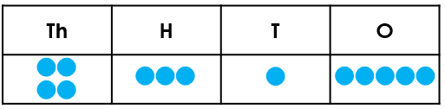  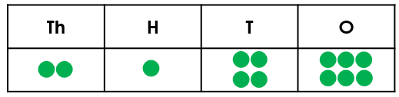  4,315 + 2,146 = 6,461 or 2,146 + 1,425 = 3,571; 4,315 + 1,425 = 5,740 |  | Problem solving 1  Bethany is not correct. If a 6 was rolled for each missing digit, there would be two exchanges needed – one in each calculation. | 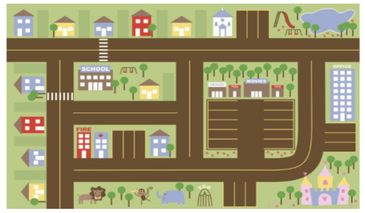  Problem solving 2  Each day Victoria visits two places. During the week she visits each place at least once.  Which places could she have visited each day?  