Task 1 | Task 2 | Task 3 | Task 4
Developing Task Answers  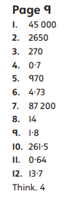  Practice  Have a go at these additions. Use the written method:  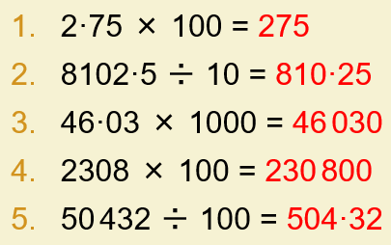  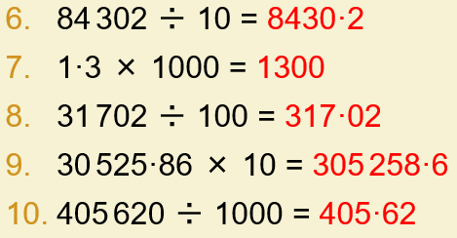  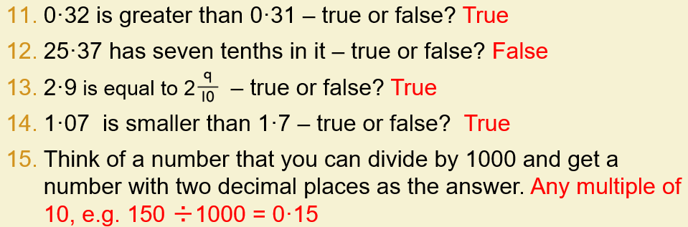 | Arithmetic  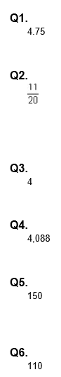 | Reasoning  Explain your answers.  Task 1  10  Task 2  The correct number circled as shown:  9,700 907 9,007 970  Accept alternative unambiguous positive indications, e.g. number ticked.  Task 3  47 ÷ 100 = 0.47  AND  4.07 × 10 = 40.7  Numbers within calculations may be given in either order. | Problem solving  Task 1  (a) £2.97  Accept £2.97p OR £2 97 OR 297p OR £2 97p OR 2.97 OR 297  Do not accept £297p OR £297 OR 2.97p  (b) 10  No mark is awarded if any units are shown, eg 10p  Task 2  Award TWO marks for the correct answer of £4.10 OR 410p  If the answer is incorrect, award ONE mark for evidence of  appropriate working, eg  4 × 60 = 240  2 × 85 = 170  240 + 170 = wrong answer  Accept for ONE mark £410 OR £410p as evidence of appropriate working.  Calculation must be performed for the award of ONE mark.

