Year 6 Maths
Developing activity
Lesson 2
LO: TBAT subtract numbers.
Success Criteria:
- Write out the subtraction (one number under the other) with a totals line.
- Start taking away the digits from the right hand side.
- Do not remember to carry if the total is more then 1- digit.
- Remember to borrow if the number at the top is smaller than the bottom number.
- Check your answer.
Model
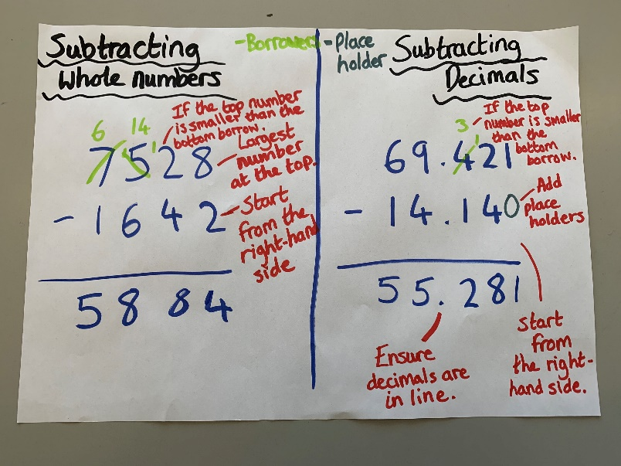
Now you try…
65,042 – 4,327 = 57,135 – 3,493 = 23,055 – 2,289 = 79,588 – 28,846 = 67,014 – 53,198 =
72,743 – 65,339 =
Then, create 3 of your own!
Year 6 Maths
Expected/ Greater depth activity
Lesson 2
LO: TBAT use subtraction in a range of contexts.
Task:
You are going apply your knowledge of subtraction to solve several problems.
Success Criteria:
- For written methods ensure your place value columns are lined up correctly.
- When subtracting decimals ensure decimals are in line.
- Find the lowest common multiple before subtracting fractions.
- Using the inverse can help check your answers.

Recap:
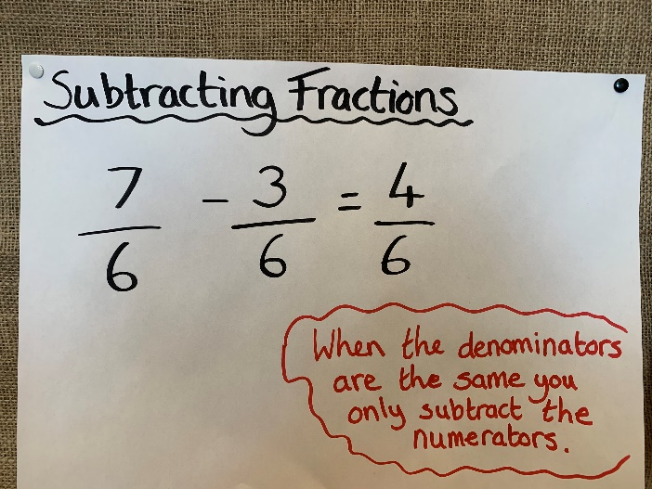 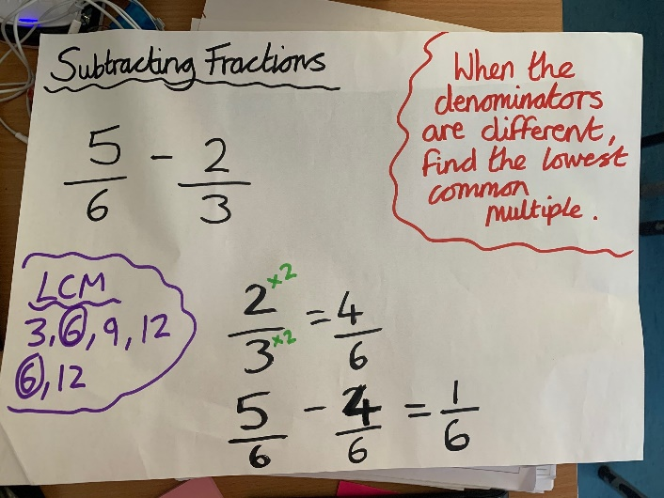 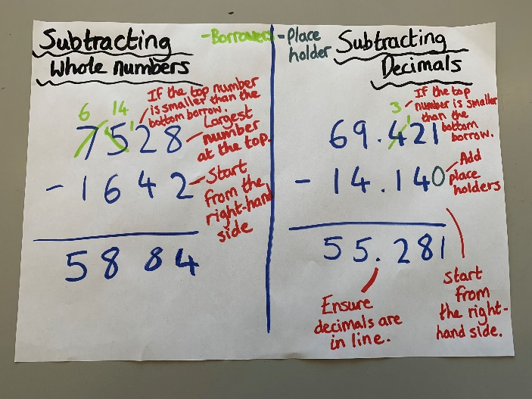
Year 6 Maths
Main activity
Complete at least 2 columns, more if you can!
Task 1 | Task 2 | Task 3 | Task 4
Practice  Have a go at these subtractions. Use the written method:  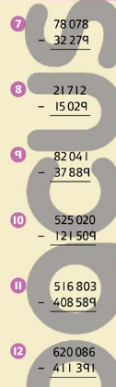 | Arithmetic  Have a go at these subtractions.  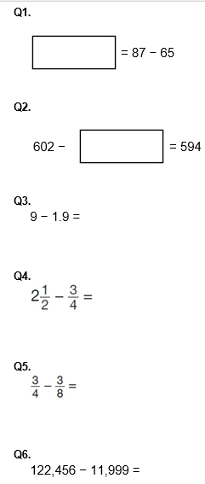 | Reasoning  Task 1  Explain your answers.  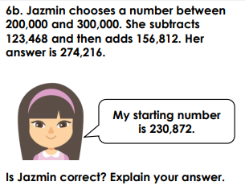  Task 2  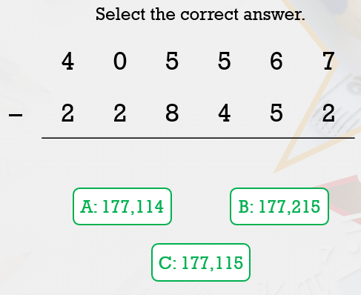 | Problem solving  Task 1  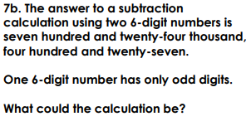  Task 2  