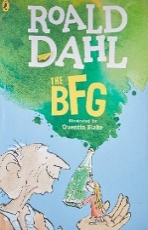**Year 4 Reading**

**Text:**

**Date: Tuesday 24th March 2020  
LO: To identify author choices**

**Task:**

Read the next chapter of the BFG- ‘The Snatch’

Focus on the section below. What words and phrases does Roald Dahl use to build a feeling of tension in you- the reader? (As though you are on the edge of your set!)

What effect do these have on the reader? **E.g.**

1. **Roald Dahl says ‘her blood froze’, which tells me that Sophie is petrified.**
2. **Roald Dahl says there is a ‘huge hand’ but does not say whose it is.** **This makes me curious about who it is and makes me want to read more!**

**Steppingstone activity**

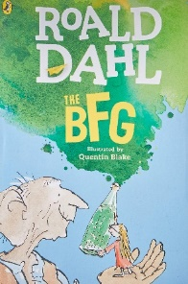

**Task:**

Share the next chapter of the BFG with an adult or an older sibling – ‘The Snatch’.

Look at the extract. Highlight or write down words or phrases that make this chapter feel a bit **scary** for the reader.

**Text:**

