Year 3 Reading
Text: The Enormous Crocodile

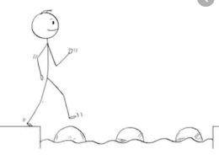
Year 3 Reading
Steppingstone activity
Day 2
LO: To identify descriptive vocabulary used by the author
Success Criteria:
- Read the text
- Draw a picture of yourself
- Find and copy words the crocodiles use to describe children (like you!)

Year 3 Reading
Date: Day 2
LO: To identify descriptive vocabulary used by the author
Success Criteria:
- Read the text
- Draw a picture of yourself
- In one colour, find and copy words and phrases the crocodiles use to describe children.
- In another colour, Write 5 of your own powerful adjectives or phrases you would use to describe children!

