Year 4 Writing
Lesson 2
LO: To create descriptive sentences
Task (with links):
Watch this video clip: https://www.literacyshed.com/takingflight.html
Look at the pictures you have been given.
Create 2 descriptive sentences for each one, including a fronted adverbial and an expanded noun phrase. Use the word bank to help you.
Use the words you collected yesterday.
Success Criteria:
- Look at the picture
- Choose a fronted adverbial or create your own
- Choose a noun or create your own
- Choose 2 adjectives or create your own
- Choose a verb or create your own
- Create your sentence. Make sure you read it back to check it makes sense!
Word bank:
Fronted Adverbials | Adjectives | Nouns | Verbs
Upon the box,  Above them,  Beside the river,  As quick as a flash, | disappointed, fed-up  twinkling, galaxy  dense, twisting  lone, makeshift | boy  sky  vegetation  aeroplane | waited  glowed  climbed  flew
E.g. Upon the box, the disappointed, fed-up boy waited patiently for his Grandpa.
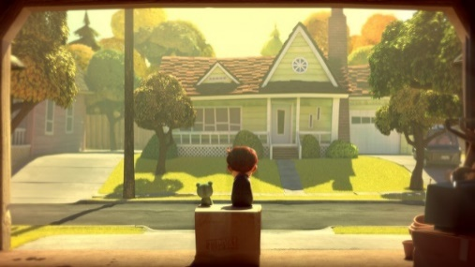

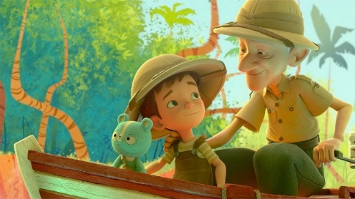
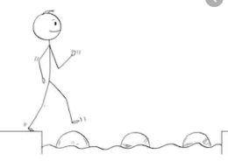
Year 4 Writing
Steppingstone activity
Lesson 2
LO: To create expanded noun phrases
Success Criteria:
Task (with links):
Watch this video clip: https://www.literacyshed.com/takingflight.html
Look at the pictures you have been given.
Create 2 expanded noun phrases for each one. Use the word bank to help you.
Use the words you collected yesterday.

- Look at the picture
- Choose a noun
- Choose 2 adjectives to describe the noun (or come up with your own!)
- Remember your comma!
Word bank:
Adjectives | Nouns
disappointed red  fluffy light  fed up adventurous  elderly  twinkling  galaxy  enormous  glowing  thick  twisting  fast  flowing  lonely | boy  man  sky  moon  plants  river  aeroplane  clouds  E.g.  adventurous, elderly man
