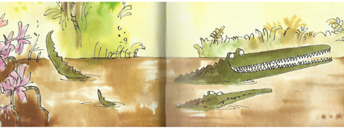
Year 3 Writing
Lesson 2
LO: To recognise alliteration
Task:
Read from P14 - P 21 (…he bit through the tree that Muggle-Wump was sitting in and down it came).
Alliteration is when several words in a sentence deliberately have the same sound at the beginning: E.g. you foul and filthy fiend.
Copy down 3 phrases that have alliteration in them and practise saying them. What effect does this have on the text? (sad, funny, serious, scary…..?). Make sure you take time to spell words accurately, especially as they are already in the text.
Look at the nouns in the grid below. Choose at least 6 of them to write descriptive sentences that use alliteration.
E.g. river: The crocodiles lived in a rapid, running river that rolled noisily over rocks and boulders.

Success Criteria:
- Practise saying words that alliterate with your noun- check they make sense though.
- Use correct sentence punctuation and try to vary sentence starters each time.
- Try to use a variety of sentence types and punctuation (e.g. questions, direct speech and exclamations).
- Try to write sentences with more than one idea (joined with a conjunction).
- Remember to use commas in a list.
- Think about effective presentation so it is clear to see which word you have chosen and which are the words that demonstrate alliteration.

Nouns: | jungle | crocodile | hippo | monkey
trees | teeth | claws | mud | tricks

Extra challenge (optional):
Write a short piece about the crocodiles in the jungle, which includes alliteration and some direct speech between the characters- try to copy the author’s style in your own writing.

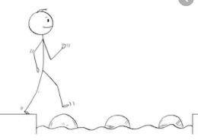
Year 3 Writing
Steppingstone activity
Lesson 2
LO: To recognise alliteration
Task:
Share the book with an adult or older sibling from P14 - P 21 (…he bit through the tree that Muggle-Wump was sitting in and down it came).
Talk about what has happened and check any difficult words or meanings.
Alliteration is when several words in a sentence deliberately have the same sound at the beginning: E.g. you foul and filthy fiend.
Use the words in the word bank to make at least 2 sentences that have alliteration. Draw pictures to show me what they look like.

Look at the words that the characters say (direct speech) – can you see the speech marks?
Think about what direct speech is (the words a character says).
Draw the two crocodiles and put in speech bubbles to record what they say.

Success Criteria:
- Use capital letters and full stops.
- Start each sentence on a new line.
- Spell the words from the word bank correctly.
- Check the sentences make sense- say them quietly to yourself.

Word bank:
hippo | crocodile | monkey | grass
huge  hungry  hairless | creepy  cruel  cranky | marvellous  mischievous  merry | green  growing

Extra challenge (optional):
Make up some more sentences of your own that have alliteration to describe things in the book.

