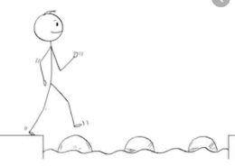
Year 2 Writing
Lesson 2 Steppingstone activity
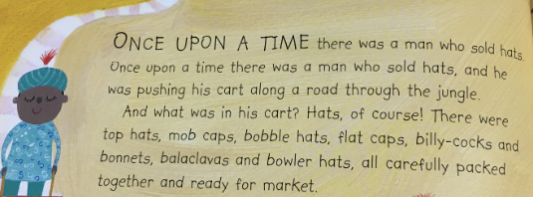
Tuesday 24th March 2020
LO: To create expanded noun phrases

Success Criteria:
- Look at the hat chart
- Write some sentences using adjectives to describe the hats
- Draw your hats
E.g. Big tall top hats.
Word bank:
Adjectives | Nouns
tall  black  green  big  soft  hard | top hats  mob caps  bobble hats  flat cap  bowler hats  bonnets
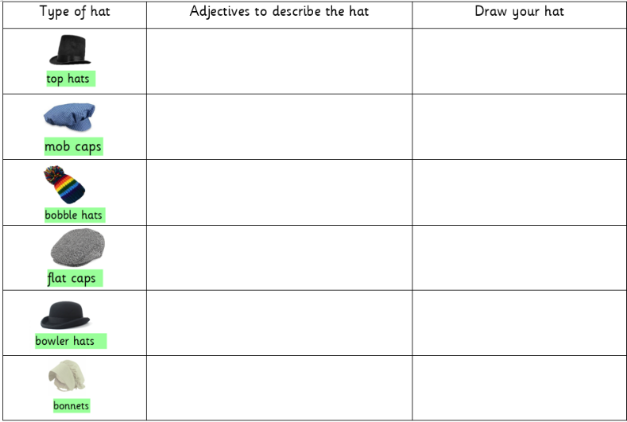

Year 2 Writing
Lesson 2
Tuesday 24th March 2020
LO: To create descriptive sentences

Success Criteria:
- Re-read the beginning of our book ‘Monkey-See, Monkey-Do’
- Look at the hat chart below
- Write some of your own adjectives for each type of hat
- Draw your version of each type of hat

Challenge: Turn your ideas into full sentences for each type of hat
EG: In the man’s cart there were tall, black top hats and white floppy bonnets.
