Year 1 Writing
Lesson 2
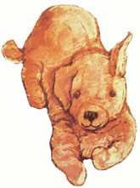
Tuesday 24th March 2020
LO: To punctuate sentences using capital letters and full stops

Write a description of Dogger using the words below to help you.
Don’t forget to write in sentences using capital letters and full stops.
Dogger | belongs to |  | Dave
He | has | light brown | fur
 |  | floppy | ears
 |  | glass | eyes
 | feels | soft
 | smells

How do you think he feels and smells?

Stepping Stone Activity:
Complete these sentences about Dogger.
Dogger is a toy ____________ .
He belongs to ____________.
He has light brown_______ and floppy ___________.
He feels __________.

