Year 5 Maths
Steppingstone activity
Lesson 2
LO: To multiply 2 digit numbers by 2 digit numbers
Success Criteria:
- Layout your multiplication accurately (brackets in line with answers)
- Multiply the top 2 digit number by the units first
- Multiply the top 2 digit number by the 10’s remembering to add a ‘0’ as a placeholder
- Add the two amounts together to form an answer.
- Layout your multiplication accurately (brackets in line with answers as in last example))

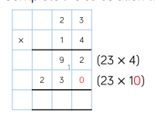
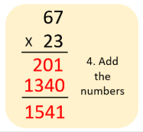
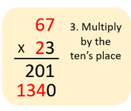
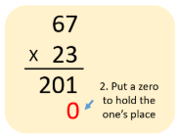
Model
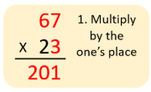
- 2. 3. 4.

Now you try… 456 468 418
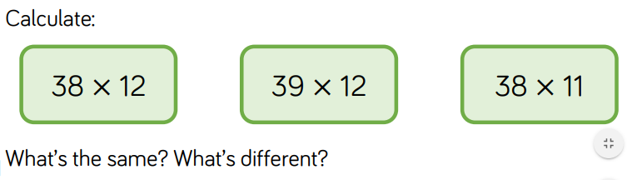
Explain what you notice about the 3 calculations.
Year 5 Maths
Lesson 2
LO: To multiply 3-digit numbers by 2-digit numbers
Task:
You are going to practise multiplying!
Success Criteria:
- Layout your multiplication accurately (brackets in line with answers)
- Multiply the top 3 digit number by the units first
- Multiply the top 3 digit number by the 10’s remembering to add a ‘0’ as a placeholder.
- Add the two amounts together to form an answer.
- Layout your multiplication accurately (brackets in line with answers)

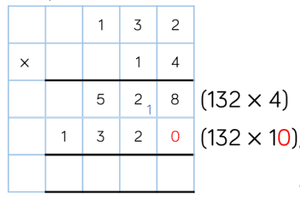
Model:

Make sure all your answers are in the correct columns!!!
Year 5 Maths
Lesson 2
LO: To multiply 3-digit numbers by 2-digit numbers
Main activity
Using the same method try these problems – remember to show your working out to prove your answer!
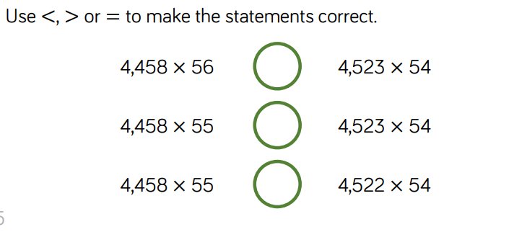

244,242
249,648
<
244,242
245,190
>

244,188
245,190
>

Extension
Try any tasks from yesterday’s grid that you didn’t complete!

