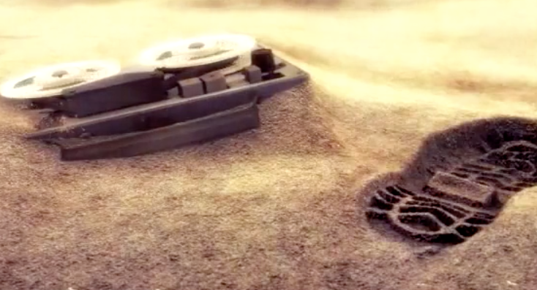**Year 5 Writing**

**Lesson 2  
LO: To describe the setting**

**Task (with links):**

Watch this video clip called ‘Replay- with English subtitles’: <https://www.literacyshed.com/replay.html>

Think about living inside a bunker.

**A BUNKER:** is a reinforced underground shelter, typically used in wartime.

1. Create a list or table of vocabulary to describe what it was like living inside the bunker. Think of vocabulary to summarise how they had lived.
2. Write a detailed description from the brother or the sister’s perspective describing the setting and using words from your vocabulary list. Use your senses when thinking about describing the setting.
3. Draw your own image or floor plan of a bunker, clearly labelling what the different things are in the room.

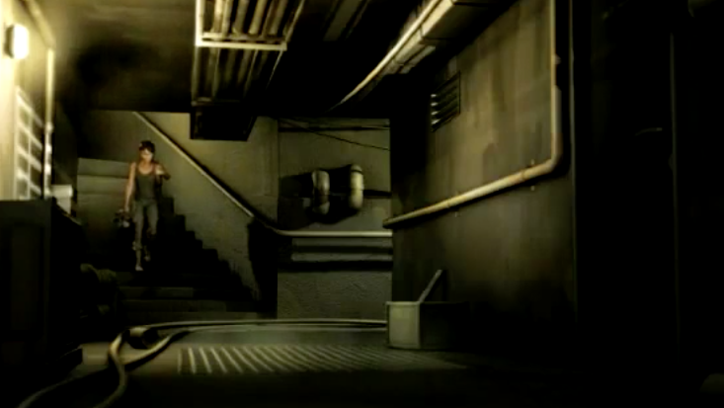 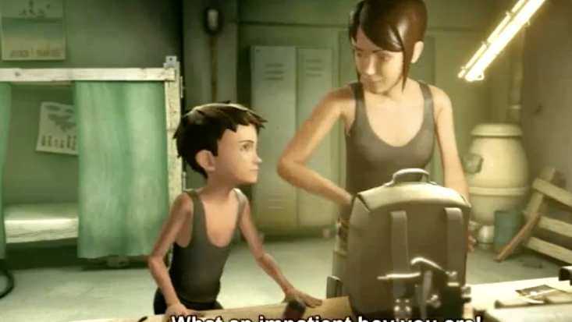

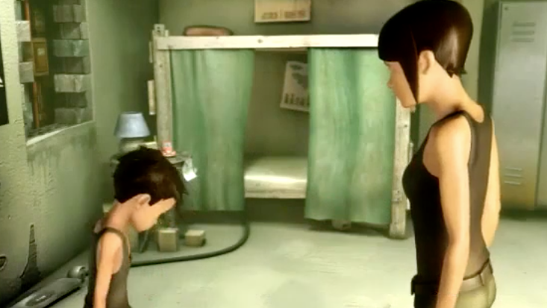 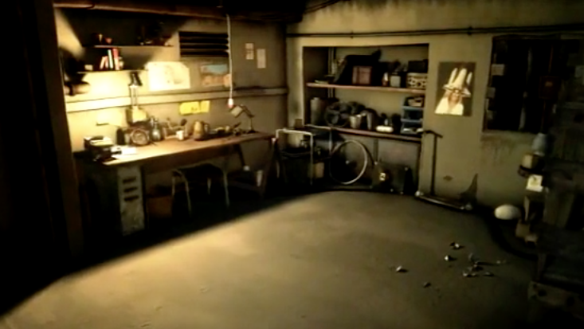

|  |  |  |  |
| --- | --- | --- | --- |
| **Adverbs** | **Verbs** | **Adjectives** | **Nouns** |
|  |  |  |  |