Literacy:

1. Handwriting warm up: practice forming the letters c a d g o s

(remember to say the description for each letter as you write it).

1. Today is the day you are going to use the story map of Jack and the Beanstalk to retell the story.
2. Remember to use all that lovely story book language in your story – and some of the actions we use too!

Once upon a time; who; early one morning; suddenly; and they all lived happily ever after

Physical: Join some paper clips together. How many can you join?

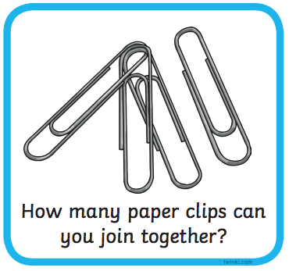

Song

10 in the Bed

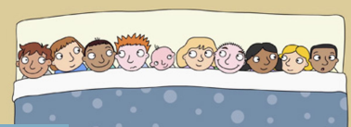

<https://www.bbc.co.uk/teach/school-radio/nursery-rhymes-ten-in-the-bed/z7bnmfr>

This week’s

Expressive Arts and Design

Make the Giant’s castle. You can use any materials that you have in your house. You can draw or use old boxes. You could use lego or even cut up pictures from magazines. You choose! Take a picture and put it on Tapestry.

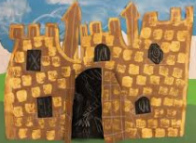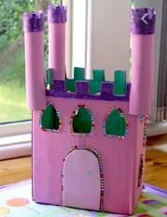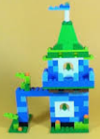

Maths: **Finding half of a number**

Colour in half of the apples. How many is that? What is half of 6? What is half of 10?

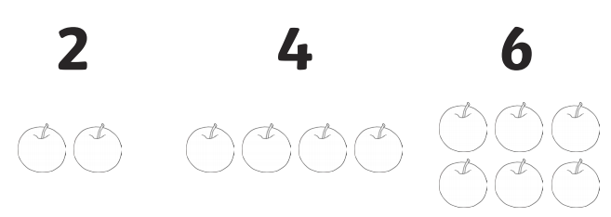

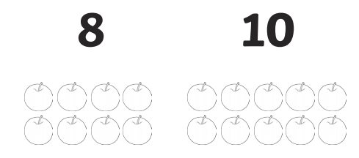

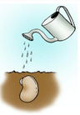

**Phonics – this video demonstrates how to say the pure sounds** <https://www.youtube.com/watch?v=qB6SvZscxgg>

u (u – u – umbrella) in the middle of words

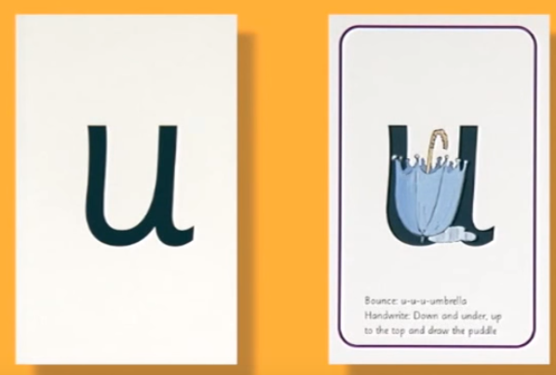

Write or use magnetic letters to build these words:

cut

sun

bus

rug

bun

Draw a picture for each one.

Challenge – make up a caption, eg a bug on a rug.

qu : qu-qu-qu-qu-queen ‘Round her head, up past her earrings and down her hair

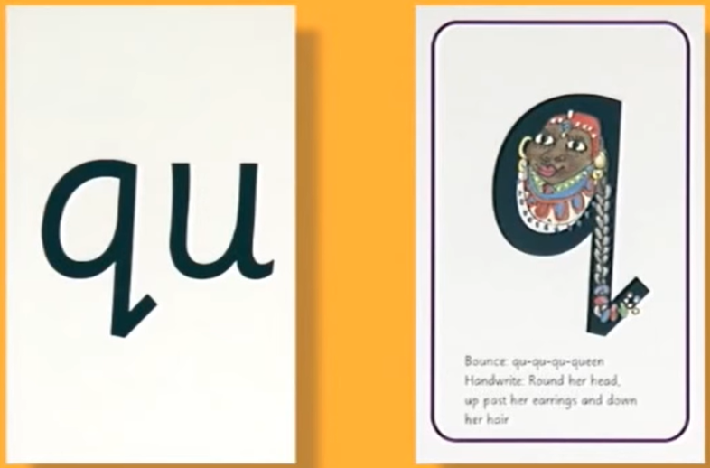

Click this link to find out

What things Geraldine the

Giraffe finds with the qu

phoneme: <https://www.youtube.com/watch?v=mYGGk0MH_xQ>

Now go around your house; can you find the same things that Geraldine found in her house or are you able to find even one more thing than her? 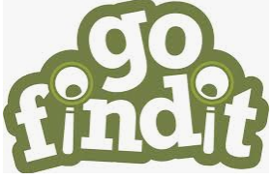

When you have found all the things that have the qu sound in them, show your adult how you use your phoneme fingers to sound out the word.

oo “look at a book”

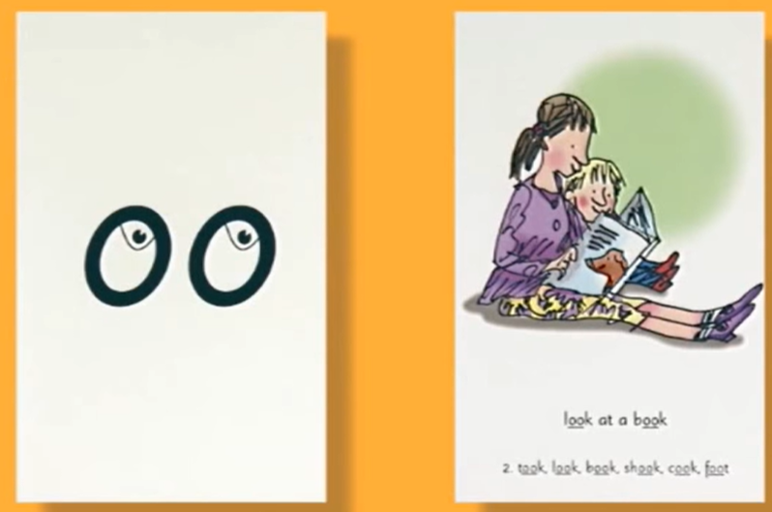

Watch this Alphablocks video

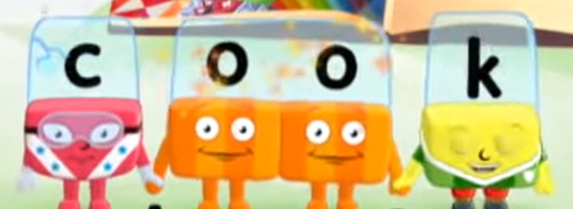

<https://www.youtube.com/watch?v=XEI9QWcX2aA>

Can you hear the difference between the long oo sound (poo at the zoo) and the short oo (look at a book)?

Use your Fred phoneme fingers to sound out these words

