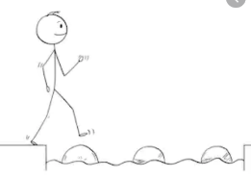
Year 2 Maths
Steppingstone activity
Lesson 3
LO: To identify one more and one less
Success Criteria:
- Draw three squares
- Write the given number in the middle square (e.g. 10)
- Write - 1 above the left-hand square
- Write + 1 above the right-hand square
- Count backwards from the middle number and write the number one less than it in the - 1 box
- Count forwards from the middle number and write the number one more than it in the + 1 box
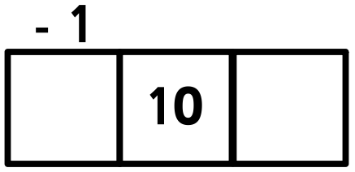
Model:
3.
2.
1.
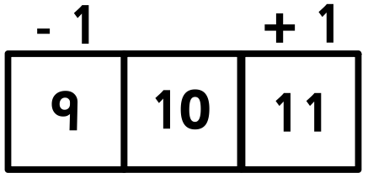
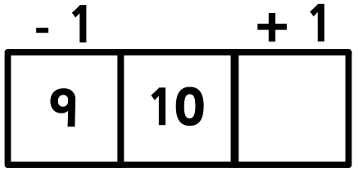
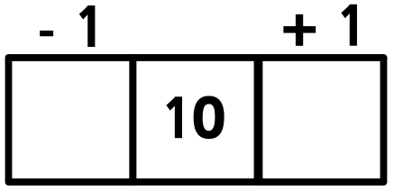
5.
6.
4.

Now you try…
7 11 15 20 24 29 36 40 42
If you’d like to show one more and one less for numbers beyond 50, feel free to come up with some of your own!

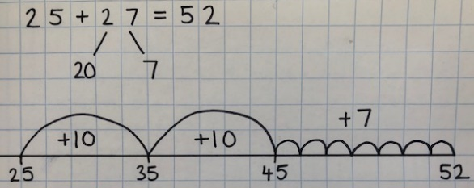
Year 2 Maths
Lesson 3
LO: To add two 2-digit numbers
Task:
You are going to be using partitioning and number lines for addition with exchange
Success Criteria:
- Write the number sentence, leaving the answer blank e.g. 25 + 27 =
- Partition the number that you are adding (e.g. 25 + 27 =) into tens and ones
- Start a number line from the first number (e.g. 25 + 27 =)
- Make your tens jumps (e.g. 25 + 27 = two jumps of ten from 25) and mark the numbers on the number line
- Make your ones jumps (e.g. 25 + 27 = seven jumps of one from 45) and mark the number on the number line
- Write the final answer after your number sentence e.g. 25 + 27 = 52

Model:
3.
2.
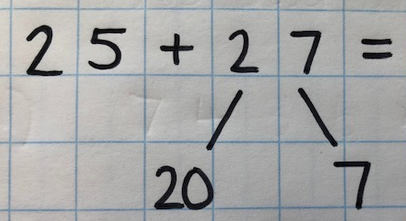
1.

4.
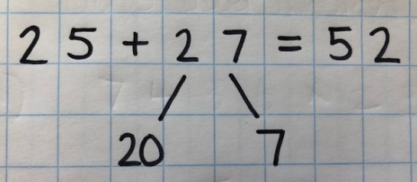
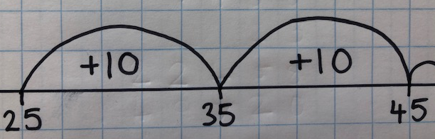
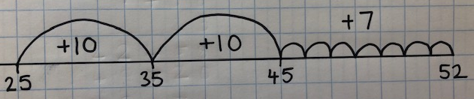
5.
6.

Year 2 Maths
Main activity
Complete at least 2 columns, more if you can!
Task 1 | Task 2 | Task 3 | Task 4
Practice  Use a number line to add these 2-digit numbers:  17 + 16 =  27 + 14 =  34 + 17 =  38 + 25 =  42 + 29 = | Practice  Use a number line to add these 2-digit numbers:  29 + 25 =  36 + 37 =  44 + 26 =  52 + 39 =  67 + 34 =  85 + 26 = | Reasoning  Explain your answers.  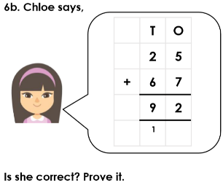  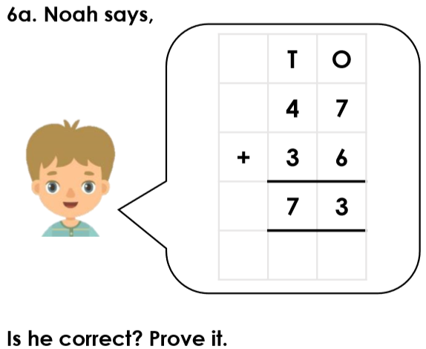 | 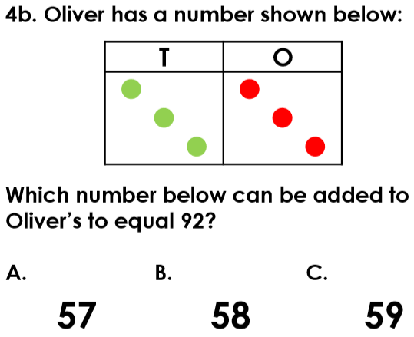  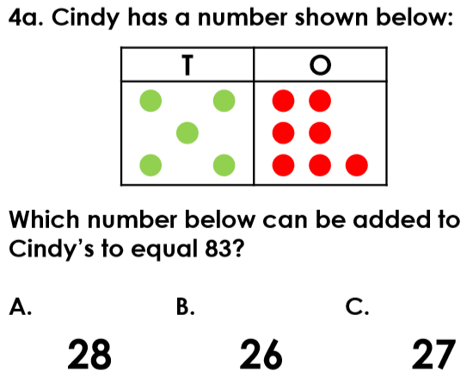  Problem solving

