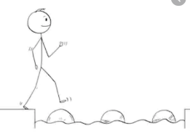
Year 3 Maths
Steppingstone activity
Lesson 3
LO: To tell the time (half past and o’clock)
Success Criteria:
- Look at the long minute hand (straight up say o’clock, straight down say half past)
- Look at the short hour hand say the number it points to (or has just gone past)
- Put the words together e.g. five o’clock or half past nine
- Keep an eye on the clock at home to see when it shows o’clock or half past each hour.

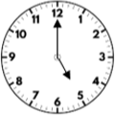
Model
Now you try: What times do these clocks show?
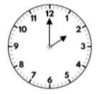
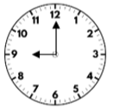
When the long hand (minute hand) is pointing straight upwards to the 12, this is called o’clock.
The short hand (hour hand) tells us what hour of the day it is.
We say them together, like this:
5 (where the short hour hand is pointing) o’clock (the long minute hand is pointing straight up to the top) so, five o’clock.

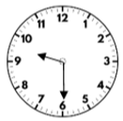
When the long hand (minute hand) is pointing straight down to the 6, this is called half-past.
The short hand (hour hand) tells us what hour of the day it has just gone past.
We say them together, like this:
Half past (the long minute hand is pointing straight down to the bottom) 9 (where the short hour hand has gone past) so, half past nine.
Now you try: What times do these clocks show? 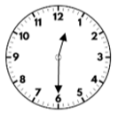 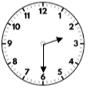

Year 3 Maths
Lesson 3
LO: To tell the time to the nearest 5 minutes
Success Criteria:
- Look at which side of the clock the long minute hand is on (To or Past)
- Use the clock below or count round in 5s to see how many minutes To or Past
- Look at which number the short hour hand is closest to
- Read them together

Model
Now you try:
What times do these clocks show? 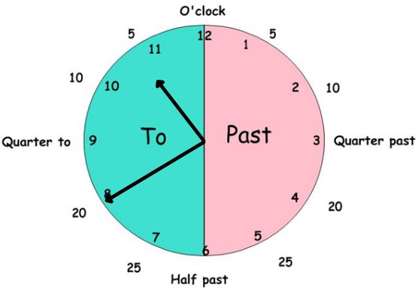

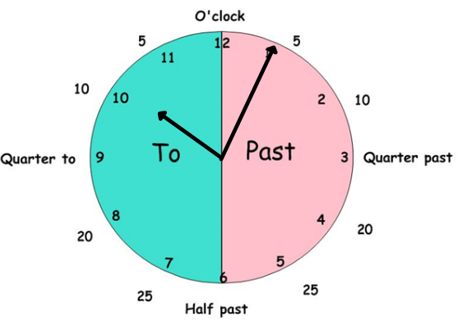
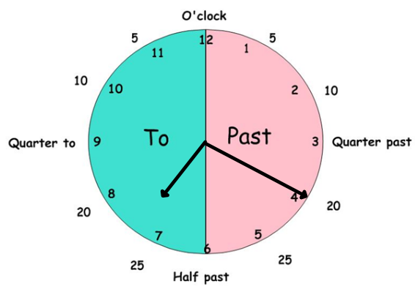
The long minute hand is on the PAST side of the clock.
It is 20 minutes past o’clock (use the minutes written on the outside of the clock to help).
The short hour hand is closest to 7.
We call the time: twenty minutes past seven.
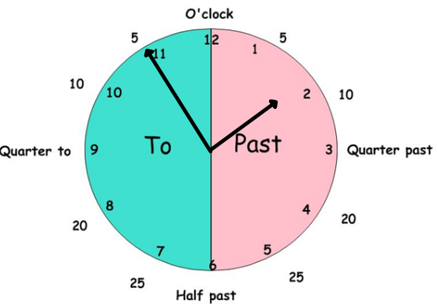
The long minute hand is on the TO side of the clock.
It is 5 minutes away from o’clock (use the minutes written on the outside of the clock to help).
The short hour hand is closest to 2.
We call the time: five minutes to two.

Year 3 Maths
Main activity
Complete at least 2 columns, more if you can!
Task 1 | Task 2 | Task 3 | Task 4
Practice  What’s the time?  - 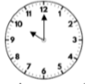  - 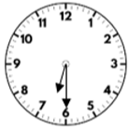  - 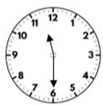  - 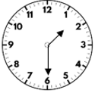  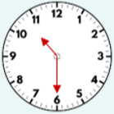 | Practice  - 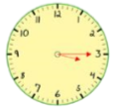  - 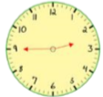  - 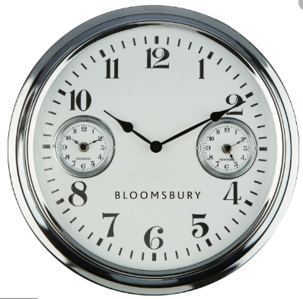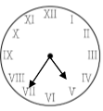  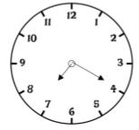 | Reasoning  Explain your answers.  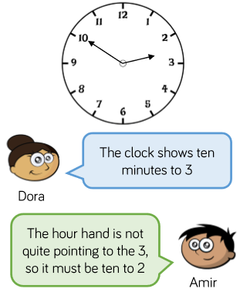  Who do you agree with? Explain your reason.  Chase and Leah are drawing twenty minutes to nine on a clock.  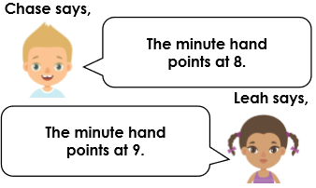  Who is correct? Explain why | Problem solving  