Year 6 Maths
Developing activity
Lesson 3
LO: TBAT multiply numbers.
Success Criteria:
- Write out the multiplication.
- Partition the numbers to fill the grid.
- Start multiplying the numbers together.
- Once you have all your totals, add them together.
- Check your answer.
Model
Grid method
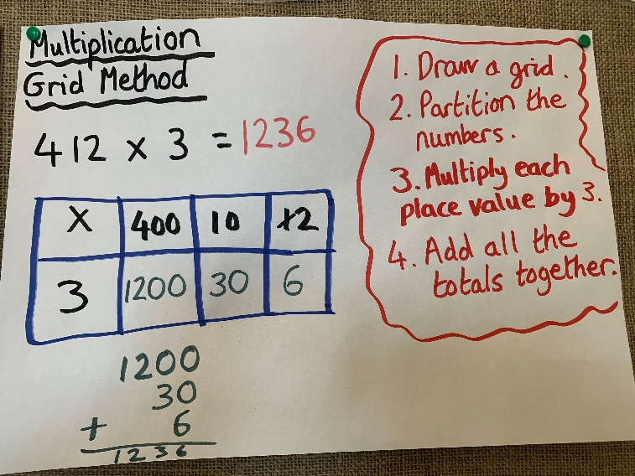

Now you try…
324 x 14 = 513 x 12 = 625 x 13 = 242 x 14 = 146 x 12 = 453 x 13 =
Then, create 3 of your own!
Year 6 Maths
Expected/ Greater depth activity
Lesson 3
LO: TBAT use multiplication in a range of contexts.
Task:
You are going apply your knowledge of multiplication to solve several problems.
Success Criteria:
- For written methods ensure your place value columns are lined up correctly.
- When multiplying with decimals ensure decimals are in line.
- When multiplying fractions, multiply the numerators together and then the denominators.
- If multiplying a fraction by a whole number, make the whole number the numerator and place 1 as the denominator.

Recap:
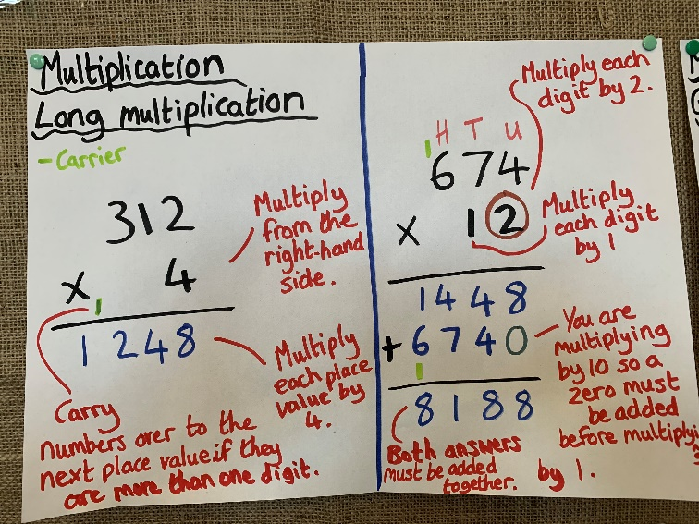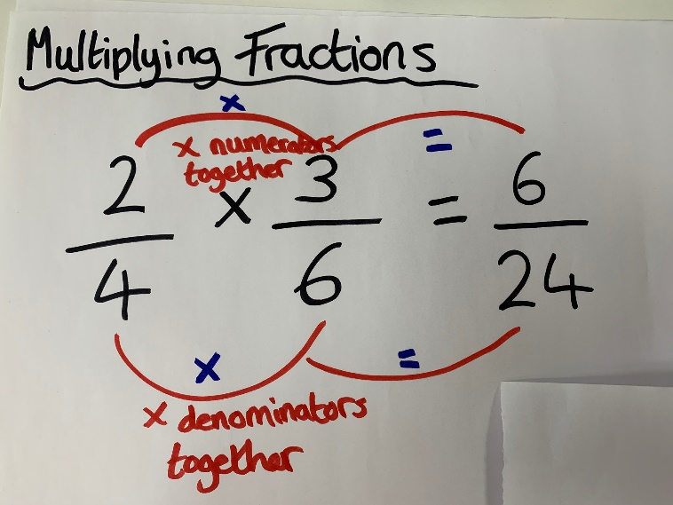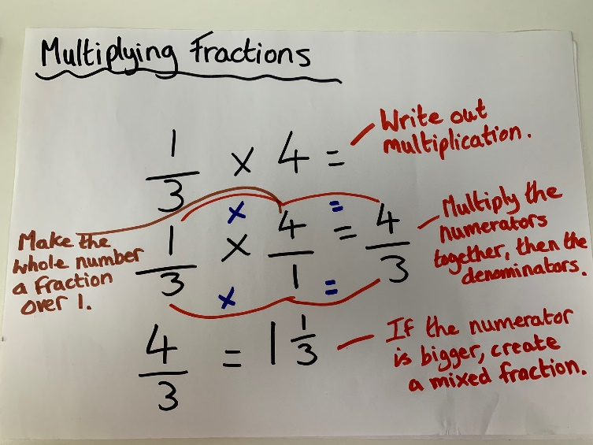
Year 6 Maths
Main activity
Complete at least 2 columns, more if you can!
Task 1 | Task 2 | Task 3 | Task 4
Practice  Have a go at these multiplications. Use a written method:  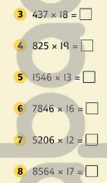 | Arithmetic  Have a go at these subtractions.  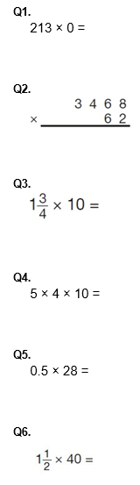 | Reasoning  Explain your answers.  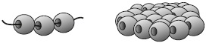  Task 1  Layla makes jewellery to sell at a school fair.  Each bracelet has 53 beads.  She makes 68 bracelets.  Each necklace has 105 beads.  She makes 34 necklaces.  How many beads does Layla use altogether?  Task 2  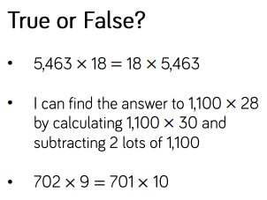 | Problem solving  Task 1  In this grid, there are four multiplications.  Write the three missing numbers.  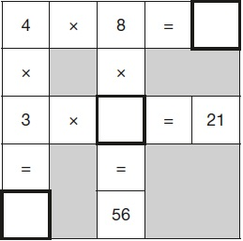  Task 2  