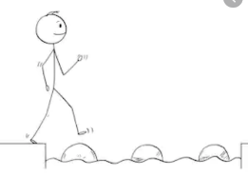
Year 4 Maths
Steppingstone activity
Lesson 3
LO: To subtract two 4-digit numbers
Success Criteria:
- Write out the calculation – check digits are in the correct columns!
- Subtract the bottom ones digit from the top ones digit.
- Subtract the bottom tens digit from the top tens digit.
- Subtract the bottom hundreds digit from the top hundreds digit.
- Subtract the bottom thousands digit from the top thousands digit.
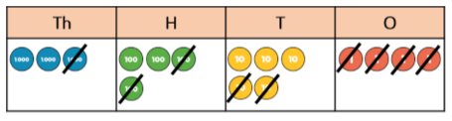
Model

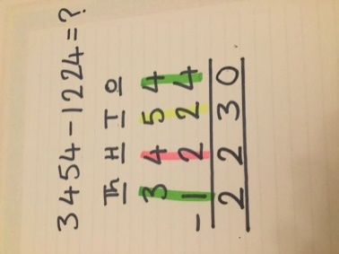
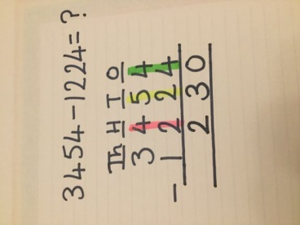
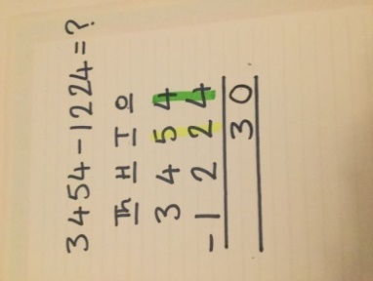
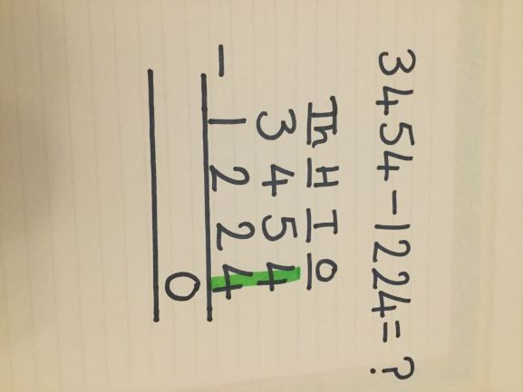
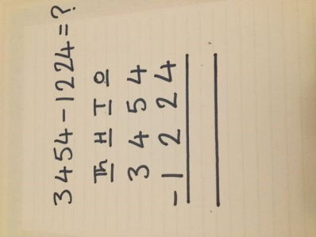
- 2. 3. 4. 5.

Now you try…
7745 – 5223 = 6936 – 2513 = 5038 – 1014 = 8765 – 7654 = 2944 – 1321 =

Stepping stone challenge:
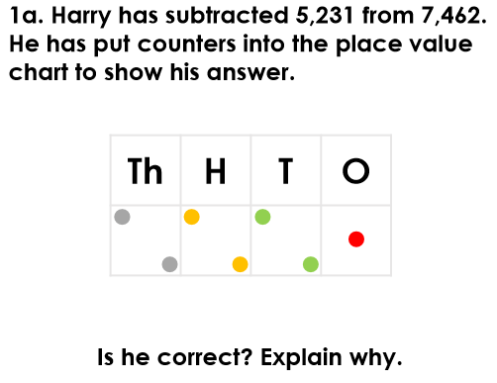
Year 4 Maths
Lesson 3
LO: To subtract two 4-digit numbers
Task:
You are going to practise subtracting with exchanges.
Success Criteria for 5643 - 4316
- Write out the calculation – check digits are in the correct columns!
- Can you subtract the bottom digit from the top digit? No. Exchange one ten for ten ones.
- Subtract the bottom one from the new 2-digit number above.
- Go to the tens column and subtract the bottom ten from the new top ten.
- Subtract the bottom hundreds digit from the top hundreds digit.
- Subtract the bottom thousands digit from the top thousands digit.
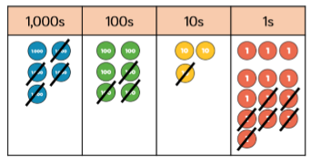
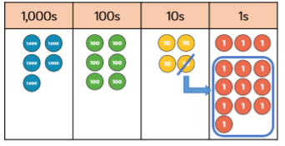
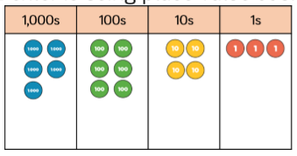
Model:

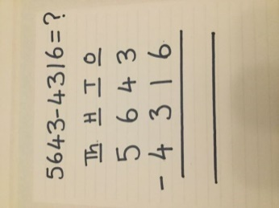
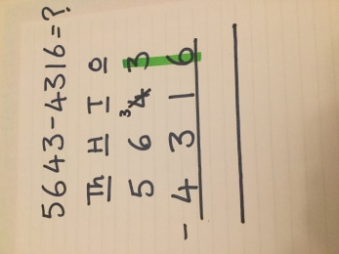
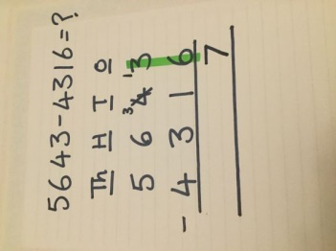
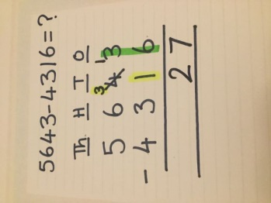
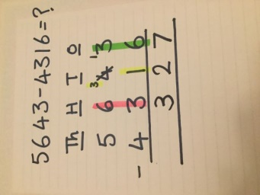
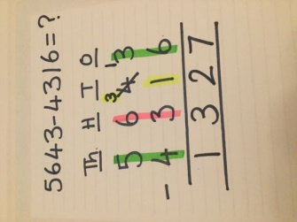
1. 2. 3. 4. 5. 6.

Make sure all your answers are in the correct columns!!!
Year 4 Maths
Main activity
Complete at least 2 columns, more if you can!
Task 1 | Task 2 | Task 3 | Task 4
Practice  Have a go at these subtractions (one exchange)  4721 – 3605 =  3425 – 1283 =  4172 – 3650 =  8259 – 4750 =  4721 – 3650 = | Practice  Have a go at these subtractions (more than one exchange)  5142 – 4085 =  9756 – 5837 =  8291 – 6534 =  7352 – 4867 =  5063 – 3258 = | Reasoning  Explain the mistake in the calculation below.  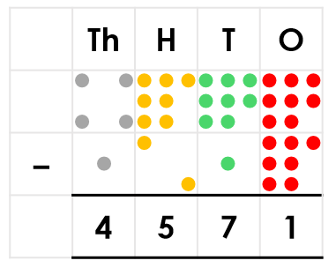  Complete the calculation below  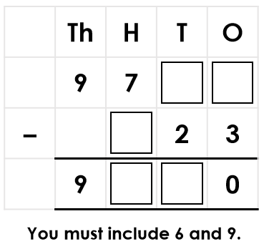 | Problem solving  Chloe is given a starting number of 7,968. She rolls four dice and gets the numbers 1, 2, 3 and 6. She arranges them to make different 4-digit numbers which she subtracts from her starting number.  The grid shows four of the numbers she created after completing her subtractions.  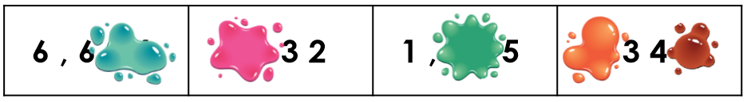  What subtractions did she complete?

