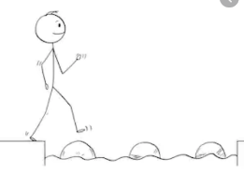
Year 4 Maths
Steppingstone activity
Lesson 3
LO: To subtract two 4-digit numbers
Success Criteria:
- Write out the calculation – check digits are in the correct columns!
- Subtract the bottom ones digit from the top ones digit.
- Subtract the bottom tens digit from the top tens digit.
- Subtract the bottom hundreds digit from the top hundreds digit.
- Subtract the bottom thousands digit from the top thousands digit.
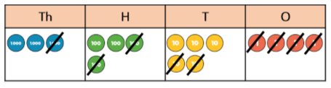
Model

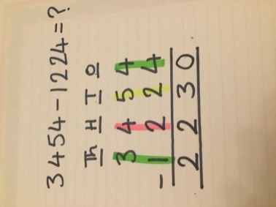
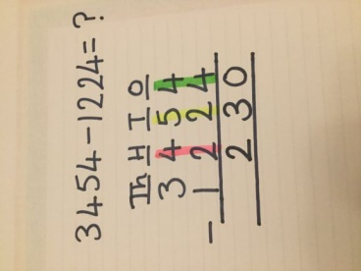
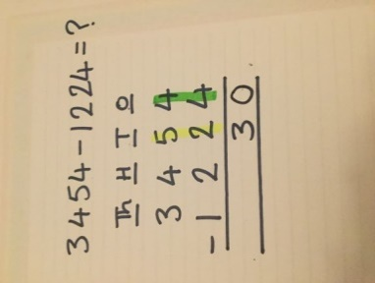
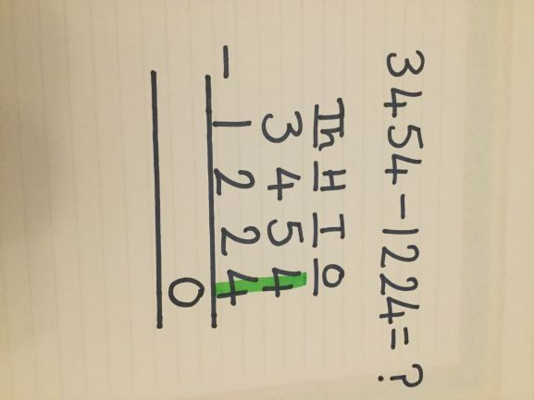
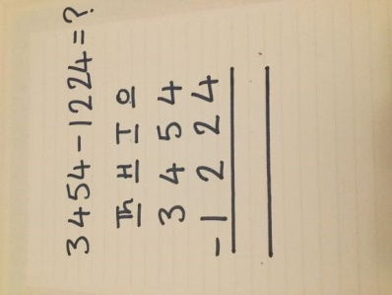
- 2. 3. 4. 5.

Now you try…
7745 – 5223 = 2522 6936 – 2513 = 4423 5038 – 1014 = 4024
8765 – 7654 = 1111 2944 – 1321 = 1623

Stepping stone challenge:
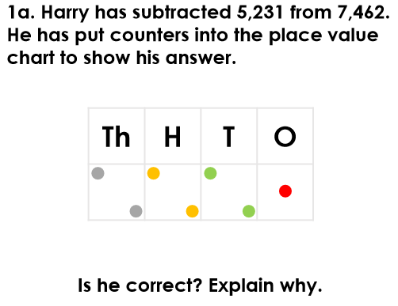

ANSWER: Harry is incorrect. He has subtracted the tens column incorrectly. The answer should be 2,231.

Year 4 Maths
Lesson 3
LO: To subtract two 4-digit numbers
Task:
You are going to practise subtracting with exchanges.
Success Criteria for 5643 - 4316
- Write out the calculation – check digits are in the correct columns!
- Can you subtract the bottom digit from the top digit? No. Exchange one ten for ten ones.
- Subtract the bottom one from the new 2-digit number above.
- Go to the tens column and subtract the bottom ten from the new top ten.
- Subtract the bottom hundreds digit from the top hundreds digit.
- Subtract the bottom thousands digit from the top thousands digit.
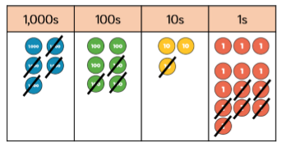
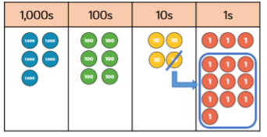
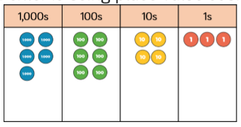
Model:

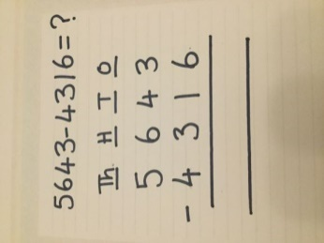
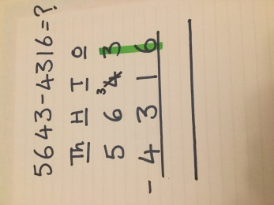
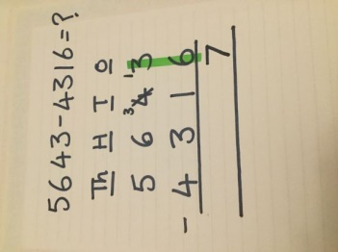
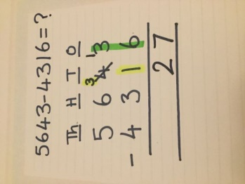
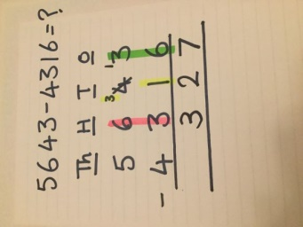
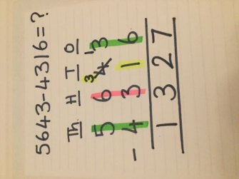
1. 2. 3. 4. 5. 6.

Make sure all your answers are in the correct columns!!!
Year 4 Maths
Main activity
Complete at least 2 columns, more if you can!
Task 1 | Task 2 | Task 3 | Task 4
Practice  Have a go at these subtractions (one exchange)  4721 – 3605 =  1116  3425 – 1283 =  2142  4172 – 3650 =  522  8259 – 4750 =  3509  4721 – 3650 =  1071 | Practice  Have a go at these subtractions (more than one exchange)  5142 – 4085 =  1057  9756 – 5837 =  3883  8291 – 6534 =  1757  7352 – 4867 =  2485  5063 – 3258 =  1805 | Reasoning  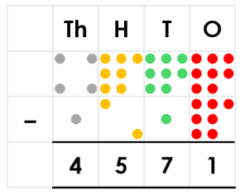  The thousands column is incorrect. 1,000 has not been subtracted from 4,000. The answer should be 3,571.  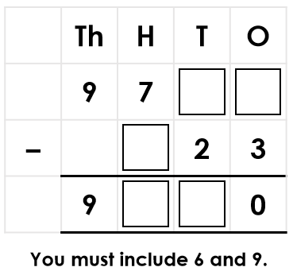  Possible answers: 9,793 – 623 = 9,170; 9,793 – 123 = 9,670 | Problem solving  Chloe is given a starting number of 7,968. She rolls four dice and gets the numbers 1, 2, 3 and 6. She arranges them to make different 4-digit numbers which she subtracts from her starting number.  The grid shows four of the numbers she created after completing her subtractions.  What subtractions did she complete?  Various answers, for example:  7,968 – 1,362 = 6,606 7,968 – 2,136 = 5,832 7,968 – 6,213 = 1,755 7,968 – 3,621 = 4,347

