Answers from lesson 2 (add by making 10)
Stepping stone activity
9 + 7 = 16 7 + 4 = 11 5 + 7 = 12
Model activity
10 + 3 = 13 10 + 6 = 16 10 + 1 = 11
Main activity
Task 1 | Task 2
5+8 = 13  6+8= 14  9+4 = 13 | 5+8= 5+5+3=13  6+8 6+4+4 =14  9+4= 9+1+3=13
Task 3 | Task 4
They are both correct because addition is commutative and the answer to both calculations is 15.  Teddy has started with 7 and partitioned the 8 into 3 and 5 to make 10.  Eva has started with 8 and partitioned the 7 into 2 and 5 to make 10. | Dexter is wrong because the answer should be 14. He should have filled the first ten frame before starting a second one.
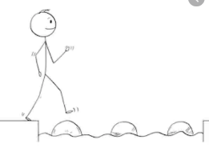
Year 1 Maths
Steppingstone activity
Lesson 3
LO: To subtract a single digit number
Steps to success:

- Draw the number of biscuits there are now in the now column.
- Fill in the missing words in the sentences.
- Fill in the part whole model with the whole number at the top, the part that were eaten and the part there were left.
- Write the calculation.
Model
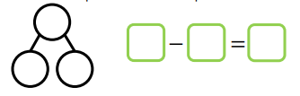
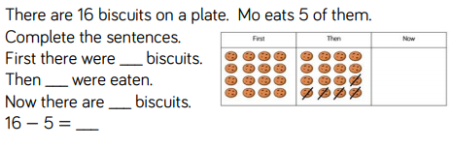

Year 1 Maths
Main activity
Complete at least 2 tasks, more if you can.
Task 1 | Task 2
First Then Now  Draw your own objects and complete your own sentences.  First there were______  Then____ were ______(taken away)  Now there are______ | 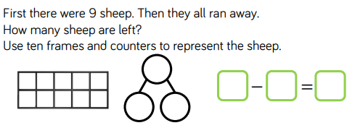  Make up a number story of your own.  First there were_____________________________.  Then_______________________________________.  Now there are______________________________.  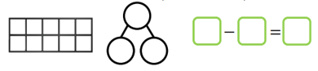

Task 3 | Task 4
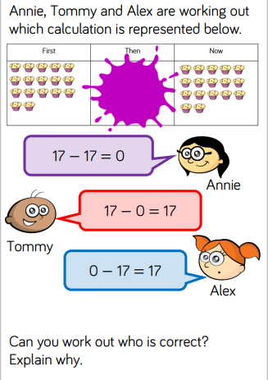 | 