Literacy: Can you create little Hungry Caterpillar story puppets using pens and pencils? Cut them out and stick them on lollipop sticks or spoons. (This whole process is an opportunity to support your child’s pencil grip, ensuring they are holding it with a tripod grip- I will put a picture of what this looks like on Tapestry.) Maybe your child would like to do a performance for your family! This will support their confidence, language and understanding of story structure.

Physical: Use the playdough for 5 minutes of Dough Disco.

Do 10 tuck jumps-

-How high can you jump?

-Can you jump higher than someone else?

-How many can you do without stopping?

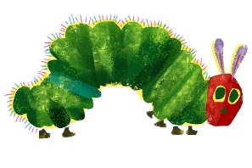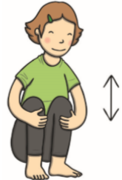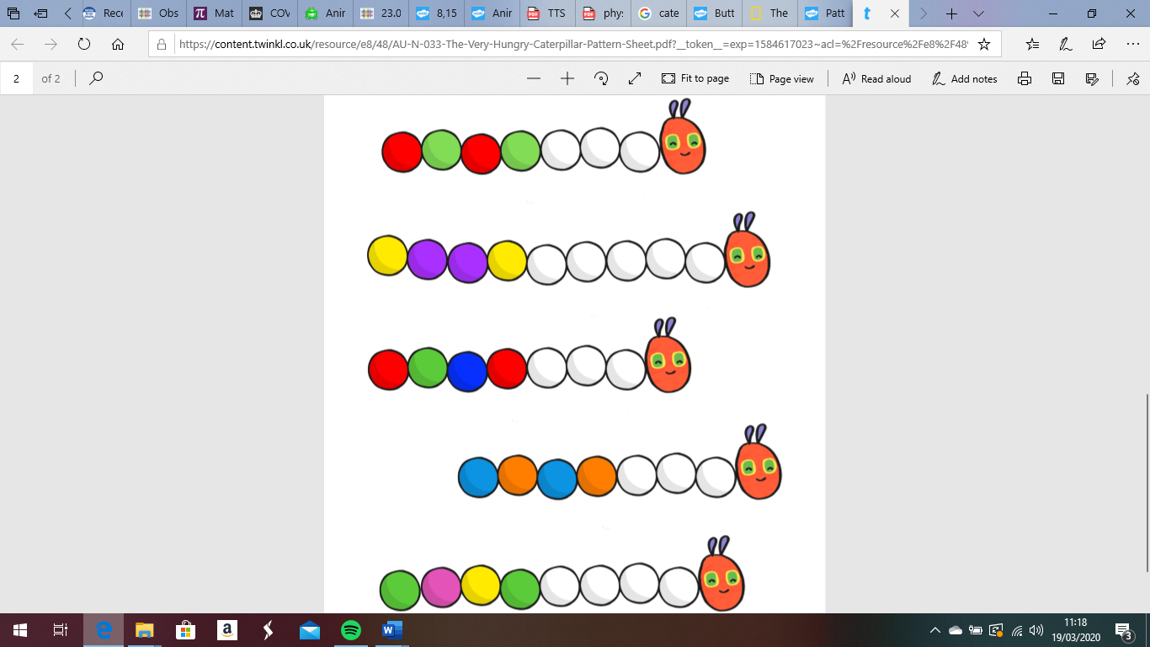[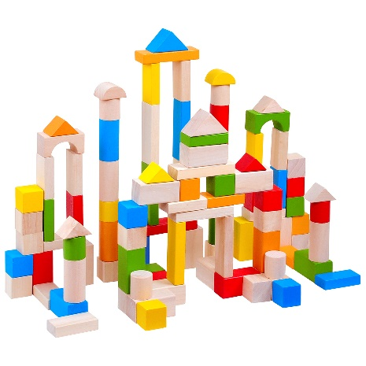](https://www.google.co.uk/url?sa=i&url=https://www.therange.co.uk/baby-nursery-and-toddler/baby-toys-bouncers-and-rattles/baby-and-toddler-toys/100-building-blocks/&psig=AOvVaw2rbj1IA7DyQeXjoZPHG3AJ&ust=1584700362230000&source=images&cd=vfe&ved=0CAIQjRxqFwoTCKi4hoOrpugCFQAAAAAdAAAAABAF)[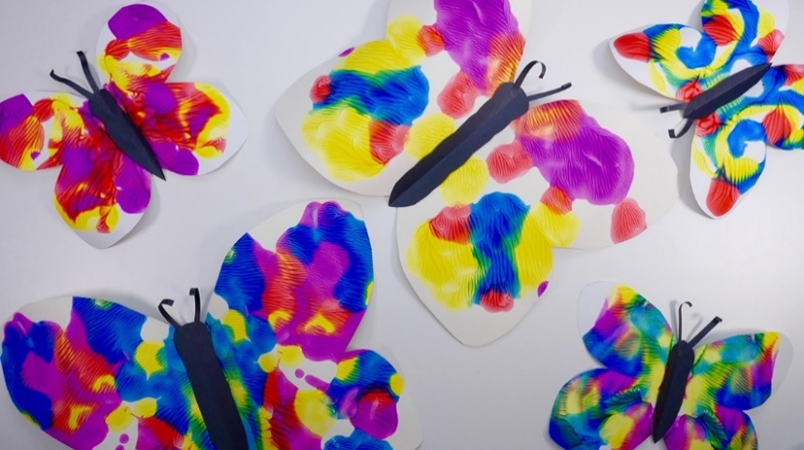](https://www.google.co.uk/url?sa=i&url=https://www.tes.com/lessons/DLe_9r0x5LYZ0A/copy-of-symmetry-butterflies-and-bugs&psig=AOvVaw2CbdmhEiYGUMww95AKrC8T&ust=1584702440583000&source=images&cd=vfe&ved=0CAIQjRxqFwoTCNjhjuKypugCFQAAAAAdAAAAABAn)

Song:

If You’re Happy and You Know It- this encourages lots of different sounds with your body! Can you think of any new ones?

This week’s Expressive Arts and Design:

Can you make a pattern using a butterfly or a caterpillar picture? Draw the outline of one or the other (or both).

For the butterfly, give your child some paint to be able to paint one side of the butterfly. Try to encourage them to think carefully about detail, look at a picture of the butterfly to see the different colours and shapes. Can they paint some small circles or a variety of lines- wavy, straight, curved etc. Fold the paper to print the same pattern on the other side.

For the caterpillar, can they paint or draw

a repeated pattern using different colours

or different shapes along its body.

Maths: Can you use blocks or other construction your child enjoys such as Lego to make a tall tower? Who can build the tallest tower? Who can build the shortest tower? Could you use playdough to measure which is the tallest or create a long wall from one side of the room to the other? You could use trains or cars to drive along the blocks you have built and begin more of an

imaginary game.

Why not use the Numicon and place them at

different ‘stops’; ask your child to drive the car

or train to the number 5 Numicon, or number 7

Numicon and so on.

Phonics:

Using the story map you made yesterday, think about the sounds you could add to your story. You could use sounds with your body such as clapping, stamping, clicking, noises with your mouth- POP! Or you could use instruments if you have them. Think about what sounds you could use for the beginning, when all is quiet and then when the sun comes up- will it come up with a loud noise, or a soft, gentle rise like on a xylophone. If you want to use instrument noises but don’t have them, look at household items!