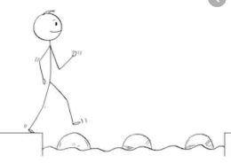
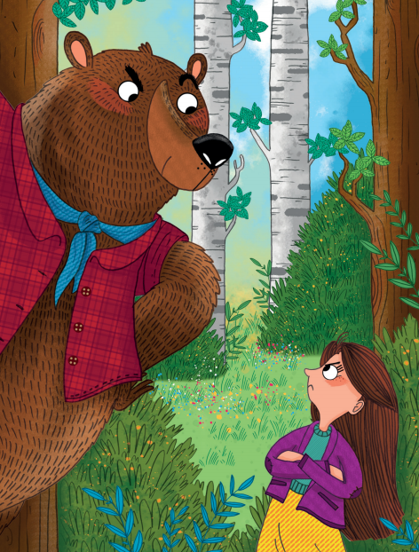
Year 2 Reading
Text:
Once there was a girl called Masha, who lived with her granny at the edge of the woods. One day Masha said, “Granny, can I play outside with my friends?”
“Yes, Masha,” said Granny, “but don’t run off into the woods, will you? There are big bad animals there that bite …” Off went Masha to play with her friends. They played hide-and-seek.
Masha went away to hide and she hid right deep in the woods. Then she waited for her friends to find her. She waited and waited but they never came. So Masha came out of her hiding place and started to walk home.
She went this way, then that way, but very soon she knew she was lost. “He-e-e-lp!” she shouted. “He-e-e-elp!” But no one came. Then very suddenly up came a huge muscly bear…

Year 2 Reading
Steppingstone activity
Date: Wednesday 25th March 2020
LO: To make inferences based on images
Success Criteria:
- Look at the picture- How do you think they feel?
- Draw the picture
- Label your drawing with words for feelings of the characters

Year 2 Reading
Date: Wednesday 25th March 2020
LO: To make inferences based on what we know so far
Success Criteria:
1. Read the text
2. Think about the clues and evidence for your inference
3. Write an inference based on what you know so far

EG: I think Masha is going to get eaten by the bear because Grandma warned her of the big bad animals that bite.

