Year 3 Reading
Text: The Enormous Crocodile
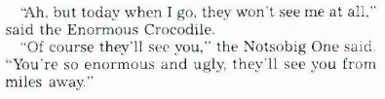
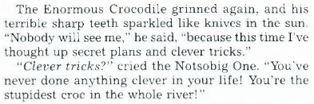
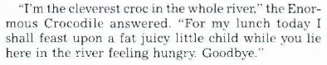
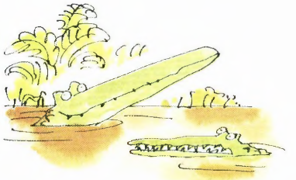
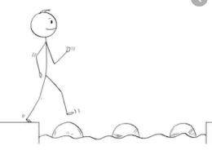
Year 3 Reading
Steppingstone activity
Day 3
LO: To make predictions
Success Criteria:
- Read the text
- What clever tricks do you predict the crocodile will use to catch a child?
- Draw and label 2 ideas of what the crocodile’s trick could be

Prediction 2:
Prediction 1:
Year 3 Reading
Day 3
LO: To make predictions
Success Criteria:
- Read the text
- What secret plans and clever tricks do you predict the crocodile will use to catch a child?
- Draw and label 3 ideas of what the crocodile’s plan could be
Prediction 3:
Prediction 2:
Prediction 1:

