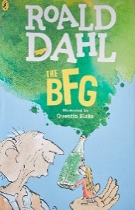
Year 4 Reading
Date: Wednesday 25th March 2020
LO: To identify effective vocabulary
Task:
Read the next chapter of the BFG- ‘The Cave’
This chapter is full of action, as Sophie is taken by the giant to a cave! It is full of powerful vocabulary that makes us feel on the edge of our seat!
Your task is to identify all the powerful verbs (doing words) that make this chapter so action-packed! Write them around the picture.
How do you think Sophie was feeling when they arrived at the cave?

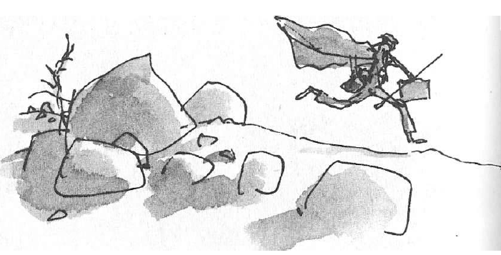

EXT: Another technique that Roald Dahl uses to make this chapter so action packed is the use of short snappy sentences! Can you find 5 that you think are really effective?

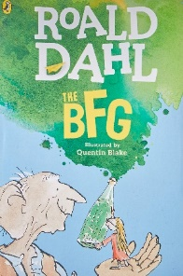
Year 4 Reading
Steppingstone activity
Date: Wednesday 25th March 2020
LO: To identify effective vocabulary
Task:
Share the next chapter of the BFG with an adult or older sibling- ‘The Cave’
This chapter is full of action, as Sophie is taken by the giant to a cave! It is full of powerful vocabulary that makes us feel on the edge of our seat!
Your task is to identify all the powerful verbs (doing words) on the first page of the chapter. Write them around the picture.
How do you think Sophie was feeling when they arrived at the cave?

