Year 6 Writing
Lesson 3
LO: To describe key events
Task (with links):
Watch this video clip: https://www.literacyshed.com/pigeon-impossible.html
Look at the pictures you have been given.
Create 2 descriptive sentences for each one, including a subordinate clause and a main clause in every sentence. Use the word bank to help you.
Success Criteria:
- Look at the picture
- Choose a subordinate clause or create your own
- Choose a noun or use your own
- Choose 2 adjectives or use your own
- Choose a verb or use your own
- Create your sentence. Make sure you read it back to check it makes sense!
Word bank:
Subordinate clauses | Adjectives | Nouns | Verbs
When he offered the pigeon a crumb of his bagel,  As the bagel hit the red button,  Before Walter could stop it,  Although the agent tried his best, | freshly-baked  curious  hi-tech  complex  metallic  peaceful  chaotic  desperate | pigeon  buttons  suit  Washington DC  agent  equipment  bagel  rocket | offered  rejected  flew  imprisoned  landed  fired
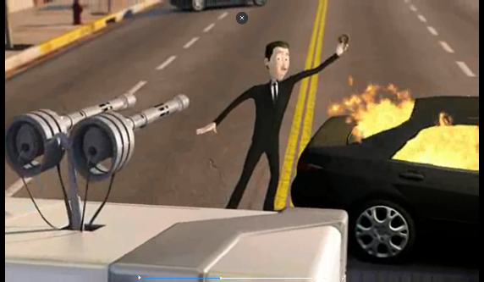
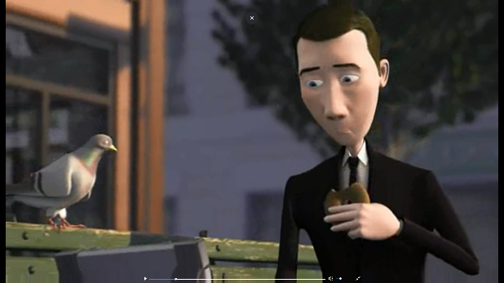
E.g. While the pigeon wreaked havoc, Agent Walter Becket attempted to retrieve his hi-tech briefcase.

