Year 4 Writing
Lesson 3
LO: To describe a character’s feelings
Task (with links):
Watch this video clip: https://www.literacyshed.com/takingflight.html
Also on: https://www.youtube.com/watch?v=Gj6V-xZgtlQ ‘Taking Flight’
We have chosen two images from the adventurous jungle scene that Tony and his Grandpa embark on.
Write a setting description of one of the images.
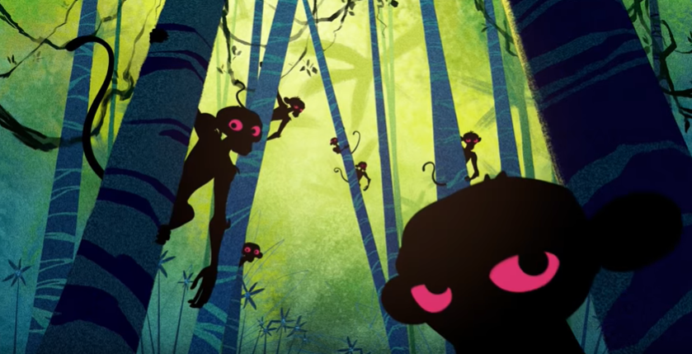
Year 4 spelling words: Can you include ‘–tion’, ‘-sion’, -‘ssion’, ‘-cian’ words? Possession, attention
Fronted Adverbials | Adjectives | Nouns | Verbs
In the trees,  Above them,  Across the sky,  Beside the river,  Up in the clouds,  As quick as a flash,  In the distance, | tropical dense  tangled fearsome  swampy gigantic  desolate humid  green wild  vast exotic  colourful mysterious | Boy  Man  Grandpa  Tony  Monkey  River  Temples | waited hid  dangled paddled  climbed scoured  flew searched  Sailed wandered  drifted  swung
Conjunctions: when, if, because, although, after, once, until, while, but, so
Use the word bank in this order to create your sentences.
Success Criteria:
- Look at the picture
- Use expanded noun phrases
- Use fronted adverbials
- Use a range of sentence starters
- Use a range of conjunctions
- Look at your checklist when reading back through

Model:
Above them, towering, fearsome temples swung from side to side like a skyscraper. In the trees, strong, excited monkeys dangled from the sturdy, thick trees. As quick as a flash, colourful birds shoot across the sky.
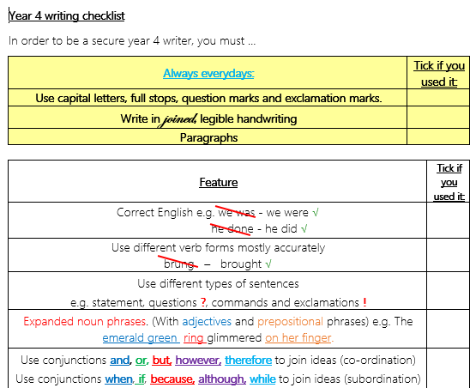

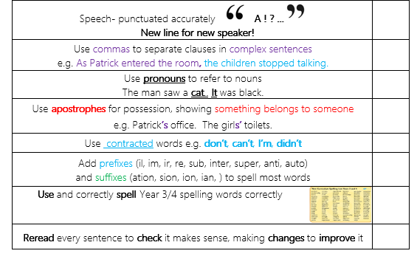

Year 4 Writing
Steppingstone activity
Lesson 3
LO: To describe a character’s feelings
Year 4 spelling words: Can you include ‘–tion’, ‘-sion’, -‘ssion’, ‘-cian’ words? Possession, attention
Task (with links):
Watch this video clip: https://www.literacyshed.com/takingflight.html
Also on: https://www.youtube.com/watch?v=Gj6V-xZgtlQ ‘Taking Flight’
We have chosen an image from the adventurous jungle scene that Tony and his Grandpa embark on. Write a setting description of this image.

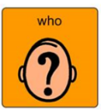  Nouns | 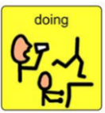  Verbs | Adjectives | 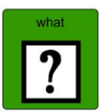  Nouns
Boy  Man  Grandpa  Tony  Monkey | waited hid  dangled paddled  climbed scoured  flew searched  Sailed wandered  drifted  swung | tropical dense  tangled fearsome  swampy gigantic  desolate humid  green wild  vast exotic  colourful mysterious | River  Trees  Temple  Canyon  Jungle  Waterfalls  Sky
Success Criteria:
- Look at the picture
- Use expanded noun phrases
- Use your colourful semantics
- Look at your checklist when reading back through

Model:
The small, young boy paddled down the meandering, powerful river. The old, aged Grandpa searched the swampy, humid jungle for somewhere to stop. There were strong, excited monkeys swinging in the trees.

