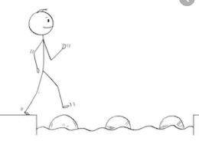
Year 2 Writing
Lesson 3 Steppingstone activity
Wednesday 25th March 2020
LO: To use verbs
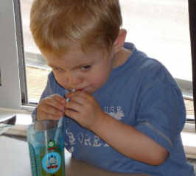
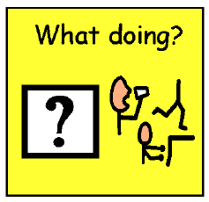

Success Criteria:
- Look at the picture
- Say a sentence to describe it (Who is doing what?)
- Write your sentence using a verb, a capital letter and full stop.

Challenge: Use an adjective too!
EG: The little girl is eating.

Nouns | Verbs
girl  boy | eating  drinking  drawing

Year 2 Writing
Lesson 3
Wednesday 25th March 2020
LO: To use verbs in the past tense

Once upon a time there was a man who sold hats.
He pushed his cart down the road.
There was a big hole in the road and the cart tipped over.
The hats fell out of the cart.

Success Criteria:
- Read the sentences
- Write the sentences and underline the verbs in them
- Re-write the sentences again and up-level your work by choosing new, improved verbs
- Draw pictures for your sentences

Challenge: Include adjectives to describe

EG: The hats violently flew out of the wooden, brown cart.

