Year 1 Writing
Lesson 3
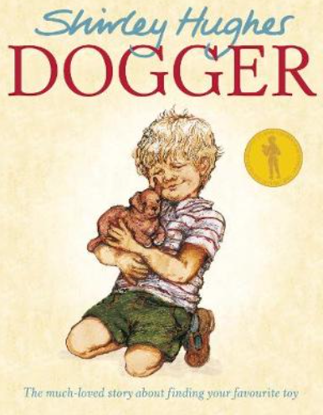
Wednesday 24th March 2020
LO: To make predictions

Look at the cover of the book Dogger.
What do you think happens in the story? Tell a grown up.
Who is the boy? Who is Dogger? Make up a story of what happens to Dave and Dogger. If you know the story already try and remember what happens.
Write a few sentences saying what you think will happen in the story.
Stepping Stone Activity:
Look at the cover of the book Dogger.
What do you think happens in the story? Tell a grown up.

