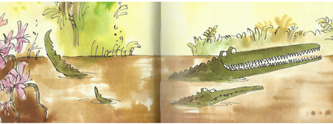
Year 3 Writing
Lesson 3
LO: To identify opportunities to include adverbs in story writing
Task:
Remind yourself of what an adverb is (a word that describes a verb E.g. the monkey jumped powerfully from branch to branch.)
Often you add –ly to the end of a word to make it into an adverb. If the original word ends in y, you need to change the spelling to an i : angry…angrily.
Pick some phrases from the part of the book you have read so far. Choose some adverbs to add more detail to the sentence. Try to vary the word order.
E.g. The Enormous crocodile grinned wickedly at Humpy Rumpy.
The Enormous Crocodile cunningly grinned again and his terrible, sharp teeth sparkled terrifyingly, like knives in the sun.
Say the new sentence to yourself to check it makes sense before you write it down. Check difficult spellings with a dictionary (online or printed) and check that you are including correct punctuation when you write. Try to do at least 8 sentences. You can draw pictures to match if you wish.
Success Criteria:
- Choose phrases/sentences you like from the book that have a verb.
- Choose an adverb (to describe the verbs) for each sentence.
- Make sure that you copy the words taken from the text accurately.
- Vary the order in which you put the adverbs (before/after the verb).
- Start each new sentence on a new line.
- Make sure you include correct punctuation (including commas in lists).
Word bank: (you do not have to choose these adverbs- they are just a suggestion)
wickedly | unkindly | bravely | quickly | swiftly
slowly | terrifyingly | desperately | greedily | disapprovingly

E.g. “I’m the cleverest croc on the whole river,” the Enormous Crocodile said boastfully.

Extra challenge (optional):
Write an extra paragraph or your own to describe what Mugglewump did straight after he escaped from the Enormous Crocodile. Underline the adverbs you included and think about varying where you place them in the sentence.

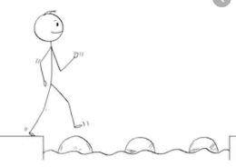
Year 3 Writing
Steppingstone activity
Lesson 3
LO: To use adverbs and verbs
Task:
Share the book with an adult or older sibling again up to the point we reached yesterday.
Remind yourself of what a verb is (action in the sentence: E.g. The Enormous Crocodile laughed out loud).
An adverb is an extra word to describe how the action is done.
You need to choose some things that the Enormous Crocodile (or other characters in the story) did. Draw a picture of what they did and write a sentence with an adverb under the picture.
E.g. Mugglwump jumped off the tree quickly.
Jumped is the verb and quickly is the adverb
Try to do at least 4 pictures and sentences.

Success Criteria:
- Choose things that the characters in the book have done so far.
- Draw the characters and think about what they are doing and how they are doing it.
- Write a sentence to describe each picture.
- Make sure you include an adverb in each sentence.

Word bank: (you do not have to choose these adverbs- they are just a suggestion)
said meanly | walked slowly | quickly jumped | smiled wickedly

