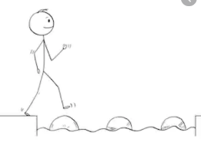
Year 5 Maths
Steppingstone activity
Lesson 3
LO: To multiply 2 digit numbers by 2 digit numbers
Success Criteria:
- Layout your multiplication accurately (brackets in line with answers)
- Multiply the top 2 digit number by the units first
- Multiply the top 2 digit number by the 10’s remembering to add a ‘0’ as a placeholder
- Add the two amounts together to form an answer.
- Layout your multiplication accurately (brackets in line with answers as in last example))

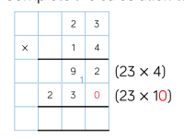
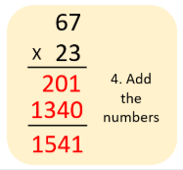
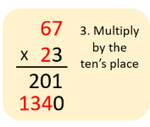
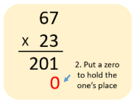
Model
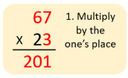
- 2. 3. 4.

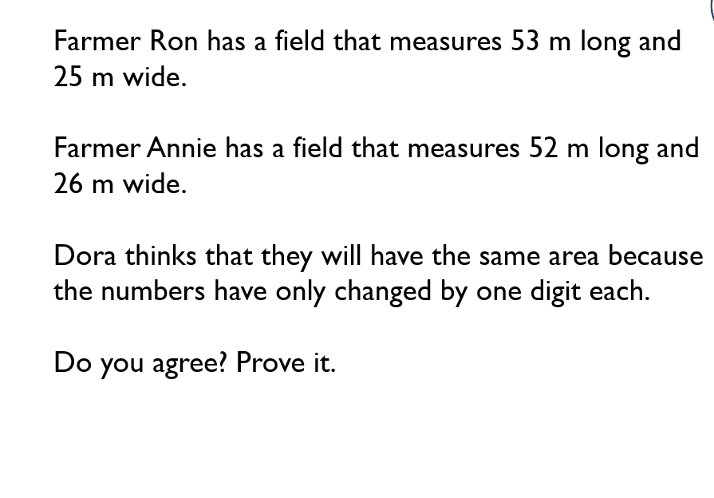
Now you try…
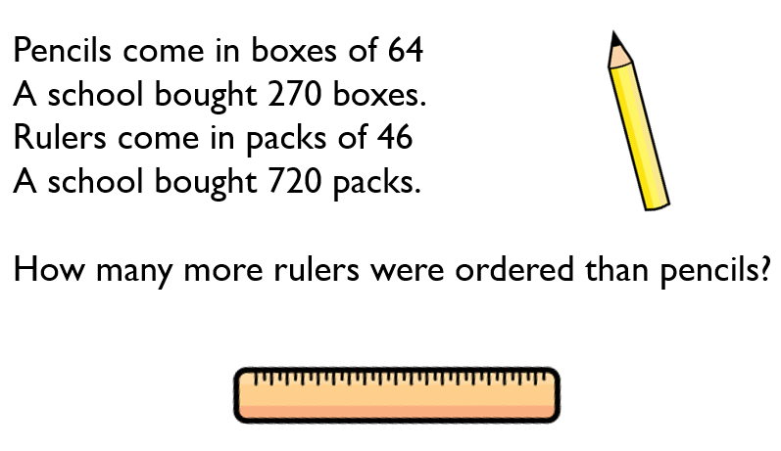
1.
2.

Pencils – 17,280 Rulers – 33,120 Do not agree - Ron – 1,325 cm2
15,840 more Rulers. Annie – 1,352 cm2

Year 5 Maths
Lesson 3
LO: To multiply 3-digit numbers by 2-digit numbers
Task:
You are going to continue practising multiplying!
Success Criteria:
- Layout your multiplication accurately (brackets in line with answers)
- Multiply the top 3 digit number by the units first
- Multiply the top 3 digit number by the 10’s remembering to add a ‘0’ as a placeholder.
- Add the two amounts together to form an answer.
- Layout your multiplication accurately (brackets in line with answers)

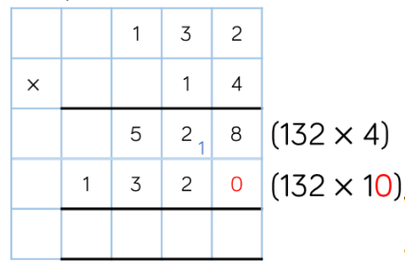
Model:

Make sure all your answers are in the correct columns!!!
Year 5 Maths
Main activity Lesson 3
Using the same method try these problems – remember to show your working out to prove your answer!
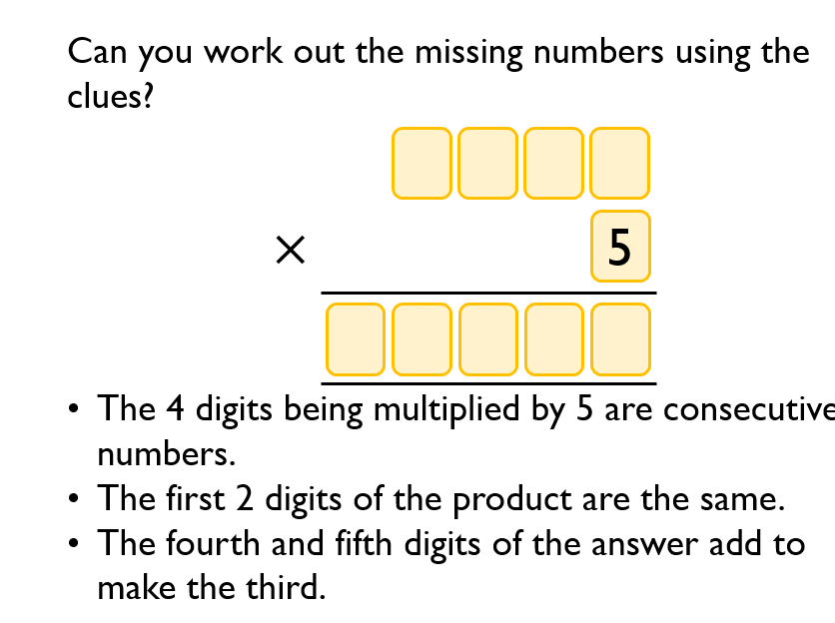
Do not agree - Ron – 1,325 cm2 Annie – 1,352 cm2

1 1 7 2 5
2 3 4 5
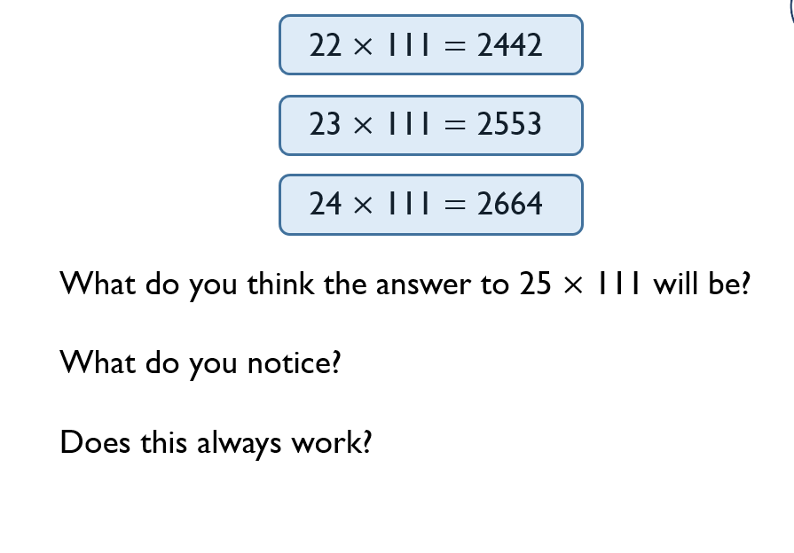
Pencils – 17,280 Rulers – 33,120

15,840 more Rulers.

